|  |  |
| --- | --- |
|  | **MINISTRY OF EDUCATION AND TRAINING** |

|  |
| --- |
| **FPT UNIVERSITY** |
| Capstone Project Document |
| Study on Reinforcement Learning and Its Application for Delivery problem |
|  |
| |  |  | | --- | --- | | **Group 4** | | | **Group Members** | Phạm Hoàng Đức Nhã – SE61869  Phan Quốc Minh – SE62019  Hoàng Tuấn Anh – SE62103  Phạm Phú Tiến – SE61597 (Drop) | | **Supervisor** | Đoàn Nguyễn Thành Hòa | | **Ext Supervisor** |  | | **Capstone Project code** | RLFDP | |
| - Ho Chi Minh City, 01/2018 - |

*This page is intentionally left blank*

**Table of Contents**

**Definitions, Acronyms, and Abbreviations 9**

**A. Introduction 10**

**1. Project Information 10**

**2. Introduction 10**

**3. Current Situation 10**

**4. Problem Definition 11**

**5. Proposed Solution 11**

**6. Role and Responsibility 11**

**B. Software Project Management Plan 13**

**1. Problem Definition 13**

**1.1. Name of this Capstone Project 13**

**1.2. Problem Abstract 13**

**1.3. Project Overview 13**

**1.3.1. Current Situation 13**

**1.3.2. The Proposed System 14**

**1.3.3. Boundaries of the System 14**

**1.3.4. Future Plans 14**

**1.3.5. Development Environment 15**

**1.3.5.1. Hardware Requirement 15**

**1.3.5.2. Software Requirement 15**

**2. Project organization 15**

**2.1. Software Process Model 15**

**2.2. Roles and Responsibilities 16**

**2.3. Tools and Techniques 17**

**3. Project Management Plan 18**

**3.1. Software development life cycle 18**

**3.2. Phase Detail 20**

**3.2.1. Initialization and basic research 20**

**3.2.2. Read paper and design 20**

**3.2.3. Implement demo application 21**

**3.2.4. Test demo application 21**

**3.2.5. Complete report document 22**

**3.2.6. Write paper 22**

**3.3. All Meeting Minutes 22**

**4. Coding Convention 22**

**C. Software Requirement Specification 25**

**1. User Requirement Specification 25**

**2. System Requirement Specification 25**

**2.1. External Interface Requirement 25**

**2.1.1. User Interface 25**

**2.1.2. Hardware Interface 26**

**2.1.3. Software Interface 26**

**2.2. System Overview Use Case 27**

**2.3. List of Use Case 28**

**2.3.1. Run Algorithm 28**

**2.3.1.1. Adjust Parameters 29**

**2.3.1.2. Select an algorithm 31**

**2.3.1.3. Load model of environment 33**

**2.3.1.4. Run the algorithm 36**

**2.3.1.5. View real-time graph 38**

**2.3.1.6. Save solutions as a log 40**

**2.3.2. Map management 42**

**2.3.2.1. Search solutions 43**

**2.3.2.2. Apply road map to saved solutions 45**

**2.3.2.3. Apply road map to each cluster 47**

**2.3.3. Log Management 49**

**2.3.3.1. Compare selected logs 49**

**2.3.3.2. View Detailed statistics 51**

**3. Software System Attribute 53**

**3.1. Usability 53**

**3.2. Reliability 53**

**3.3. Availability 53**

**3.4. Security 54**

**3.5. Maintainability 54**

**3.6. Portability 54**

**3.7. Performance 54**

**D. Software Design Description 55**

**1. Design Overview 55**

**2. Detailed Description 55**

**2.1. Class Diagram 55**

**2.2. Class Diagram Explanation 56**

**2.2.1. ACOAnt 56**

**2.2.2. ACO 57**

**2.2.3. ACOGraph 58**

**2.2.4. SimAnneal 58**

**2.2.5. AntQAnt 59**

**2.2.6. AntQGraph 59**

**2.2.7. AntQ 60**

**2.2.8. KmeansPP 61**

**2.2.9. AntQClustering 62**

**2.2.10. DeliveryAlgorithm 63**

**2.2.11. Log 64**

**2.3. Interaction Diagram 65**

**2.3.1. Run the Combination of AntQ and K-Means++ Algorithm 65**

**2.3.2. Run ACO Algorithm 66**

**2.3.3. Run SA Algorithm 67**

**2.3.4. Get List Log 68**

**2.3.5. Compare logs 69**

**3. User Interface Design 70**

**3.1. Main User Interface 70**

**3.1.1. Graph UI 70**

**3.1.1.1. Ant-Q UI 71**

**3.1.1.2. ACO UI 73**

**3.1.1.3. Simulated Annealing UI 75**

**3.1.1.4. Chart Line Layout 76**

**3.1.1.5. Function Layout 77**

**3.1.2. Google Maps UI 79**

**3.1.2.1. Log Manager 80**

**3.1.2.2. Route Result 81**

**3.1.3. Task bar 82**

**3.1.4. Graph Container 83**

**3.2. Log User Interface 84**

**4. Algorithms 86**

**4.1. Delivery algorithm 86**

**4.1.1. Definition 86**

**4.1.2. Define Problem 86**

**4.1.3. Solution 86**

**4.1.4. Complexity 88**

**4.1.5. Flowchart 89**

**4.2. K-means++ algorithm 90**

**4.2.1. Definition 90**

**4.2.2. Define problem 90**

**4.2.3. Solution 90**

**4.2.4. Complexity 91**

**4.2.5. Flowchart 91**

**4.3. Other heuristic algorithms 92**

**4.3.1. Ant Colony Optimization algorithm 92**

**4.3.2. Simulated Annealing algorithm 93**

**E. System Implementation & Test 94**

**1. Introduction 94**

**1.1. Overview 94**

**1.2. Test Approach 94**

**2. Performance Measures 94**

**3. Test Plan 95**

**3.1. Features to be tested 95**

**3.2. Features not to be tested 95**

**4. System Testing Test Case 96**

**4.1. GUI 96**

**4.2. Main Window Function 97**

**4.2.1. Graph UI Function 97**

**4.2.2. GoogleMap UI Function 99**

**4.3. Log Window Function 101**

**F. Software User’s Manual 103**

**1. Installation 103**

**1.1. Prepare dependencies 103**

**1.2. Install application 105**

**2. User guide 107**

**2.1. Generate data 107**

**2.2. Apply new parameter 110**

**2.3. Run algorithm 112**

**2.4. Run on Google Map 114**

**2.5. View a cluster on googlemap 117**

**2.6. Search logs 118**

**2.7. Add log to table 120**

**2.8. Compare logs 123**

**G. Appendix 126**

**List of Tables**

Table 1: Roles 12

Table 2: Hardware Requirement 15

Table 3: Software Requirement 15

Table 4: Responsibilities 17

Table 5: Tools and Techniques 17

Table 6: Software development life cycle 19

Table 7: Initialization and basic research 20

Table 8: Read paper and design 21

Table 9: Implement demo application 21

Table 10: Test demo application 22

Table 11: Write report document 22

Table 12:Write paper 22

Table 13: Class dictionary 56

Table 14: GUI Test Case 97

Table 15: Graph UI Test Case 99

Table 16: GoogleMap UI Test Case 101

Table 17: Log Window Test Case 102

Table 18: Pure Python 103

Table 19: Python libraries 103

**List of figures**

Figure 1: Software Process Model 16

Figure 2: Use case overview 27

Figure 3: Adjust Parameter Use Case 29

Figure 4: Select an algorithm Use Case 31

Figure 5: Load model of environment Use Case 33

Figure 6: Run the algorithm Use Case 36

Figure 7: View real-time graph Use Case 38

Figure 8: Save solution as a log Use Case 40

Figure 9: Map management Use Case 42

Figure 10: Search solutions Use Case 43

Figure 11: Apply road map to saved solutions Use Case 45

Figure 12: Show maps applied to each cluster Use Case 47

Figure 13: Log Management Use Case 49

Figure 14: Compare selected logs Use Case 49

Figure 15: View Detailed statistics Use Case 51

Figure 16: Run the Combination of AntQ and K-Means++ algorithm Sequence Diagram 65

Figure 17: Run ACO algorithm Sequence Diagram 66

Figure 18: Run SA algorithm Sequence Diagram 67

Figure 19: Get list log Sequence Diagram 68

Figure 20: Compare logs Sequence Diagram 69

Figure 21: The Algorithm View (Main View) 70

Figure 22: The container contains Ant-Q algorithm parameters 71

Figure 23: The container contains ACO algorithm parameters 73

Figure 24: The container contains Simulated Annealing algorithm parameters 75

Figure 25: Chart Container 76

Figure 26: Function Container 77

Figure 27:The Google maps View 79

Figure 28: The Log Management Container 80

Figure 29: The route result container 81

Figure 30: Header View Bar 82

Figure 31: The Graph Container 83

Figure 32: The Log Management View 84

Figure 33: AntQ flowchart 89

Figure 34: K-means++ flowchart 91

Figure 35: ACO flowchart 92

Figure 36: SA flowchart 93

Figure 37: Test Case Overview 96

# Definitions, Acronyms, and Abbreviations

|  |  |
| --- | --- |
| SA | Simulated Annealing |
| ACO | Ant Colony Optimization |

# Introduction

## Project Information

* Project Name: Study on Reinforcement Learning and Its Application for Delivery problem
* Project Code: RLFDP
* Project Type: Desktop Application
* Start Date: 08/01/2018
* End Date: 09/04/2018

## Introduction

To determine the shortest path are one of the most addressed problems in the field of computer science. Many algorithms are currently available to solve the problems. However, since this problem is categorized as NP-hard, considering between performance and accuracy of algorithms to optimize the results in specific situations is also the dilemma which need to be solved.

Since exact algorithms are too resources-consuming, improving heuristic solutions to obtain as closest as possible the optimal result yet keeping performance to be within the acceptable threshold is currently the better approach to solve the problems. To address further, the current heuristic algorithms for shortest path problems are good only for stable environments, of which variables and states are intolerant to changes over times. Our thesis mainly focuses on how using machine learning and to be more specific, reinforcement learning would improve the accuracy of heuristic approach as well as to compare with other exact and heuristic algorithms. Furthermore, to observe how machine will “learn” to adjust itself in the inconsistent environment is also another façade of the problem we will address. The algorithm in the branch of reinforcement learning to be studied in this thesis is Ant-Q (multi-agents). To prove that the algorithm will outperform other reinforcement learning methods in terms of efficiency in time and resource usage, the collections and conclusions about the optimum of selected algorithms will be performed in this document.

## Current Situation

Choosing algorithms to solve a problem is always a difficult choice. We can not guarantee which algorithms are good or bad for research purposes. By studying previously available materials and reading some of the scientific papers on this topic, we may be able to make easier choices, but here the data is still experimental, so the error is inescapable, the collection and comparison of data from different algorithms and data sets will not normally be as expected.

Furthermore, in order to fit the situation where many delivery men would be involved in one delivery session as well as to improve the algorithm performance-wise, clustering and to be specific, K-means++ will be used to divide and conquer big delivery problems.

## Problem Definition

The current delivery problem solving algorithms always have disadvantages:

* With exact algorithms, work is reasonably fast only for small size problems.
* With heuristic algorithms, i.e., algorithms that deliver either seemingly or probably good solutions, but which could not be proved to be optimal.
* Each algorithm requires that the environment must be determined and fixed (Every changes on environment will lead to the whole algorithm to be re-run).
* Using a combination of algorithms is choosing an algorithm depending on the environment that is appropriate with that algorithm. But the method to choose the algorithm is not optimized, and there are many special cases and environments that have not optimized algorithm.

## Proposed Solution

To overcome the disadvantages of existing algorithms , we propose to use the Reinforcement Learning method, in which the Q-learning algorithm is the most efficient algorithm for solving the delivery problem.

Advantages:

* No fixed environment is required.
* Solving many special cases and environments.
* Avoid failures encountered before.
* Any changes on environments will not affect the learning process as previous learning processes are updated after each episode.

Disadvantages:

* It is necessary to have a simulated environment and a certain time to “learn” before producing optimal solution.

## Role and Responsibility

|  |  |  |  |  |
| --- | --- | --- | --- | --- |
| **No** | **Full Name** | **Role** | **Position** | **Contact** |
| 1 | Đoàn Nguyễn Thành Hoà | Project Manager | Supervisor | [hoadnt@fe.edu.vn](mailto:hoadnt@fe.edu.vn) |
| 2 | Phạm Hoàng Đức Nhã | Developer | Leader | [nhaphdse61869@fpt.edu.vn](mailto:nhaphdse61869@fpt.edu.vn) |
| 3 | Phan Quốc Minh | Developer | Member | [minhpqse62019@fpt.edu.vn](mailto:minhpqse62019@fpt.edu.vn) |
| 4 | Hoàng Tuấn Anh | Developer | Member | [anhhtse62103@fpt.edu.vn](mailto:anhhtse62103@fpt.edu.vn) |
| 5 | Phạm Phú Tiến | Developer | Member | [tienppse61597@fpt.edu.vn](mailto:tienppse61597@fpt.edu.vn) |

Table : Roles

# Software Project Management Plan

## Problem Definition

### Name of this Capstone Project

Official Name: Study on Reinforcement Learning and Its Application for Delivery problem

Vietnamese Name: Nghiên cứu về học củng cố và ứng dụng của nó trong việc giải quyết bài toán giao hàng

Abbreviation: RLFDP

### Problem Abstract

During researching, we applied Ant-Q algorithm which will be the main algorithm to solve the delivery problem. However, in order to fit the situation where many delivery men would be involved in one delivery session as well as to improve the algorithm performance-wise, clustering and to be specific, K-means++ will be used to divide and conquer big delivery problems.

By applying other solving delivery problem algorithms, specifically here we use ACO(Ant Colony Optimization) and (SA)Simulated Annealing. The process of comparing and measuring data to give specific parameters, these parameters may be useful for selecting the right solution for different situations. The results may not be as expected but it will still be useful.

### Project Overview

#### Current Situation

* PyQt5 is mainly written in C++ language, it makes difficult to convert to python language.
* The application does not guarantee to run well if input data set is over than 50 locations.
* Comparison between asynchronous logs on data makes it difficult to make a conclusion.
* Color blurring when showing route on google maps.

#### The Proposed System

To acquire the fundamental knowledge of the basic concepts, we need to learn about Machine Learning, especially Reinforcement Learning. Nevertheless, to fully understand as well as to be able to implement the algorithm, study on Q-Learning and Ant-Q via appropriate materials is also a must.

In order to compare and study on the advantages and disadvantages of Ant-Q and other heuristic approaches, we decided to create a demo application, with a certain amount of dummy data to produce comparable results.

#### Boundaries of the System

Our program applies three selected heuristic algorithms to solve the delivery problem and show the process how algorithms work on it.

Using Ant-Q, ACO and Simulated Annealing algorithms to run the process is the core of the system.

Combining Ant-Q algorithm and K-mean algorithm, k-mean divides the data set into smaller pieces then apply Ant-Q algorithm on each piece of that data set.

Recording all results when the process is done, the records will be saved as logs. Log data helps user comparing the difference between logs.

Besides that, the demo application also can apply the algorithm and its parameters which belongs to selected log to process on google maps then show route results to user.

#### Future Plans

Our system is built for the only purpose that solving the delivery problem. Not only researching, testing, collecting data to make a conclusion, a comparison or a statistic. Moreover we want to apply the solution to the practical application.

About academic researching:

* We apply three algorithms which can solve the delivery problem. there are Ant-Q, ACO, Simulated Annealing.
* Our system allows us scale out our model, we also can apply the other algorithms which belong to other concepts of machine learning.

About practical application:

* Contributing to build solutions for Logistic.
* Optimizing existing navigation algorithms.
* Being a tool for developing Artificial intelligence (AI) which is specifically the automatic navigation robot.

#### Development Environment

##### Hardware Requirement

|  |  |  |
| --- | --- | --- |
|  | **Minimum Requirements** | **Recommended** |
| **Operating System** | Windows 7 or later, macOS, and Linux | Windows 10 or later, macOS, and Linux |
| **Processors** | Intel® Core™ i3 processor | Intel® Core™ i5 processor 4300M at 2.60 GHz |
| **Disk Space** | 1 GB | 2 to 3 GB |
| **Memory** | 1 GB | 4 GB |

Table : Hardware Requirement

##### Software Requirement

|  |  |  |
| --- | --- | --- |
| **Software** | **Name/ Version** | **Description** |
| Environment | Python3 | Specification for python developer |
| Modeling tool | StarUML | Used to design UML diagrams |
| Source control | Github | Used for source control |
| IDE | Pycharm | Programming tool |

Table : Software Requirement

## Project organization

### Software Process Model

This project is developed using waterfall model. A customized waterfall model is applied to capable with current situations. This model includes 5 steps of researching the algorithm and developing the application:

* Initialization and basic research
* Read paper and design
* Implement demo application
* Write document
* Write paper

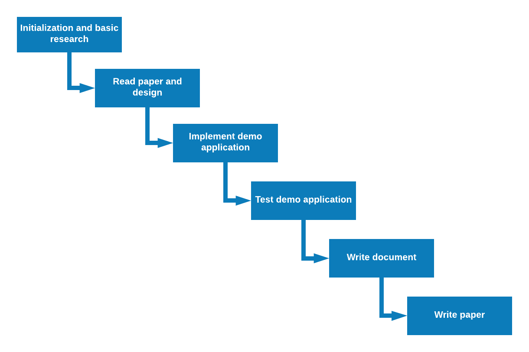

Figure : Software Process Model

### Roles and Responsibilities

|  |  |  |  |
| --- | --- | --- | --- |
| **No** | **Full name** | **Role in Group** | **Responsibilities** |
| 1 | Đoàn Nguyễn Thành Hòa | Project Manager | * Specify research requirements * Control the project process * Give some advice and ensure that the research member is researching the right things. |
| 2 | Phạm Hoàng Đức Nhã | Team Leader, Developer, Tester | * Managing process * Read and understand specify paper * Prepare document and write paper * Coding * Testing |
| 3 | Phan Quốc Minh | Developer, Tester | * Read and understand specify paper * Prepare document and write paper * Coding * Testing |
| 4 | Hoàng Tuấn Anh | Developer, Tester | * Read and understand specify paper * Prepare document and write paper * Coding * Testing |
| 5 | Phạm Phú Tiến | Developer, Tester | * Read and understand specify paper * Prepare document and write paper * Coding * Testing |

Table : Responsibilities

### Tools and Techniques

|  |  |
| --- | --- |
| **Tool/ Technique** | **Name / Version** |
| Language | Python3 |
| GUI libraries | PyQt, Matplotlib |
| Google Map API libraries | googlemaps |
| Other libraries | networkx, decorator, numpy |

Table : Tools and Techniques

## Project Management Plan

### Software development life cycle

|  |  |  |  |  |  |
| --- | --- | --- | --- | --- | --- |
| **Phase** | **Description** | **Deliverables** | **Resource needed** | **Dependencies and Constrains** | **Risks** |
| **Initialization and basic research** | -Learn python  -Research for machine learning basic and reinforcement learning | -Basic Knowledge of python  -Understand about machine learning and reinforcement learning  -Introduction document  -Project Management Plan | 3 weeks | N/A | -Misunderstanding of machine learning  -Focus wrong things. |
| **Read paper and design** | -Reading two paper:  +Ant-Q_ A Reinforcement Learning approach to the traveling salesman problem  +Reinforcement Learning For Solving Shortest-Path And Dynamic Scheduling Problems  -Design demo application | -Understand two papers and algorithms in papers  -Software Requirement Specification  -Software Design Description | 2 weeks | Depend on “Initialization and basic research” | -Cannot understand paper and equation in paper. |
| **Implement demo application** | -Use algorithms in two paper to implement a demo application for them. | -A demo application | 3 weeks | Depend on “Read paper” | -Implement wrong algorithms. |
| **Test demo application** | Prepare test plan and test cases  Test all functions and results | -System Implementation and Test | 2 week | Depend on “Read paper and design” and “Implement demo application” |  |
| **Complete report document** | Write “Software User’s Manual”  Review all documents | - Software User’s Manual | 2 weeks | Depend on “Read paper and design” | -Don’t have enough resource to complete documents. |
| **Write paper** | Write paper | -A paper | 2 weeks | Depend on “Implement demo application” and “Read paper” | -Don’t have enough time to complete paper.  -Don’t know and not use scientific terminology in paper. |

Table : Software development life cycle

### Phase Detail

#### Initialization and basic research

|  |  |  |
| --- | --- | --- |
| **Task** | **Description** | **Author** |
| **Learn python** | Learn python basic  Learn how to use numpy and matplotlib libraries | NhaPHD, MinhPQ, AnhHT, TienPP |
| **Study on machine learning and reinforcement learning basic** | Study on reinforcement learning basic: Policy, Reward Signal, Value Function, Model of the Environment, The Simulated Environment  Study on Supervised Learning, Unsupervised Learning, Semi-Supervised Learning and compare with Reinforcement Learning  Study on Markov Decision Process (MDP), Q-learning, Ant-Q | NhaPHD, MinhPQ, AnhHT, TienPP |
| **Write document** | Write Introduction document  Write Project Management Plan | NhaPHD, MinhPQ, AnhHT, TienPP |

Table : Initialization and basic research

#### Read paper and design

|  |  |  |
| --- | --- | --- |
| **Task** | **Description** | **Author** |
| **Read “Ant-Q_ A Reinforcement Learning approach to the traveling salesman problem” paper** | Understand paper and Ant-Q algorithm | NhaPHD, MinhPQ |
| **Read “Reinforcement Learning For Solving Shortest-Path And Dynamic Scheduling Problems” paper** | Understand paper and Q-learning algorithm | AnhHT, TienPP |
| **Design demo application** | Design main function and GUI of demo application | NhaPHD, MinhPQ, AnhHT, TienPP |
| **Write document** | Write Software Requirement Specification  Write Software Design Description | NhaPHD, MinhPQ, AnhHT, TienPP |

Table : Read paper and design

#### Implement demo application

|  |  |  |
| --- | --- | --- |
| **Task** | **Description** | **Author** |
| **Implement GUI** | Implement GoogleMap, Log Window and Main Window | NhaPHD, MinhPQ, AnhHT, TienPP |
| **Implement Main functions** | Implement comparing function, log management and result visualization | NhaPHD, MinhPQ, AnhHT, TienPP |
| **Implement Algorithms** | Implement AntQ, K-means++, SA, ACO algorithm | NhaPHD, MinhPQ, AnhHT, TienPP |

Table : Implement demo application

#### Test demo application

|  |  |  |
| --- | --- | --- |
| **Task** | **Description** | **Author** |
| **Prepare test plan** | Prepare overview plan for testing | NhaPHD, MinhPQ, AnhHT, TienPP |
| **Prepare test case** | Provide check list for function and application | NhaPHD, MinhPQ, AnhHT, TienPP |
| **Test demo application** | Test the demo application base on check list | NhaPHD, MinhPQ, AnhHT, TienPP |
| **Write document** | Write System Implementation and Test | NhaPHD, MinhPQ, AnhHT, TienPP |

Table : Test demo application

#### Complete report document

|  |  |  |
| --- | --- | --- |
| **Task** | **Description** | **Author** |
| **Write document** | Write Software User’s Manual | NhaPHD, MinhPQ, AnhHT, TienPP |
| **Review all document** | Review report 1, 2, 3, 4, 5, 6 | NhaPHD, MinhPQ, AnhHT, TienPP |

Table : Write report document

#### Write paper

|  |  |  |
| --- | --- | --- |
| **Task** | **Description** | **Author** |
| **Write abstract and introduction** | N/A | NhaPHD, MinhPQ, AnhHT, TienPP |
| **Write about Ant-Q and Q-learning algorithm** | N/A | NhaPHD, MinhPQ, AnhHT, TienPP |
| **Write comparison** | N/A | NhaPHD, MinhPQ, AnhHT, TienPP |
| **Write conclusion** | N/A | NhaPHD, MinhPQ, AnhHT, TienPP |

Table :Write paper

### All Meeting Minutes

All meeting documents could be found at [Meeting Minutes](https://docs.google.com/document/d/1I8FJTyIz-2_YblsUcHD7N9KDTqa7IkmbjVBbhv_R_24/edit)

## Coding Convention

Overview we use the convention of python coding, we also prefer to use PEP8. Besides that, we have some our specified coding convention:

* + Back-end side: we prefer to use PEP8.
    - Variable Naming:
      * Naming convention: snake case (lower_case_with_underscores)
      * Minimum length: 2.
      * Maximum length: 50.
    - Function Naming:
      * Naming convention: camel case (lowerCaseThenUpperCase)
      * Minimum length: 2.
      * Maximum length: 50.
      * The first word: Verb (getSomething)
    - Class Naming:
      * Naming convention: Upper camel case (UpperCamelCase)
      * Minimum length: 2.
      * Maximum length: 50.
      * Meaning: The whole name must be a noun.
    - Constant Naming:
      * Naming convention: Constants should be written in uppercase characters separated by underscores. Constant names may also contain digits if appropriate, but not as the first character.
      * Minimum length: 2.
      * Maximum length: 50.
    - Comments:
      * Always comment on the previous line of the function or line of code that you want to take note.
      * The comment line must be packaged in one line.
    - Blank Lines: Two blank lines between top-level definitions, one blank line between method definitions.
    - Shebang Line: Most .py files do not need to start with a #! line. Start the main file of a program with #!/usr/bin/env python with an optional single digit 2 or 3 suffix.
    - Whitespace: Follow standard typographic rules for the use of spaces around punctuation.
  + Front-end side: We prefer to use w3school coding conventions.
    - Naming Conventions:
      * Variable and function names written as camelCase
      * Global variables written in UPPERCASE (We don't, but it's quite common)
      * Constants (like PI) written in UPPERCASE
    - Hyphens in HTML and CSS:
      * HTML5 attributes can start with data- (data-quantity, data-price).
      * CSS uses hyphens in property-names (font-size).
    - Accessing HTML Elements:
      * Use the same naming convention (as JavaScript) in HTML.

# Software Requirement Specification

## User Requirement Specification

We build a demo application for researching so the demo application gives everyone permission to do the same functions like each others. We call the people who interact with the application is referred to as “USER”.

User can use all functions available in the application:

* + Algorithm View:
    - Generate JSON Data File contains a set of locations data.
    - Adjust algorithm parameters
    - Apply algorithm parameters
    - Run selected algorithm.
    - Save the record as a log.
    - Run the selected log and show list route result on google maps.
    - Select cluster and show the selected cluster on google maps.
  + Log View:
    - Search logs by their name and algorithm.
    - Add selected logs to the comparing table.
    - Comparing the results between logs.
    - Rename the selected log on the tree list view.
    - Remove the selected log from the tree list view.
    - View the information of the selected log.
    - Remove the selected log from the comparing table.

## System Requirement Specification

### External Interface Requirement

#### User Interface

* General requirement for graphics user interface is that the GUI should be simple, clear, intuitive and reminiscent.
* Depend on the level of importance of each component, its position and its size will be more special than the others helps user can focus on it.
* By using flat and minimalist design, the depth of each objects is also designed clearly and subtly.
* We don’t use any specific principles for a desktop application. Instead of that, we applied a general principle named “DOET” which stands for “Design of Everyday Things”:

#### Hardware Interface

* Laptop or Computer which is connected to Internet via wifi or cable.
* The device also need to meet some minimum requirements:
* CPU :    Intel, Core i3
* RAM :     4 GB
* Hard Drive :    HDD
* Graphic Card : Onboard Card/ Intel Graphic
* Connect port :  LAN : 10/100/1000 Mbps, WIFI : IEEE 802.11

#### Software Interface

* Desktop application: recommended Windows (7 or above)

### System Overview Use Case

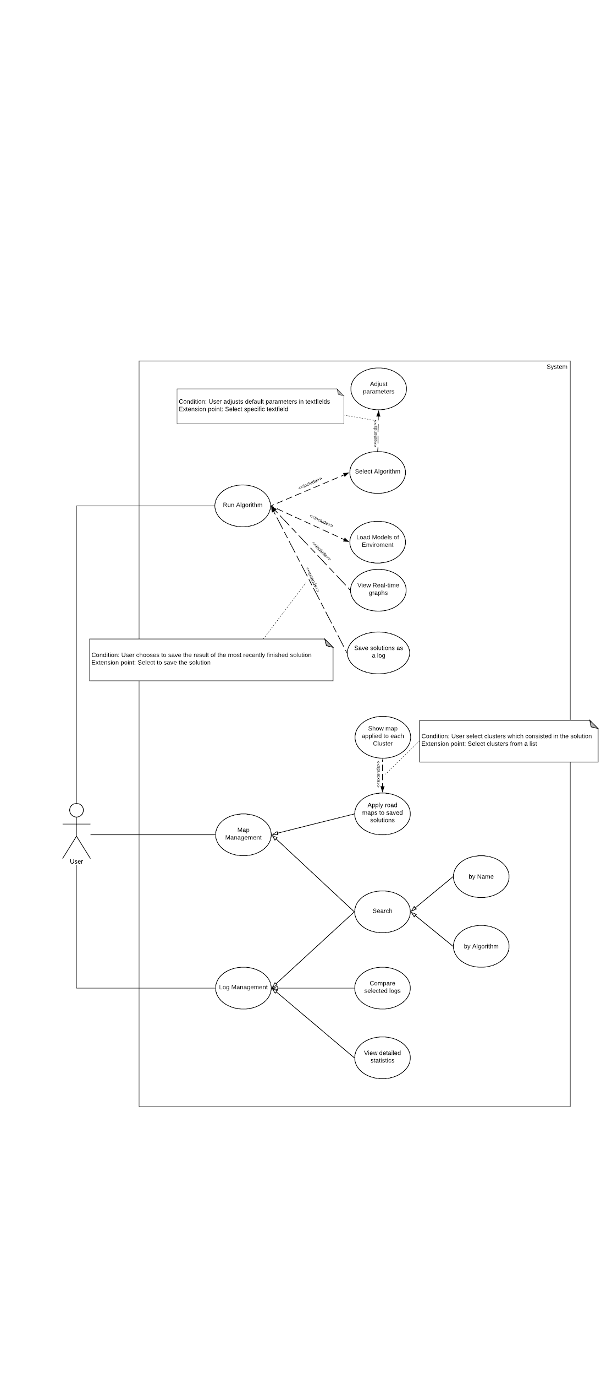

Figure : Use case overview

### List of Use Case

#### Run Algorithm

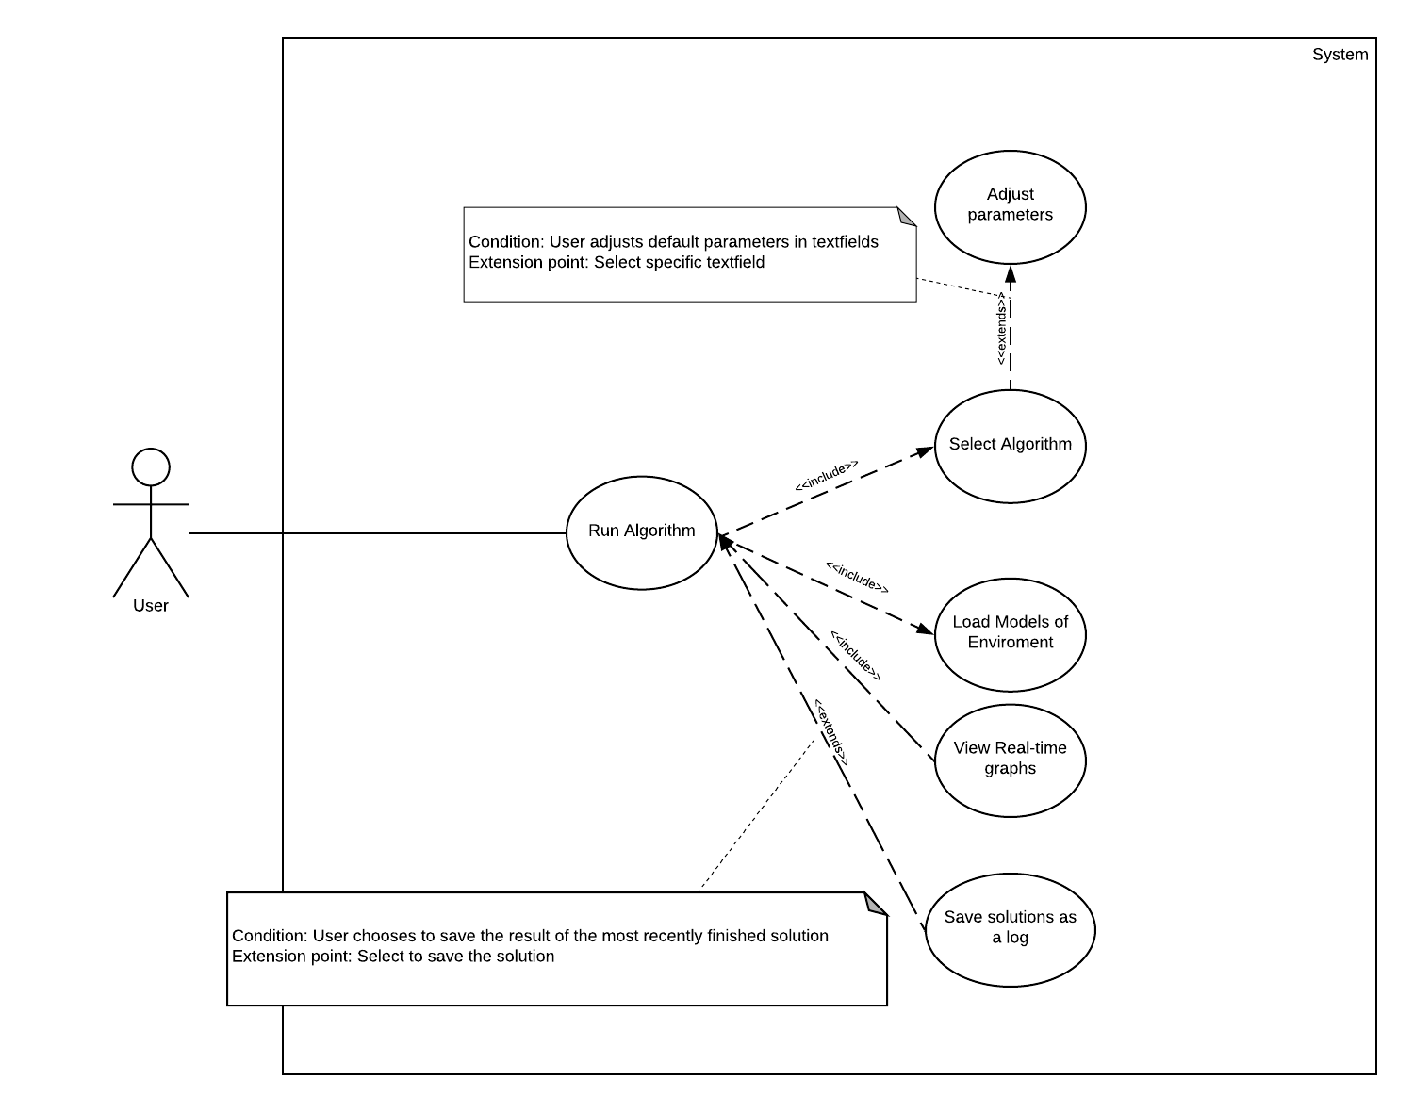

##### Adjust Parameters

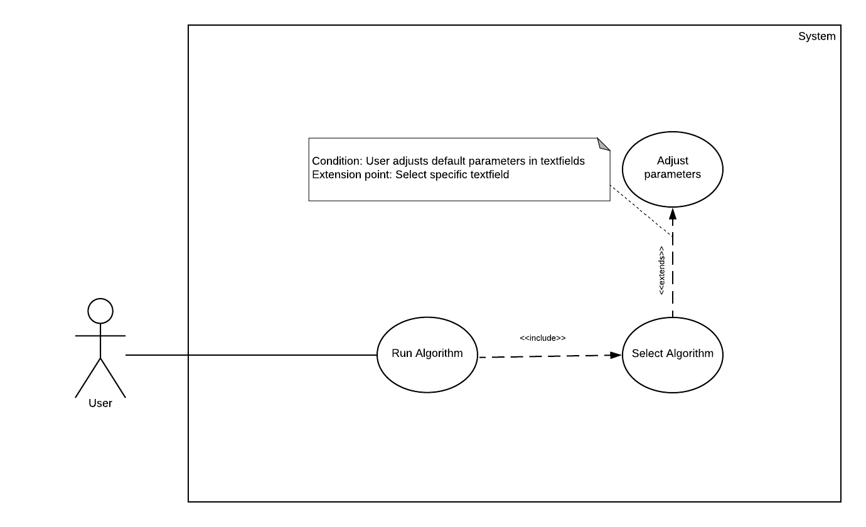

Figure : Adjust Parameter Use Case

|  |  |  |  |
| --- | --- | --- | --- |
| **USE CASE - UC-01** | | | |
| Use Case No. | 1 | Use Case Version | 2.0 |
| Use Case Name | Adjust Parameters | | |
| Author | Hoang Tuan Anh | | |
| Date | 10/02/18 | Priority | Normal |
| **Actor**:   * User   **Summary**:   * This use case allows User to modify default parameters provided by the system.   **Goal**:   * User can adjust parameters after selecting an algorithm.   **Triggers**:   * When an algorithm is selected   **Preconditions**:   * Algorithm must be selected.   **Post** **Conditions**:   * Success: System adjust parameters used to run the algorithm after the input paramters. * Failed: Messages show when input parameters are inappropriate.   **Main** **Success** **Scenario**:   |  |  |  | | --- | --- | --- | | Step | Actor Action | System Response | | 1 | User ignores parameter fields | System uses default parameters to start the algorithm. | | 2 | User modifies default parameters | System should inform user that the action is successful. |   **Alternative** **Scenario**: N/A  **Exceptions**:   |  |  |  | | --- | --- | --- | | No | Actor Action | System Response | | 1 | User leaves blank field when start the algorithm. | System shows error message to ask user to fill the required fields. | | 2 | User starts algorithm with non-numeric parameters. | System shows error message to ask user to change inappropriate inputs. | | 3 | User inputs parameters which excesses the threshold. | System shows error message to inform which input fields have exceed the threshold and ask User to change the inappropriate inputs. |   **Relationships:** Extends from “Select an algorithm”  **Business Rules:**  Parameters must satisfy:   * Number of agents (n) should be in range [0.6*n, n] * Learning rate (α) should be in range [0, 1] * Discount Factor (γ) should be in range [0, 1] * Heuristic Balancer (β) should be numeric. * AQ-value Balancer (δ) should be numeric. * Clustering parameter will be used in AntQ only. | | | |

##### Select an algorithm

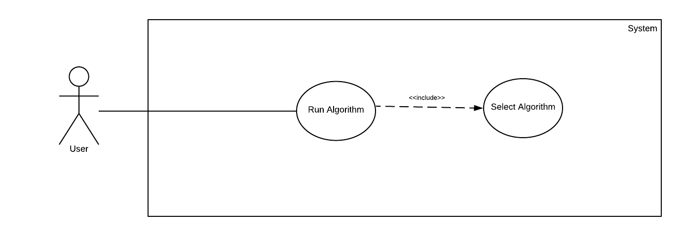

Figure : Select an algorithm Use Case

|  |  |  |  |
| --- | --- | --- | --- |
| **USE CASE - UC-02** | | | |
| Use Case No. | 2 | Use Case Version | 2.0 |
| Use Case Name | Select an algorithm | | |
| Author | Hoang Tuan Anh | | |
| Date | 10/02/18 | Priority | High |
| **Actor:**   * User   **Summary:**   * User select an algorithm.   **Goal:**   * To allow system to run on behalf of the selected algorithm.   **Triggers**:   * User chooses to an algorithm.   **Preconditions**: N/A  **Post** **Conditions**:   * Success: User allows to adjust parameters. * Failed: Error message shows.   **Main Success Scenario:**   |  |  |  | | --- | --- | --- | | Step | Actor Action | System Response | | 1 | User selects an algorithm | Set of parameters required for the selected algorithm will be loaded . |   **Alternative Scenario:**   |  |  |  | | --- | --- | --- | | Step | Actor Action | System Response | | 1 | User does not select any algorithms | System will use AntQ as a default algorithm. |   **Exceptions: N/A**  **Relationships:**  **Business Rules:**   * File should be in .json format. * Data should be an array of marker format objects in which contains marker’s address, latitude and longitude. | | | |

##### Load model of environment

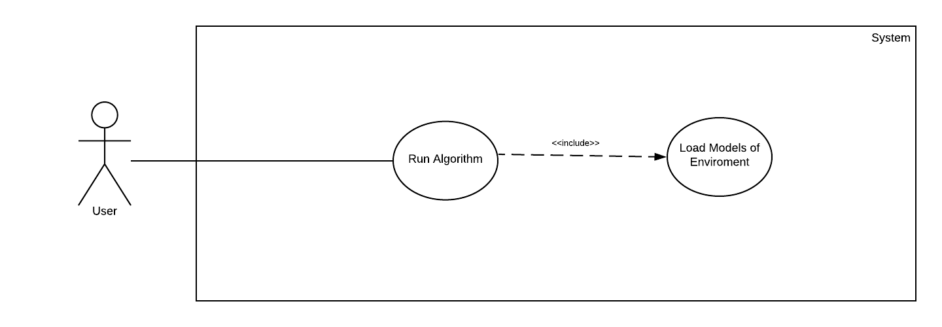

Figure : Load model of environment Use Case

|  |  |  |  |
| --- | --- | --- | --- |
| **USE CASE - UC-03** | | | |
| Use Case No. | 3 | Use Case Version | 2.0 |
| Use Case Name | Load models of environment | | |
| Author | Pham Hoang Duc Nha | | |
| Date | 26/02/18 | Priority | High |
| **Actor:**   * User   **Summary:**   * This use case allows User to load the models of environment.   **Goal:**   * To load the models of environment in which consist of locations, distances, address...   **Triggers:**   * When User select the action Load Model   **Preconditions: N/A**  **Post Conditions:**   * Success: System will add points coordinated with their relative locations in the model to the graph. * Fail: System informs that error has occurred when loading file.   **Main Success Scenario:**   |  |  |  | | --- | --- | --- | | Step | Actor Action | System Response | | 1 | Successfully load a file | Show points contained in the file to the graph.  System uses parameters saved in the file as the default parameters. |   **Alternative Scenario:**   |  |  |  | | --- | --- | --- | | Step | Actor Action | System Response | | 1 | User has already load a model of environment | System shows a message suggesting User with following options:   * Replace points already shown on the graph with the points loaded from file. * Cancel the action of loading markers from file. |   **Exceptions:**   |  |  |  | | --- | --- | --- | | No | Actor Action | System Response | | 1 | File are not in correct format | System shows a message to inform User that selected file are not in correct format | | 2 | Errors occurred when loading and parsing data from file | System logs exceptions if happened.  System shows a message to inform User to check the content of the loaded file. | | 3 | Number of points does not match the dimension of the matrix in the loaded model. | System shows a message to inform User to check the content of the loaded file. | | 4 | Number of points consists in the model is less than 3 | System shows a message to inform User to check the content of the loaded file. |   **Relationships:** N/A  **Business Rules:**   * File should be in .atsp or .tsp format. * Number of points consists in the model must be greater than 2. * File should consists of:   + A matrix contains relative distance from one point to another (if .atsp).   + A set of points based on their real latitude and longitude.   + A set of addresses relative to each points (not required)   + Parameters (not required). | | | |

##### Run the algorithm

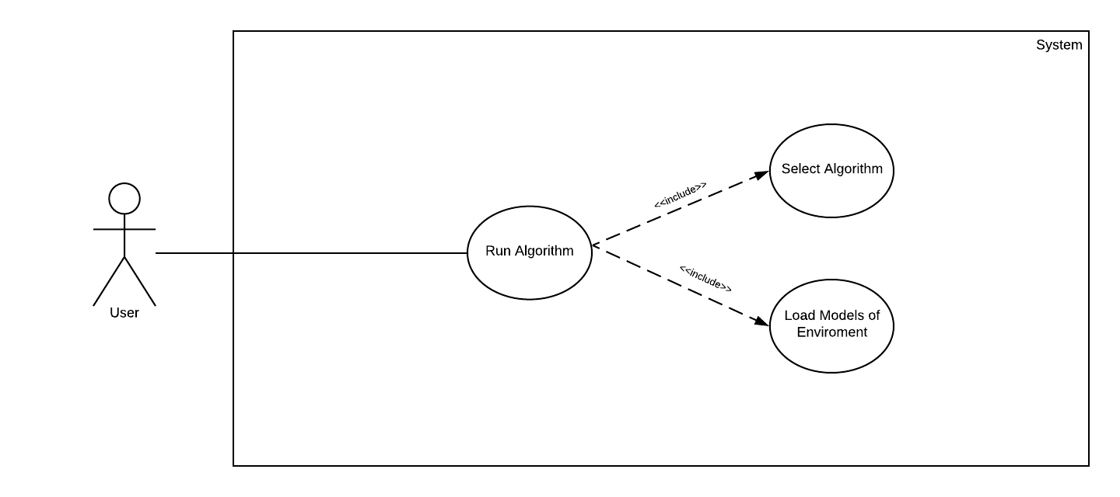

Figure : Run the algorithm Use Case

|  |  |  |  |
| --- | --- | --- | --- |
| **USE CASE - UC-04** | | | |
| Use Case No. | 4 | Use Case Version | 1.0 |
| Use Case Name | Run the algorithm. | | |
| Author | Hoang Tuan Anh | | |
| Date | 26/02/18 | Priority | High |
| **Actor**:   * User   **Summary**:   * This use case allows User to run the algorithm with their desired settings.   **Goal:**   * As running the algorithm, the system will show real-time statistics as well as highlight the taken paths on the graph.   **Triggers:**   * User select action Run   **Preconditions**:   * All parameters have been validated. * Models of environment is successfully selected.   **Post Conditions:**   * Success: Graph and Path map are changed as the algorithm runs * Failed: System shows message that errors have occurred.   **Main Success Scenario:**   |  |  |  | | --- | --- | --- | | Step | Actor Action | System Response | | 1 | Select action Run | System runs the algorithm as well as updates real-time graphs and generates statistics |   **Alternative** **Scenario**: N/A  **Exceptions**:   |  |  |  | | --- | --- | --- | | No | Actor Action | System Response | | 1 | User leaves blank field when start the algorithm. | System shows error message to ask user to fill the required fields. | | 2 | User starts algorithm with non-numeric parameters. | System shows error message to ask user to change inappropriate inputs. | | 3 | User inputs parameters which excesses the threshold. | System shows error message to inform which input fields have exceed the threshold and ask User to change inappropriate inputs. | | 4 | The number of added pointers is less than 3. | System shows a message to suggest User to add more pointers either by loading from another file or modify the current file of model. |   **Relationships:**   * Includes “Select an Algorithm” * Includes “Load model of Environment”   **Business Rules:** N/A | | | |

##### View real-time graph

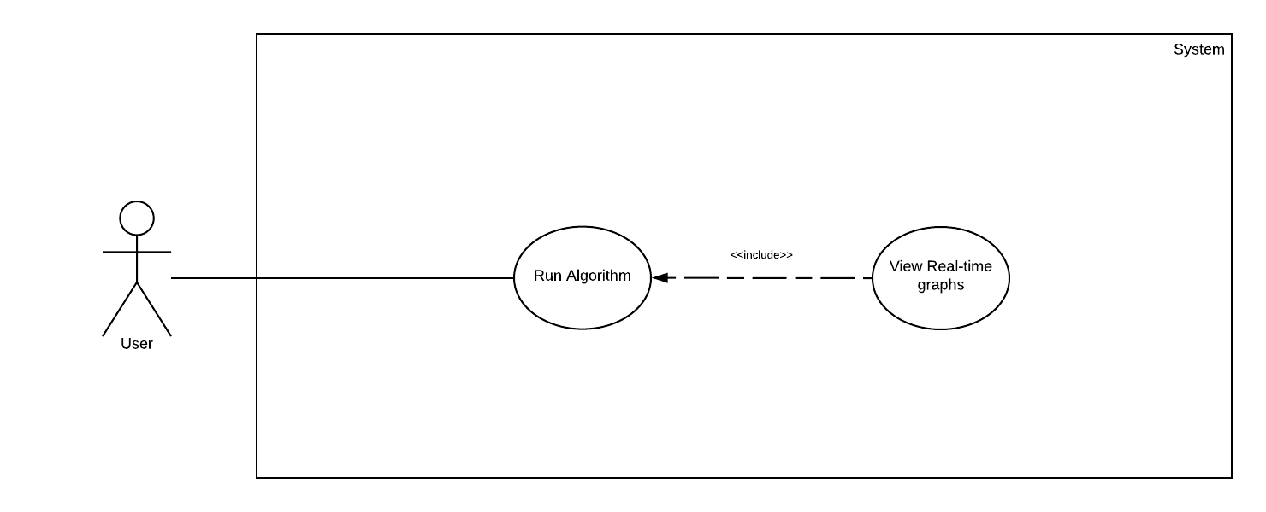

Figure : View real-time graph Use Case

|  |  |  |  |
| --- | --- | --- | --- |
| **USE CASE - UC-05** | | | |
| Use Case No. | 5 | Use Case Version | 2.0 |
| Use Case Name | View Statistics | | |
| Author | Hoang Tuan Anh | | |
| Date | 28/02/18 | Priority | Normal |
| **Actor**:   * User   **Summary:**   * This use case allows User to view graphs generated as the algorithms running.   **Goal**:   * To show real-time graph of the algorithm.   **Triggers**:   * When the algorithms are running.   **Preconditions**:   * The algorithms must be running.   **Post Conditions:**   * Success: System will show the graphs of the algorithm. * Failed: System will inform user that errors have occurred.   **Main Success Scenario:**   |  |  |  | | --- | --- | --- | | Step | Actor Action | System Response | | 1 | User selects option: best length. | System will show the best solutions so far. | | 2 | User selects option: mean length | System will show the average length produced by the algorithm in the current iteration. | | 3 | User selects option: variance | System will show the variance on the solutions in the current iteration. |   **Alternative** **Scenario**: N/A  **Exceptions: N/A**  **Relationships:** includes “Run the algorithm”  **Business Rules:**  Statistics shown should be in form of graph which indicate the following information:   * Current best solution as the algorithm running * Average path length taken by each iteration * Variance from each iteration | | | |

##### Save solutions as a log

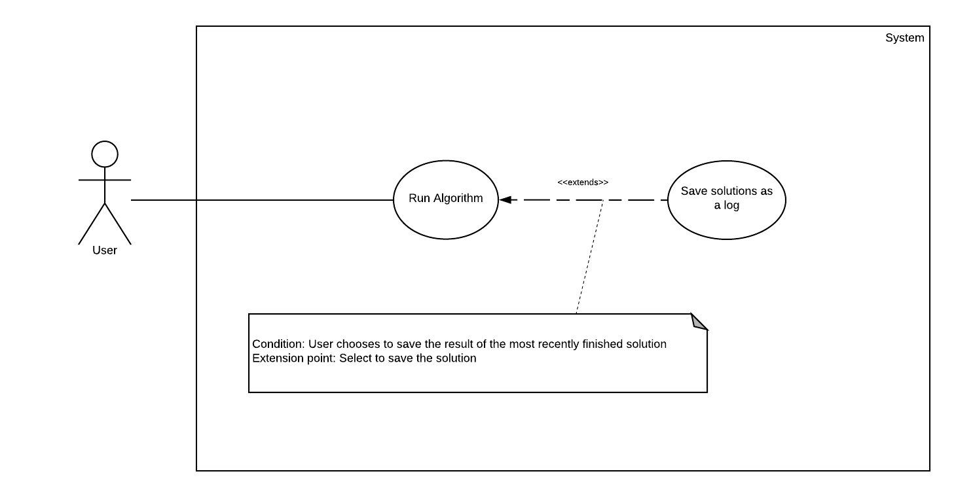

Figure : Save solutions as a log Use Case

|  |  |  |  |
| --- | --- | --- | --- |
| **USE CASE - UC-06** | | | |
| Use Case No. | 6 | Use Case Version | 2.0 |
| Use Case Name | Save solutions as a log | | |
| Author | Phan Quoc Minh | | |
| Date | 10/02/18 | Priority | Normal |
| **Actor:**   * User   **Summary:**   * This use case allows User to save AntQ matrix and environment model produced by the previous successful run of the algorithm to a file.   **Goal:**   * To save model to a file in order to compare with other algorithm or to apply maps to the solution.   **Triggers:**   * When user selects to save the model.   **Preconditions:**   * System has finished running the algorithm.   **Post Conditions:**   * Success: System will inform that data has been successfully saved. * Failed: System will inform user that errors have occurred.   **Main Success Scenario:**   |  |  |  | | --- | --- | --- | | Step | Actor Action | System Response | | 1 | User chooses to save. | System will inform user that the model has been successfully saved. |   **Alternative Scenario:** N/A  **Exceptions:**   |  |  |  | | --- | --- | --- | | No | Actor Action | System Response | | 1 | User try to save data when the algorithm is not finished running. | System shows a message to ask user to wait until the algorithm has finished. |   **Relationships:** extends from “Run the Algorithm”  **Business Rules:**   * File should be in .json format. * File should contain an object which consists of:   + A matrix contains trained AQ-values.   + A set of coordinations of the locations used to run the algorithm.   + A matrix of relative distances from one point to another   + The solution produced by the algorithm. | | | |

#### Map management

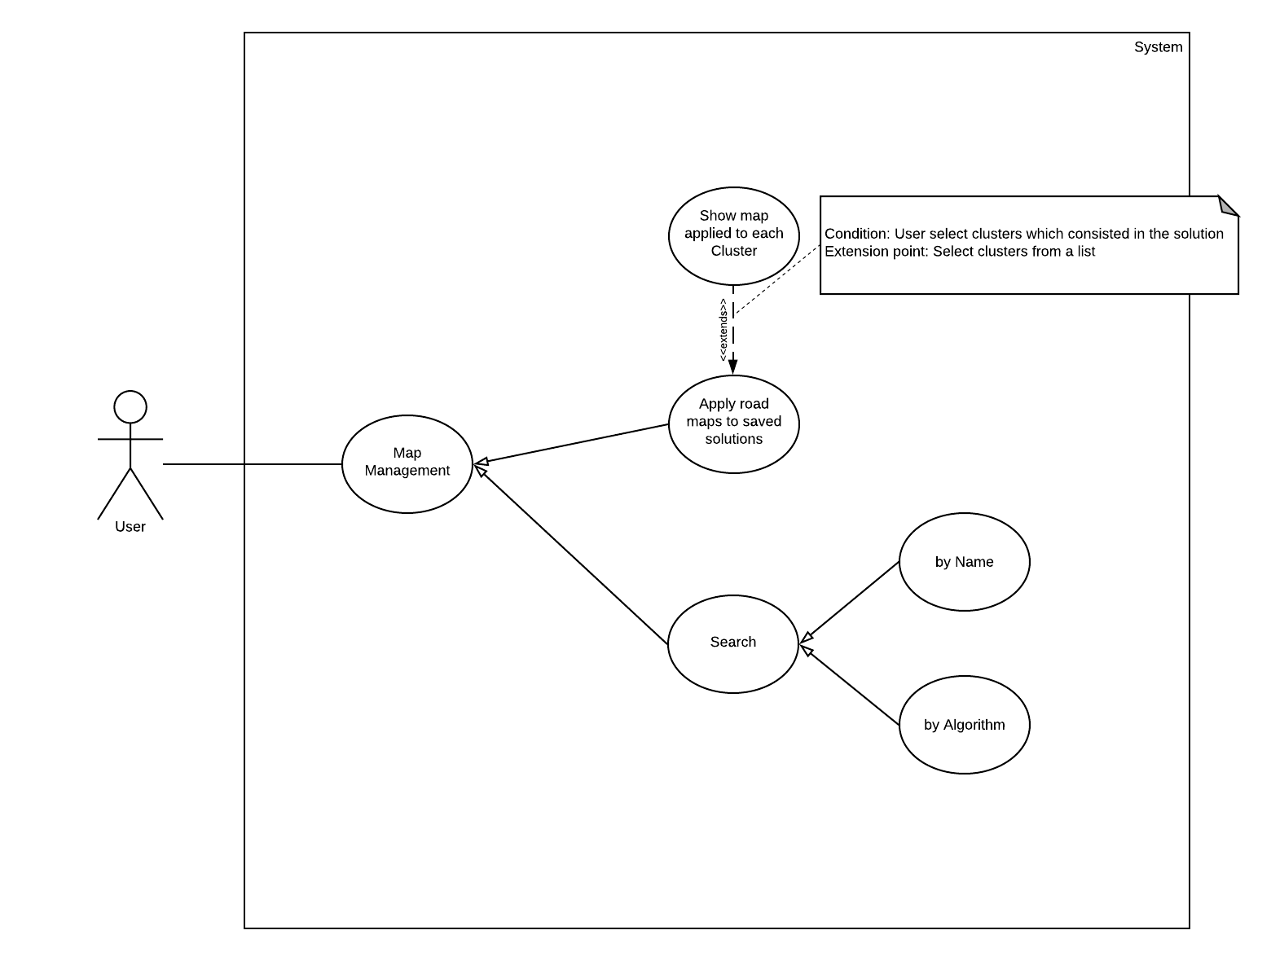

Figure : Map management Use Case

##### Search solutions

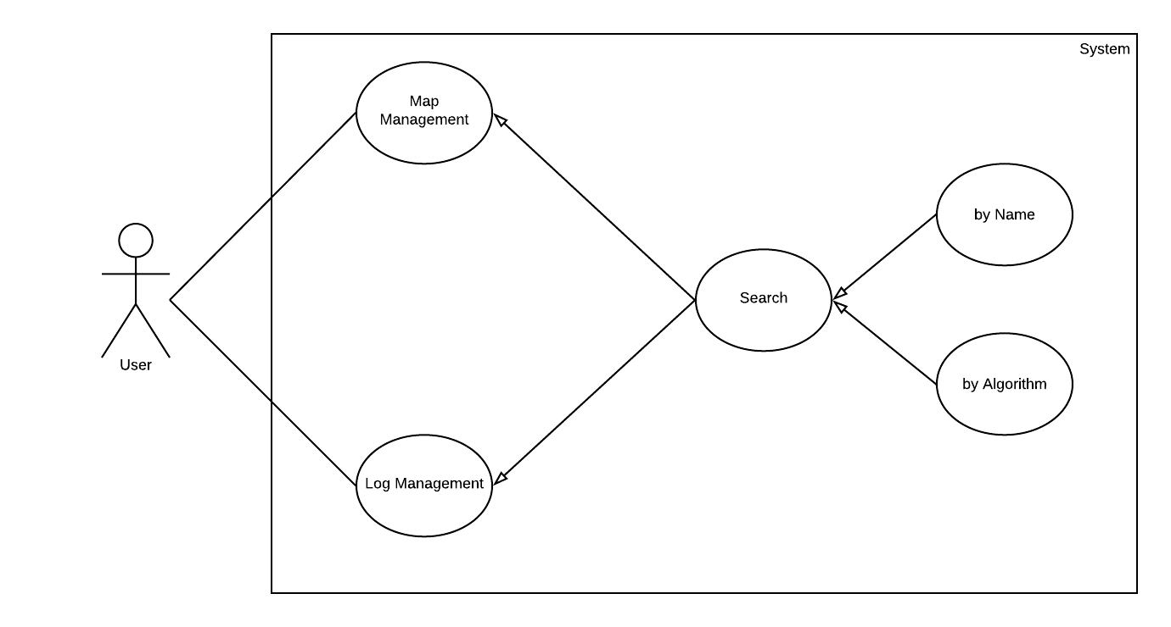

Figure : Search solutions Use Case

|  |  |  |  |
| --- | --- | --- | --- |
| **USE CASE - UC-07** | | | |
| Use Case No. | 7 | Use Case Version | 1.0 |
| Use Case Name | Search solutions | | |
| Author | Phan Quoc Minh | | |
| Date | 02/03/2018 | Priority | Normal |
| **Actor:**   * User   **Summary:**   * This use case allows User to search for a successfully executed solution.   **Goal:**   * To search for a solution to which other action could be executed.   **Triggers:**   * When user search for a solution.   **Preconditions:**   * Solutions are already saved in the system.   **Post Conditions:**   * Success: System will show the list of algorithm. * Failed: System will inform user that errors have occurred.   **Main Success Scenario:**   |  |  |  | | --- | --- | --- | | Step | Actor Action | System Response | | 1 | User search solutions by the name of the saved file. | System will show the results of the action. | | 2 | User search solutions by the name of the algorithms. | System will show the results of the action. |   **Alternative Scenario:**   |  |  |  | | --- | --- | --- | | No | Actor Action | System Response | | 1 | User inputs nothing. | System shows list of all executed solutions. |   **Exceptions:** N/A  **Relationships:**   * Specified from “Map Management” * Specified from “Log Management”   **Business Rules:**   * Allow user to search data by Name or by Algorithm. * Search Algorithm should be selected from a list of provided algorithms. | | | |

##### Apply road map to saved solutions

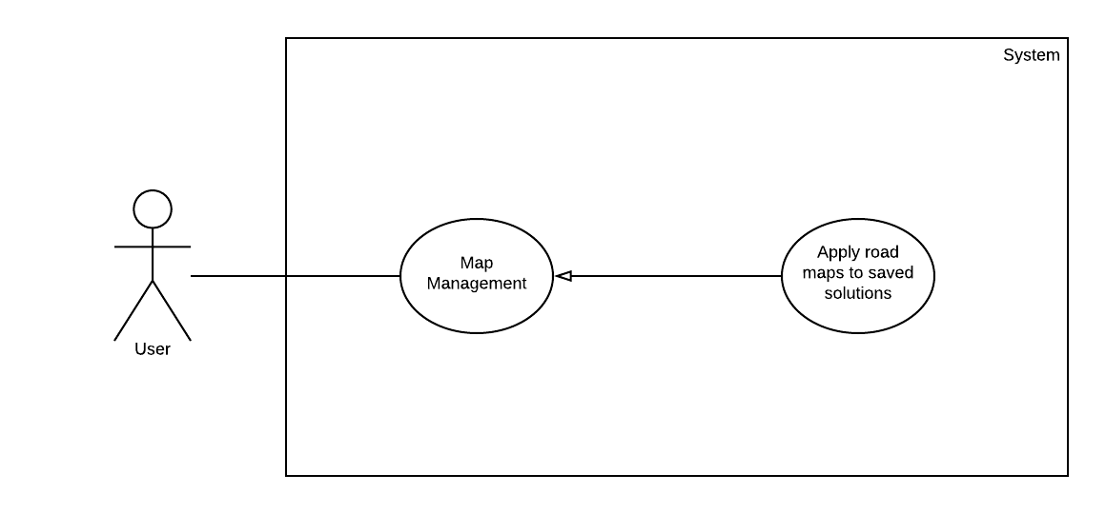

Figure : Apply road map to saved solutions Use Case

|  |  |  |  |
| --- | --- | --- | --- |
| **USE CASE - UC-08** | | | |
| Use Case No. | 8 | Use Case Version | 1.0 |
| Use Case Name | Apply road maps to saved solutions | | |
| Author | Phan Quoc Minh | | |
| Date | 05/03/2018 | Priority | Normal |
| **Actor:**   * User   **Summary:**   * This use case allows User to apply road maps to the successfully executed solution.   **Goal:**   * To apply road map to a saved solution.   **Triggers:**   * To apply road map to a saved solution   **Preconditions:**   * User already selected a solution to which road map could be applied.   **Post Conditions:**   * Success: System will show the road map. * Failed: System will inform user that errors have occurred.   **Main Success Scenario:**   |  |  |  | | --- | --- | --- | | Step | Actor Action | System Response | | 1 | User apply road map to a solution. | System will show road map of the solution. |   **Alternative Scenario:** N/A  **Exceptions:**   |  |  |  | | --- | --- | --- | | No | Actor Action | System Response | | 1 | User selects nothing to which a road map could be applied | System shows an error a message requiring user to select a solution. |   **Relationships:** specified from “Map Management”  **Business Rules:** N/A. | | | |

##### Apply road map to each cluster

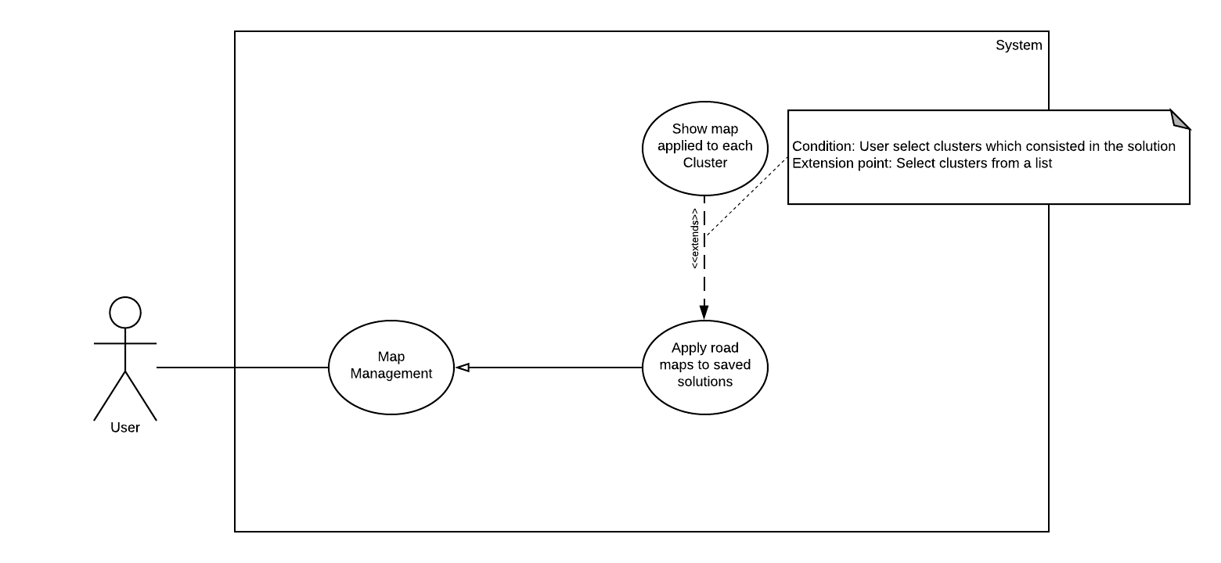

Figure : Show maps applied to each cluster Use Case

|  |  |  |  |
| --- | --- | --- | --- |
| **USE CASE - UC-09** | | | |
| Use Case No. | 9 | Use Case Version | 1.0 |
| Use Case Name | Show maps applied to each cluster | | |
| Author | Phan Quoc Minh | | |
| Date | 05/03/2018 | Priority | Normal |
| **Actor:**   * User   **Summary:**   * This use case allows User to apply road maps to each cluster of the successfully executed solution.   **Goal:**   * To apply road map to each cluster.   **Triggers:**   * When a cluster is selected so that a road map could be applied to it.   **Preconditions:**   * User already selected a solution to which road map could be applied.   **Post Conditions:**   * Success: System will show the road map of each cluster. * Failed: System will inform user that errors have occurred.   **Main Success Scenario:**   |  |  |  | | --- | --- | --- | | Step | Actor Action | System Response | | 1 | User select a cluster to which the road map could be applied. | System will show the a map of the cluster. |   **Alternative Scenario:**   |  |  |  | | --- | --- | --- | | Step | Actor Action | System Response | | 1 | User does not select any clusters | System will show road maps applied to all clusters |   **Exceptions:**   |  |  |  | | --- | --- | --- | | No | Actor Action | System Response | | 1 | User selects nothing to which a road map could be applied | System shows an error a message requiring user to select a solution. | | 2 | User selects solutions of other algorithm rather than AntQ | System shows an error a message requiring user to select a solution of the AntQ algorithm |   **Relationships:** extends from “Apply road map to a solution”  **Business Rules:**   * This use case applied to the solution of the AntQ algorithm only. | | | |

#### Log Management

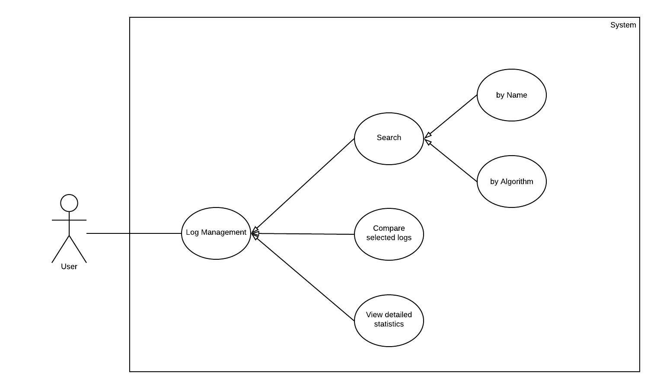

Figure : Log Management Use Case

##### Compare selected logs

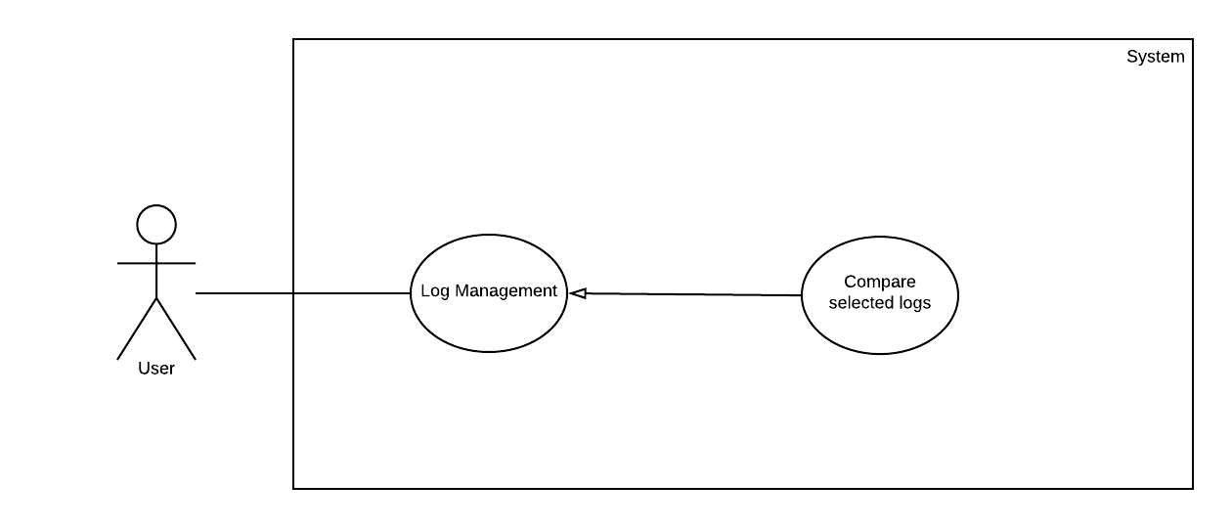

Figure : Compare selected logs Use Case

|  |  |  |  |
| --- | --- | --- | --- |
| **USE CASE - UC-10** | | | |
| Use Case No. | 10 | Use Case Version | 1.0 |
| Use Case Name | Compare selected logs | | |
| Author | Pham Hoang Duc Nha | | |
| Date | 28/02/2018 | Priority | Normal |
| **Actor:**   * User   **Summary:**   * This use case allows User to compare selected logs.   **Goal:**   * To compare selected logs.   **Triggers:**   * When a log is selected for comparing with others.   **Preconditions:**   * User already selected multiple logs for comparing.   **Post Conditions:**   * Success: System will start comparing. * Failed: System will inform user that errors have occurred.   **Main Success Scenario:**   |  |  |  | | --- | --- | --- | | Step | Actor Action | System Response | | 1 | User selects logs. | System will add logs to the table for comparing. | | 2 | User selects to compare the logs in the table | System will start comparing selected logs |   **Alternative Scenario:** N/A  **Exceptions:**   |  |  |  | | --- | --- | --- | | No | Actor Action | System Response | | 1 | User start comparing with less than 2 logs in the table | System shows an error a message requiring user to add at least 2 logs in the table for comparing. |   **Relationships:** specified “Log Management”  **Business Rules:**   * The table of logs should contain at least 2 logs. * Data to be compared should be:   + Algorithm used   + Number of iterations   + Number of agents   + Number of clusters (if AntQ is used)   + Parameters used   + Best solution generated   + Time executed | | | |

##### View Detailed statistics

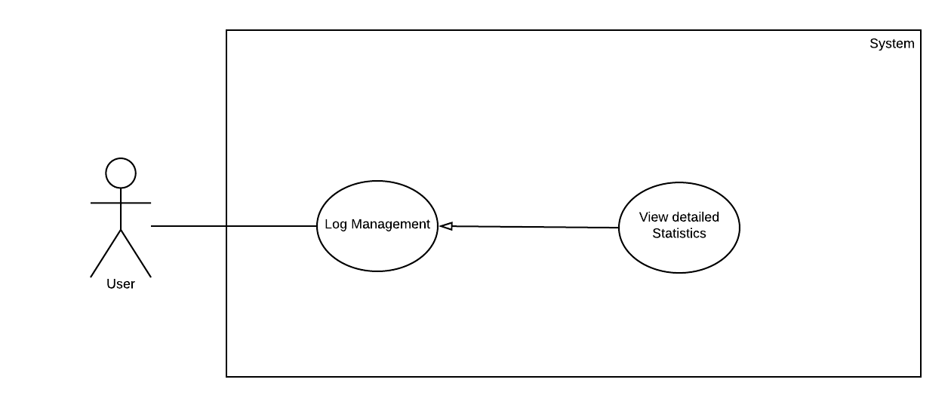

Figure : View Detailed statistics Use Case

|  |  |  |  |
| --- | --- | --- | --- |
| **USE CASE - UC-11** | | | |
| Use Case No. | 11 | Use Case Version | 2.0 |
| Use Case Name | View detailed Statistics | | |
| Author | Pham Hoang Duc Nha | | |
| Date | 02/03/2018 | Priority | Normal |
| **Actor:**   * User   **Summary:**   * This use case allows User to view detailed statistics produced by executed solutions   **Goal:**   * To show detailed statistics.   **Triggers:**   * When a solution is selected in the table of logs.   **Preconditions:**   * User already selected a solution which appears in the table of logs.   **Post Conditions:**   * Success: System will show detailed statistics of the selected logs. * Failed: System will inform user that errors have occurred.   **Main Success Scenario:**   |  |  |  | | --- | --- | --- | | Step | Actor Action | System Response | | 1 | User select to view detailed statistics of a logs. | System will show the detailed statistics of the selected log. |   **Alternative Scenario:** N/A  **Exceptions:** N/A  **Relationships:** specified “Log Management”  **Business Rules:**   * Statistics should consist of:   + Algorithm used   + Number of iterations   + Number of agents   + Number of clusters (if AntQ is used)   + Parameters used   + Results of the solution   + Mean   + Variance or Standard Deviation   + Time executed | | | |

## Software System Attribute

### Usability

* The application has a user manual document with user-friendly interface for each function of the system.
* The application informs user about how the process is going regularly, and give feedback to user in time.
* The application should be consistent, especially in similar situations so users don’t have to wonder whether different words or actions have the same meaning.
* The application requires the confirmation of user before executing the major action.
* The language used in the application and in the error messages should be expressed in plain language. It should be clear, precise and understandable.
* Finally, the application is built on Windows. Thus, the user has an experience of using Windows find it easy to use it.

### Reliability

* The application has functionality of informing any error conditions that arise.
* The application should validate all input data before performing algorithms to decrease application crash rate.
* The algorithms are proposed that with 1000 address, it can work well. The satisfaction rate of the algorithm should be 80% at least. And the error rate of the algorithm should be less than 5%.

### Availability

* Because the application uses google maps and google map API, application’s availability depends on availability of google map and google map API.
* Because the application is installed on user computer, and it doesn’t connect to anywhere except Google map and Google map API, so the availability of the application is almost 100%.

### Security

* The application won’t send data or store data in different place from user’s computer so there is no need to encrypt any data. User just use this application to manage their delivery addresses.

### Maintainability

* Coding standard and naming conventions document is an indispensable component of the application. The application source code must be followed the convention,readable and be clearly commented.
* Every 3 months, the application will be updated and fixed some existing bugs.
* The application should be maintained and repaired easily. The application is a stand-alone application, the user just needs to install/ reinstall/ repair it and use as normal.

### Portability

* The application is a window-based application and should be compatible with other systems. Python is an independent- platform language, so the application can run on different platform easily. The end-user part is fully portable. Also, the application integrated into setup file for portability to setup at all of popular platform.

### Performance

* The system's responses to the user's action should be fast, and any lengthy procedure must use temporal cues. The system should respond to any user action that the user would expect to be instantaneous (i.e. 90% of responses should be within 2 seconds). No other action should take longer than 10 seconds without the user having an opportunity to interact with the process. With equal or less than 2,000 addresses, average of 5 minutes must be processed.

# Software Design Description

## Design Overview

* This document describes the detailed descriptions and User Interface design of the demo Application System.
* The detailed descriptions of the system describes the structure of a system by showing the system's classes, their attributes, operations (or methods), and the relationships among objects.
* The user interface describes the functionality of each component of the UI.
* Document overview:
  + Section 2: gives the detail design description which includes class diagram, class explanation, and sequence diagram to details the application functions.
  + Section 3: describe screens design.
  + Section 4: describe algorithms.

## Detailed Description

### Class Diagram

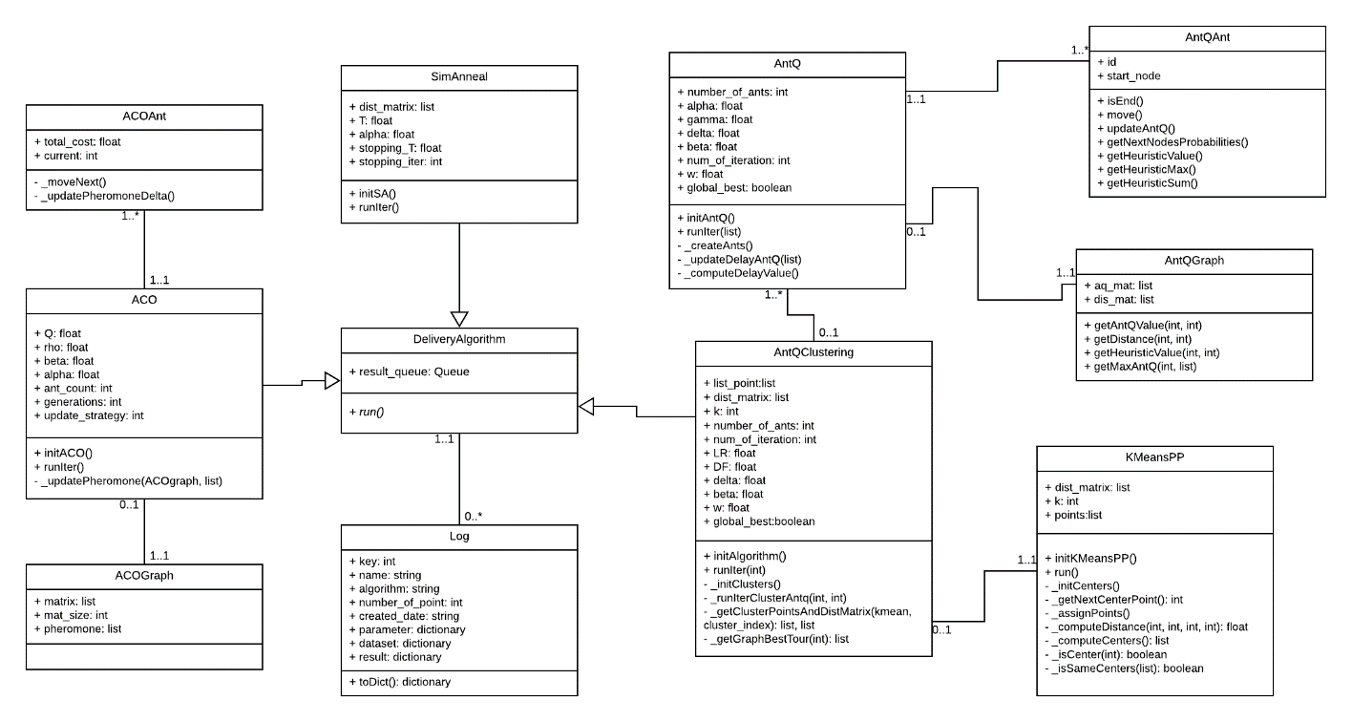

|  |  |
| --- | --- |
| Class dictionary: describe Class | |
| **Class Name** | **Description** |
| ACOAnt | Contain the Ant Colony Optimization Algorithm’s Ant informations and methods. |
| ACO | Contain parameter and implementation of Ant Colony Optimization Algorithm |
| ACOGraph | Contain informations and methods of Ant Colony Optimization Algorithm’s Graph |
| SimAnneal | Contain parameter and implementation of Simulated Annealing Algorithm |
| Ant | Contain the AntQ Algorithm’s Ant informations and methods. |
| AntQ | Contain parameter and implementation of AntQ Algorithm |
| AntQGraph | Contain informations and methods of AntQ Algorithm’s Graph |
| KmeansPP | Contain parameter and implementation of KMean Algorithm |
| AntQClustering | Contain parameter and implement the combination of AntQ and Kmean |
| Log | Contain the information of log |
| DeliveryAlgorithm | An parent class contains the methods and variables which every algorithm have to implement |

Table : Class dictionary

### Class Diagram Explanation

#### ACOAnt

*Attribute*

|  |  |  |  |
| --- | --- | --- | --- |
| **Attribute** | **Type** | **Visibility** | **Description** |
| total_cost | Float | Public | Total cost of ant |
| current | Int | Public | Current location of ant |

*Method*

|  |  |  |  |
| --- | --- | --- | --- |
| **Method** | **Return value** | **Visibility** | **Description** |
| _moveNext | Void | Private | Move to next location |
| _updatePheromoneDelta | Void | Private | Update Pheromone Delta |

#### ACO

*Attribute*

|  |  |  |  |
| --- | --- | --- | --- |
| **Attribute** | **Type** | **Visibility** | **Description** |
| Q | Float | Public | Pheromone intensity |
| rho | Float | Public | Pheromone residual coefficient |
| beta | Float | Public | Relative importance of heuristic information |
| alpha | Float | Public | Relative importance of pheromone |
| ant_count | Int | Public | Number of ant |
| generations | Int | Public | Number of iteration |
| update_strategy | Int | Public | Pheromone update strategy |

*Method*

|  |  |  |  |
| --- | --- | --- | --- |
| **Method** | **Return value** | **Visibility** | **Description** |
| _updatePheromone | Void | Private | Update Pheromone |
| initACO | Void | Public | Initialize the Ant Colony Optimization algorithm |
| runIter | Void | Public | Perform an iteration of the algorithm |
| run | Void | Public | Perform the algorithm |

#### ACOGraph

*Attribute*

|  |  |  |  |
| --- | --- | --- | --- |
| **Attribute** | **Type** | **Visibility** | **Description** |
| matrix | List | Public | Distance matrix |
| mat_size | Int | Public | Size of the distance matrix |
| pheromone | List | Public | Pheromone matrix |

#### SimAnneal

*Attribute*

|  |  |  |  |
| --- | --- | --- | --- |
| **Attribute** | **Type** | **Visibility** | **Description** |
| dist_matrix | List | Public | Distance matrix |
| t | Float | Public | Initial temperature |
| alpha | Float | Public | Exploit probability |
| stopping_t | Float | Public | Minimum temperature |
| stopping_iter | Int | Public | Maximum iteration |

*Method*

|  |  |  |  |
| --- | --- | --- | --- |
| **Method** | **Return value** | **Visibility** | **Description** |
| initSA | Void | Public | Initialize Simulated Annealing algorithm |
| runIter | Void | Public | Perform an iteration |
| run | Void | Public | Perform Simulated Annealing algorithm |

#### AntQAnt

*Attribute*

|  |  |  |  |
| --- | --- | --- | --- |
| **Attribute** | **Type** | **Visibility** | **Description** |
| id | Int | Public | ID of an ant |
| start_node | Int | Public | Start location of an ant |

*Method*

|  |  |  |  |
| --- | --- | --- | --- |
| **Method** | **Return value** | **Visibility** | **Description** |
| isEnd | Void | Public | Is ant move to end location |
| move | Void | Public | Make a move |
| updateAntQ | Void | Public | Update AntQ of algorithm |
| getNextNodesProbabilities | Void | Public | Get probabilities of next nodes |
| getHeuristicValue | Void | Public | Get heuristic value of ant |
| getHeuristicMax | Void | Public | Get maximum heuristic value |
| getHeuristicSum | Void | Public | Get total heuristic value |

#### AntQGraph

*Attribute*

|  |  |  |  |
| --- | --- | --- | --- |
| **Attribute** | **Type** | **Visibility** | **Description** |
| aq_mat | List | Public | AntQ value matrix |
| dis_mat | List | Public | Distance matrix |

*Method*

|  |  |  |  |
| --- | --- | --- | --- |
| **Method** | **Return value** | **Visibility** | **Description** |
| getAntQValue | Float | Public | Get antQ value |
| getDistance | Float | Public | Get distance between 2 location |
| getHeuristicValue | Float | Public | Get heuristic value |
| getMaxAntQ | Int, Float | Public | Get maximum antq value |

#### AntQ

*Attribute*

|  |  |  |  |
| --- | --- | --- | --- |
| **Attribute** | **Type** | **Visibility** | **Description** |
| number_of_ant | Int | Public | Number of ant |
| alpha | Float | Public | Learning rate |
| gamma | Float | Public | Discount factor |
| delta | Float | Public | Relative importance of learned value |
| beta | Float | Public | Relative importance of heuristic information |
| num_of_iteration | Int | Public | Number of iteration |
| w | Float | Public | N/A |
| global_best | Boolean | Public | Delayed reinforcement value update strategy. |

*Method*

|  |  |  |  |
| --- | --- | --- | --- |
| **Method** | **Return value** | **Visibility** | **Description** |
| _createAnts | Void | Private | Create list of ants |
| _updateDelayAntQ | Void | Private | Compute antq value by using delayed reinforcement value |
| _computeDelayValue | Float | Private | Compute delayed reinforcement value after each iteration |
| initAntQ | Void | Public | Initialize AntQ algorithm |
| runIter | Float, Float, List | Public | Perform an iteration |
| run | Void | Public | Perform AntQ algorithm |

#### KmeansPP

*Attribute*

|  |  |  |  |
| --- | --- | --- | --- |
| **Attribute** | **Type** | **Visibility** | **Description** |
| dist_matrix | List | Public | Distance matrix |
| k | Int | Public | Number of cluster |
| points | List | Public | List of points |

*Method*

|  |  |  |  |
| --- | --- | --- | --- |
| **Method** | **Return value** | **Visibility** | **Description** |
| _isCenter | Boolean | Private | Check if a point is center |
| _isSameCenters | Boolean | Private | Check if the new centers is same as previous centers. |
| _initCenters | Void | Private | Init all centers |
| _getNextCenterPoint | Int | Private | Generate next center in initialization |
| _assignPoints | Void | Private | Assign points to clusters |
| _computeDistance | Float | Private | Compute distance of 2 points |
| _computeCenters | List | Private | Generate new centers |
| initKMeansPP | Void | Public | Initialize K-Means++ algorithm |
| run | Void | Public | Perform K-Means++ algorithm |

#### AntQClustering

*Attribute*

|  |  |  |  |
| --- | --- | --- | --- |
| **Attribute** | **Type** | **Visibility** | **Description** |
| list_point | List | Public | List of point |
| dist_matrix | List | Public | Distance matrix |
| k | Int | Public | Number of cluster |
| number_of_ant | Int | Public | Number of ant |
| LR | Float | Public | Learning rate |
| DF | Float | Public | Discount factor |
| delta | Float | Public | Relative importance of learned value |
| beta | Float | Public | Relative importance of heuristic information |
| num_of_iteration | Int | Public | Number of iteration |
| W | Float | Public | N/A |
| global_best | Boolean |  |  |

*Method*

|  |  |  |  |
| --- | --- | --- | --- |
| **Method** | **Return value** | **Visibility** | **Description** |
| _ getClusterPointsAndDistMatrix | List, list | Private | Get list of points and distance matrix of a cluster |
| _initClusters | Void | Private | Perform clustering algorithm to divide list of points into several groups |
| _runIterClusterAntq | Float | Private | Perform an iteration of antq algorithm of a cluster |
| initAlgorithm | Void | Public | Initialize algorithm |
| runIter | Float, Float, List | Public | Perform an iteration of antq algorithm of all cluster |
| run | Void | Public | Perform algorithm |

#### DeliveryAlgorithm

*Attribute*

|  |  |  |  |
| --- | --- | --- | --- |
| **Attribute** | **Type** | **Visibility** | **Description** |
| result_Queue | Queue | Public | Contains the result of an iteration |

*Method*

|  |  |  |  |
| --- | --- | --- | --- |
| **Method** | **Return value** | **Visibility** | **Description** |
| run | Void | Public | Perform algorithm |

#### Log

*Attribute*

|  |  |  |  |
| --- | --- | --- | --- |
| **Attribute** | **Type** | **Visibility** | **Description** |
| key | Int | Public | Key of log |
| name | String | Public | Name of log |
| algorithm | String | Public | Name algorithm of log |
| number_of_point | Int | Public | Number point of log |
| created_date | String | Public | Created date of log |
| parameter | Dictionary | Public | Parameter of log’s algorithm |
| dataset | Dictionary | Public | Dataset of log |
| result | Dictionary | Public | Result of log |

*Method*

|  |  |  |  |
| --- | --- | --- | --- |
| **Method** | **Return value** | **Visibility** | **Description** |
| toDict | Dictionary | Public | Convert log to dictionary |

### Interaction Diagram

#### Run the Combination of AntQ and K-Means++ Algorithm

*Summary: This diagram is show process of user performs AntQ and K-mean algorithm.*

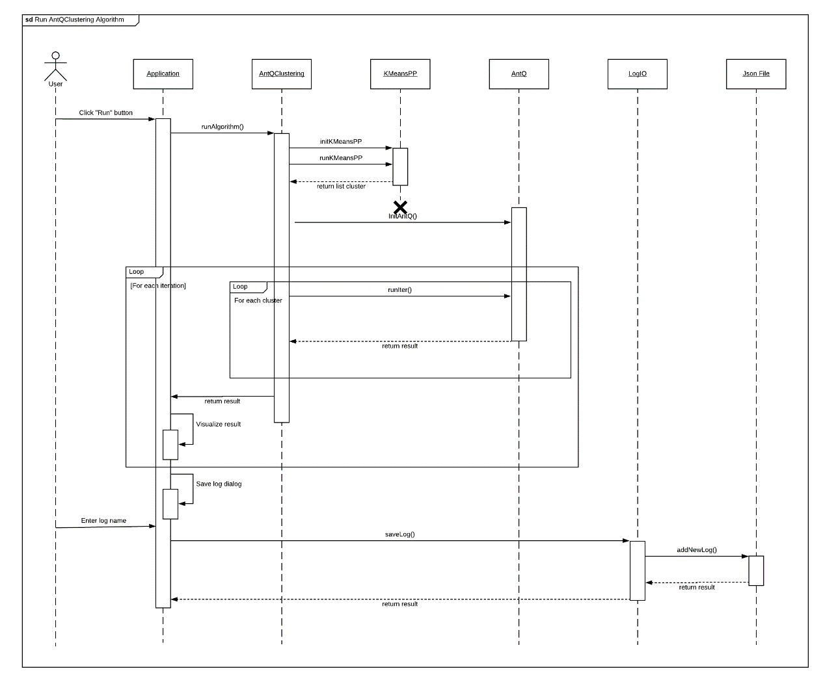

Figure : Run the Combination of AntQ and K-Means++ algorithm Sequence Diagram

#### Run ACO Algorithm

*Summary: This diagram is show process of user performs Ant Colony Optimization algorithm.*

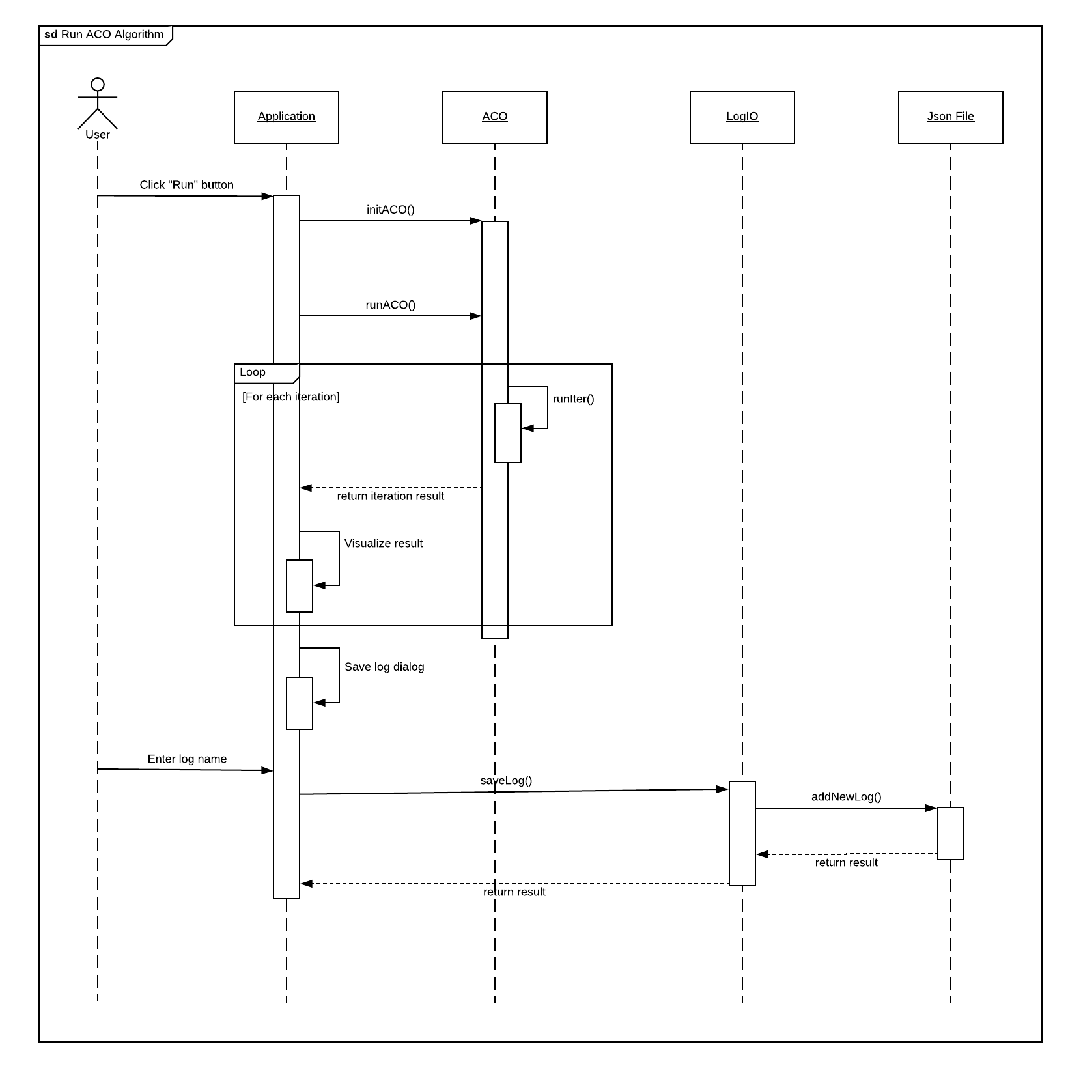

Figure : Run ACO algorithm Sequence Diagram

#### Run SA Algorithm

*Summary: This diagram is show process of user performs Simulated Annealing algorithm.*

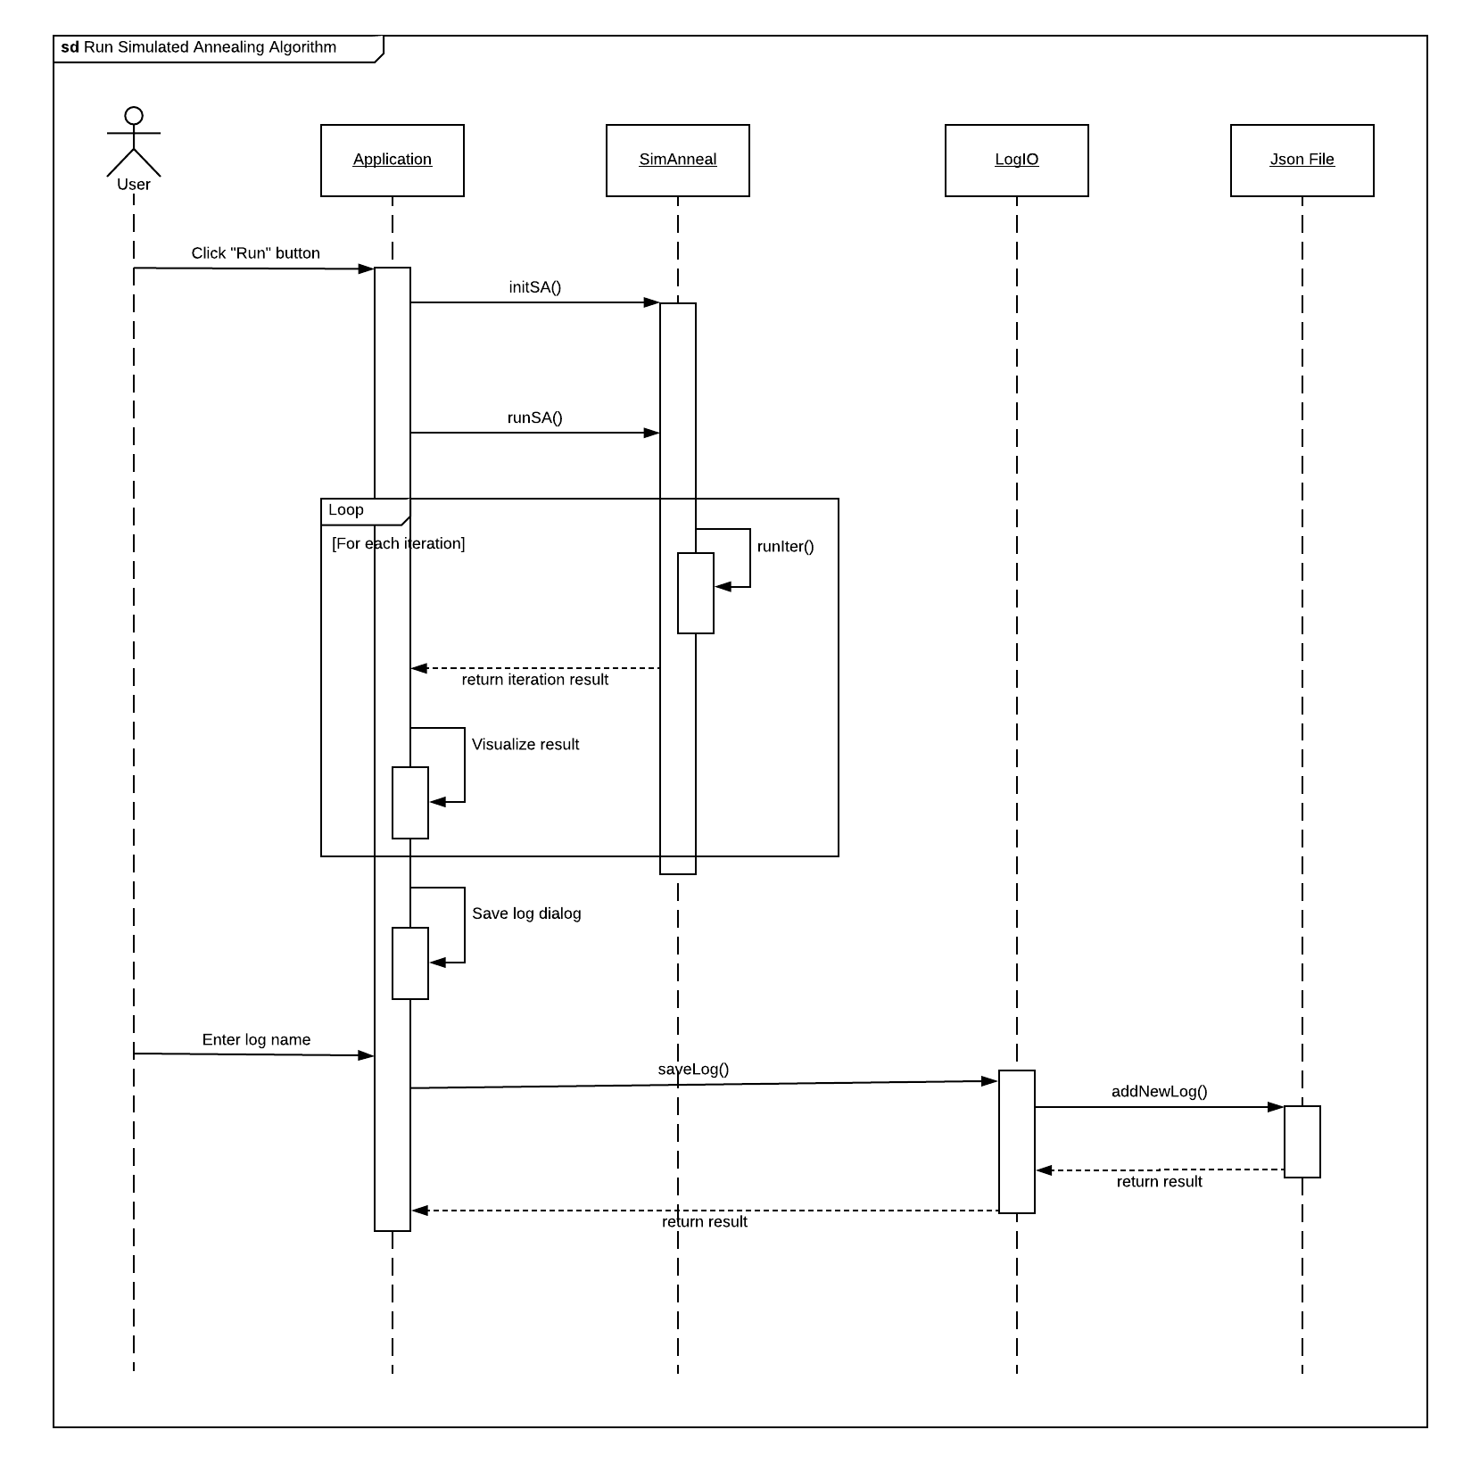

Figure : Run SA algorithm Sequence Diagram

#### Get List Log

*Summary: This diagram is show process of user gets list log.*

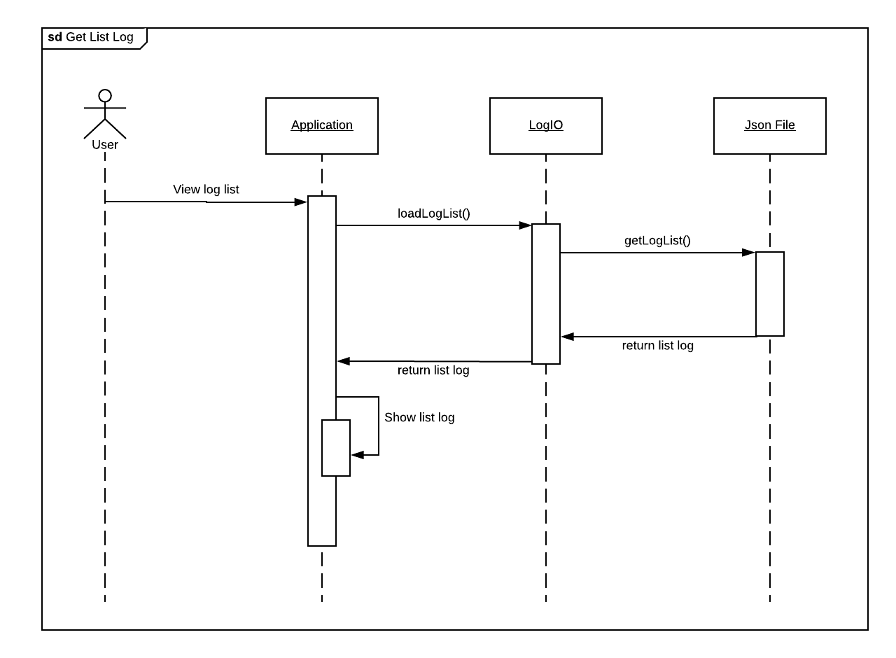

Figure : Get list log Sequence Diagram

#### Compare logs

*Summary: This diagram is show process of user compares logs.*

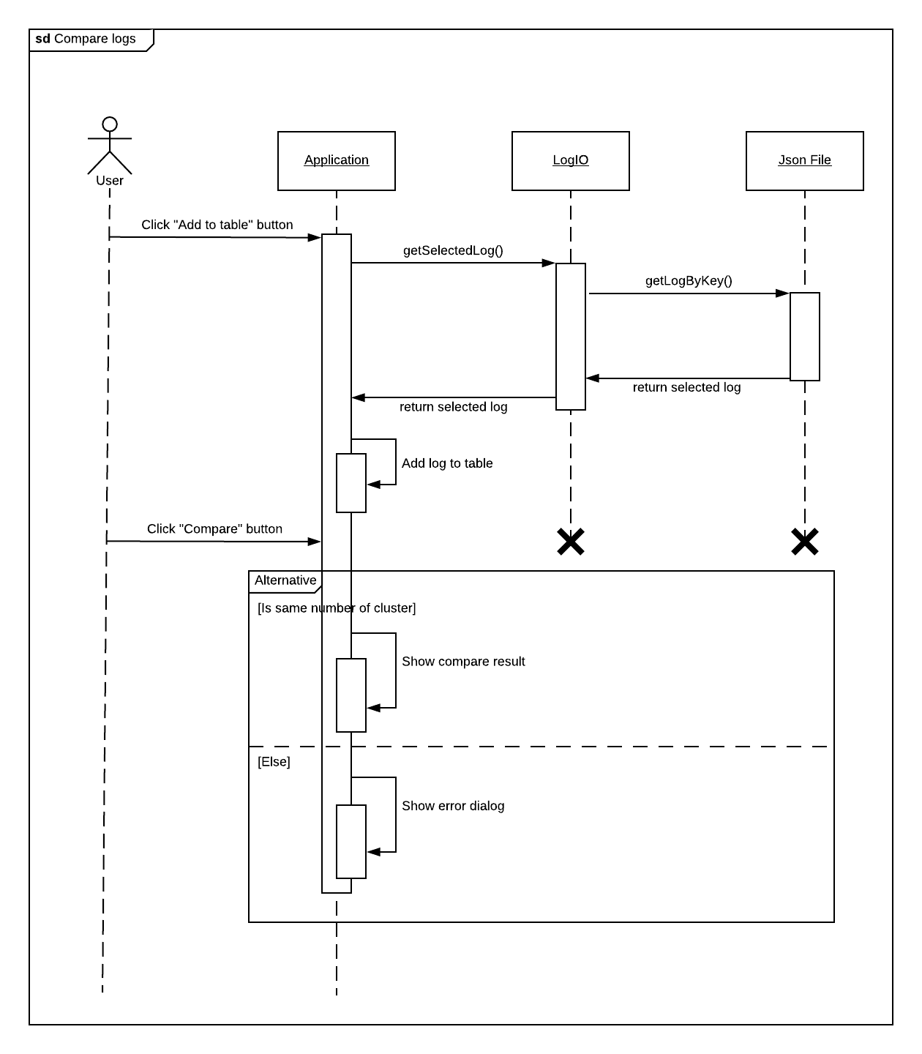

Figure : Compare logs Sequence Diagram

## User Interface Design

### Main User Interface

#### Graph UI

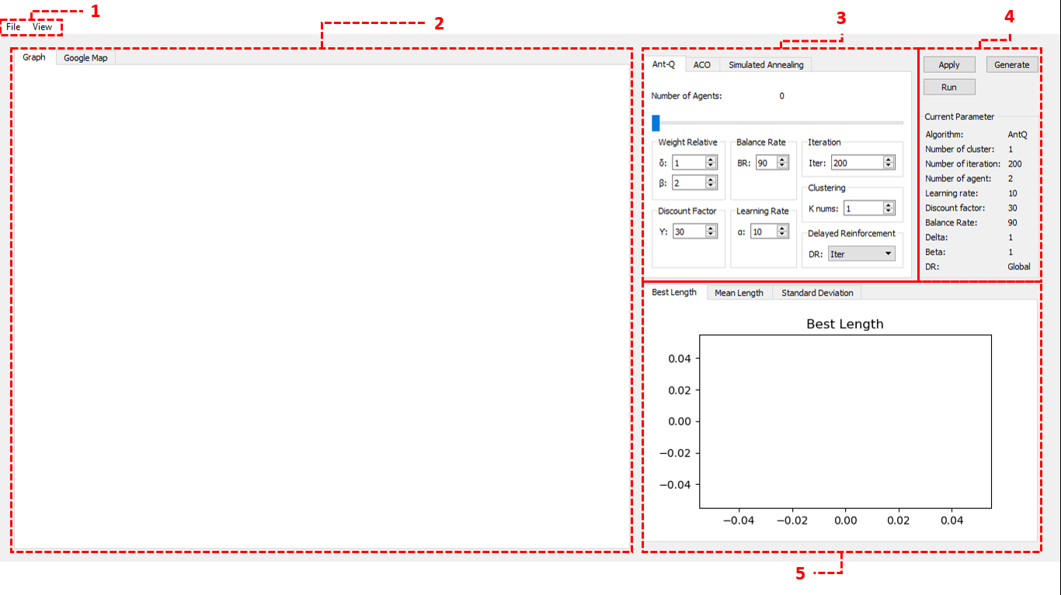

Figure : The Algorithm View (Main View)

**Layouts**

|  |  |  |
| --- | --- | --- |
| **No** | **Layout Name** | **Description** |
| 1 | Task bar | Show points graph and google maps |
| 2 | Canvas Layout | Show the process of algorithms. |
| 3 | Algorithm Layout | Adjust the parameters |
| 4 | Function Layout | Work with the demo application |
| 5 | Line Chart Layout | Show result each iterations. |

##### Ant-Q UI

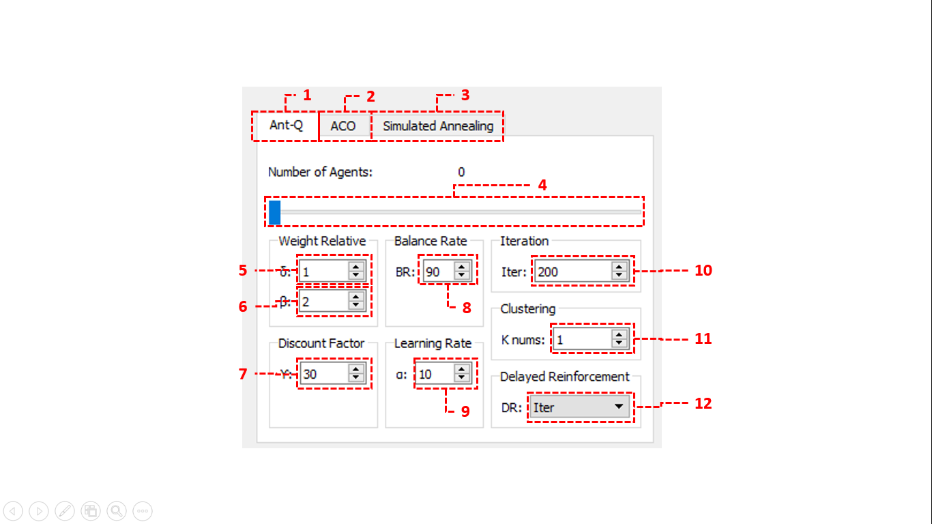

Figure : The container contains Ant-Q algorithm parameters

**Task/Tab Bar**

|  |  |  |  |
| --- | --- | --- | --- |
| **No** | **Function** | **Description** | **Outcome** |
| 1 | Ant-Q Tab Bar | Show result each iterations. | Display adjustment Ant-Q parameters layout. |
| 2 | ACOTab Bar | Show the parameters of selected log. | Display adjustment ACO parameters layout |
| 3 | Simulated Annealing Tab Bar | Manage logs. | Display adjustment Simulated Annealing parameters layout |

**Slider**

|  |  |  |
| --- | --- | --- |
| **No** | **Name** | **Description** |
| 4 | Number of Agents | Select number of agents. |

**Text Field**

|  |  |  |  |  |
| --- | --- | --- | --- | --- |
| **No** | **Field Name** | **Type** | **Description** | **Validation** |
| 5 | Delta | Integer | Weight relative importance of Ant-Q value | length: 0-1000 |
| 6 | Beta | Integer | Weight relative importance of heuristic value | length: 0-1000 |
| 7 | Gamma | Integer | Discount Factor | length: 0-100 |
| 8 | Alpha | Integer | Learning Rate | length: 0-100 |
| 9 | Balance Rate | Integer | Balance Rate | length: 0-100 |
| 10 | Iteration | Integer | Number of iteration | length: 0-2000 |
| 11 | K-num | Integer | Number of clusters | length: 0-100 |

**Combo box**

|  |  |  |
| --- | --- | --- |
| **No** | **Name** | **Description** |
| 12 | Delayed reinforcement | Select types of delayed reinforcement. |

##### ACO UI

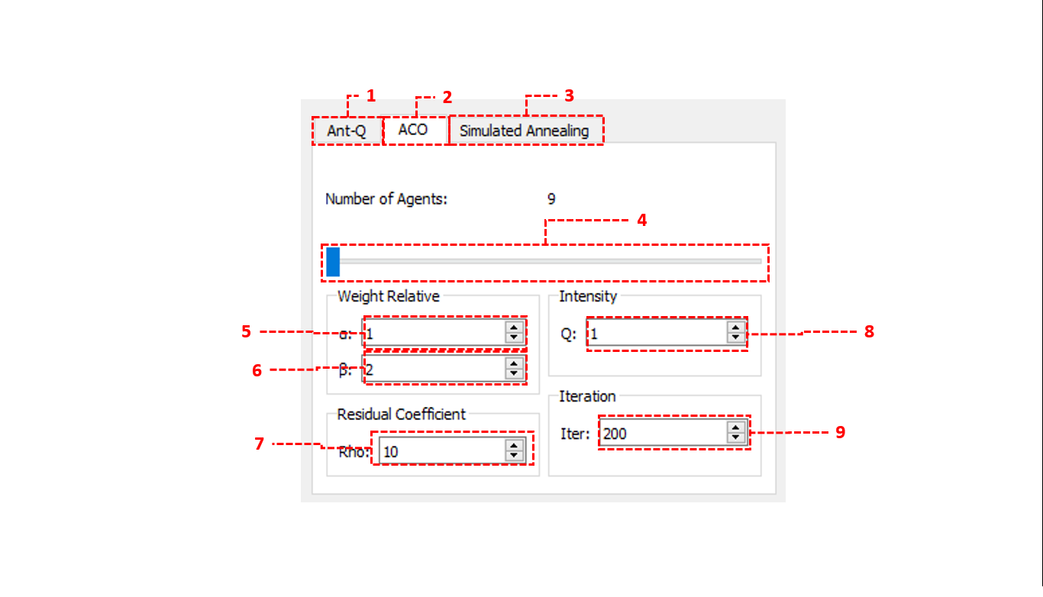

Figure : The container contains ACO algorithm parameters

**Task/Tab Bar**

|  |  |  |  |
| --- | --- | --- | --- |
| **No** | **Function** | **Description** | **Outcome** |
| 1 | Ant-Q Tab Bar | Show result each iterations. | Display adjustment Ant-Q parameters layout. |
| 2 | ACOTab Bar | Show the parameters of selected log. | Display adjustment ACO parameters layout |
| 3 | Simulated Annealing Tab Bar | Manage logs. | Display adjustment Simulated Annealing parameters layout |

**Slider**

|  |  |  |
| --- | --- | --- |
| **No** | **Name** | **Description** |
| 4 | Number of Agents | Select number of agents. |

**Text Field**

|  |  |  |  |  |
| --- | --- | --- | --- | --- |
| **No** | **Field Name** | **Type** | **Description** | **Validation** |
| 5 | Alpha | Integer | Weight relative importance of pheromone | length: 0-1000 |
| 6 | Beta | Integer | Weight relative importance of heuristic information | length: 0-1000 |
| 7 | Rho | Integer | Pheromone residual coefficient | length: 0-100 |
| 8 | Q | Integer | Pheromone intensity | length: 0-100 |
| 9 | Iteration | Integer | Number of iteration | length: 0-2000 |

##### Simulated Annealing UI

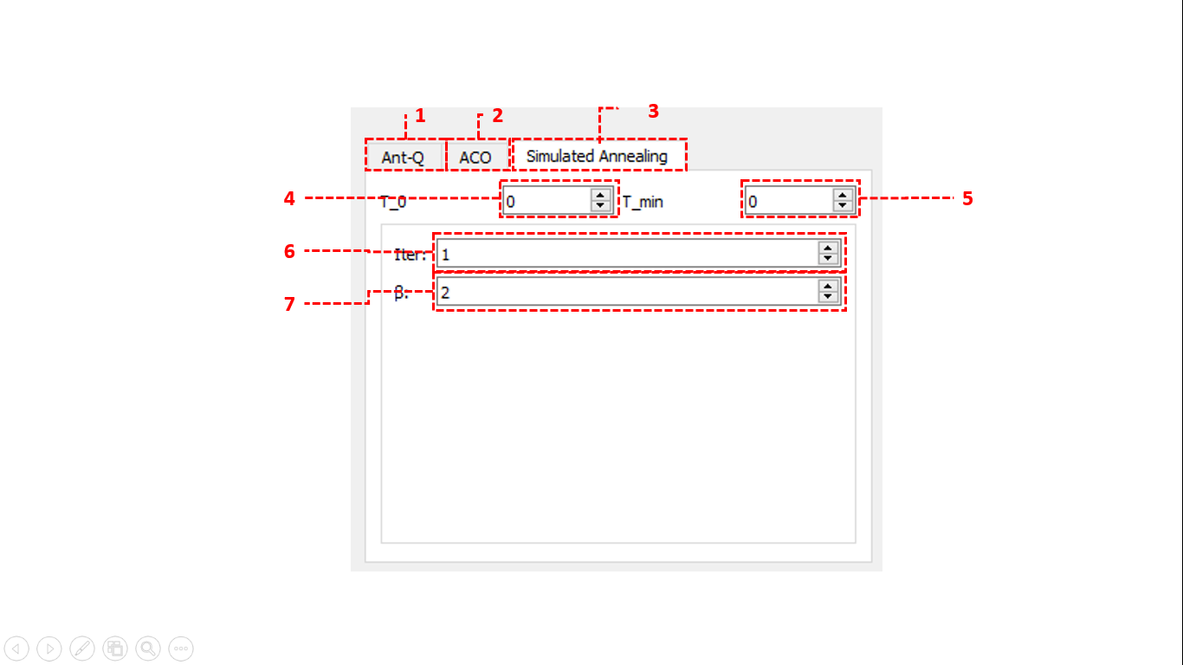

Figure : The container contains Simulated Annealing algorithm parameters

**Task/Tab Bar**

|  |  |  |  |
| --- | --- | --- | --- |
| **No** | **Function** | **Description** | **Outcome** |
| 1 | Ant-Q Tab Bar | Show result each iterations. | Display adjustment Ant-Q parameters layout. |
| 2 | ACOTab Bar | Show the parameters of selected log. | Display adjustment ACO parameters layout |
| 3 | Simulated Annealing Tab Bar | Manage logs. | Display adjustment Simulated Annealing parameters layout |

**Text Field**

|  |  |  |  |  |
| --- | --- | --- | --- | --- |
| **No** | **Field Name** | **Type** | **Description** | **Validation** |
| 4 | T_0 | Integer | Initial temperature | length: 0-100 |
| 5 | T_min | Integer | Minimum temperature | length: 0-100 |
| 6 | Iteration | Integer | Number of iteration | length: 0-2000 |
| 7 | Beta | Integer | Cooling constant | length: 0-1000 |

##### Chart Line Layout

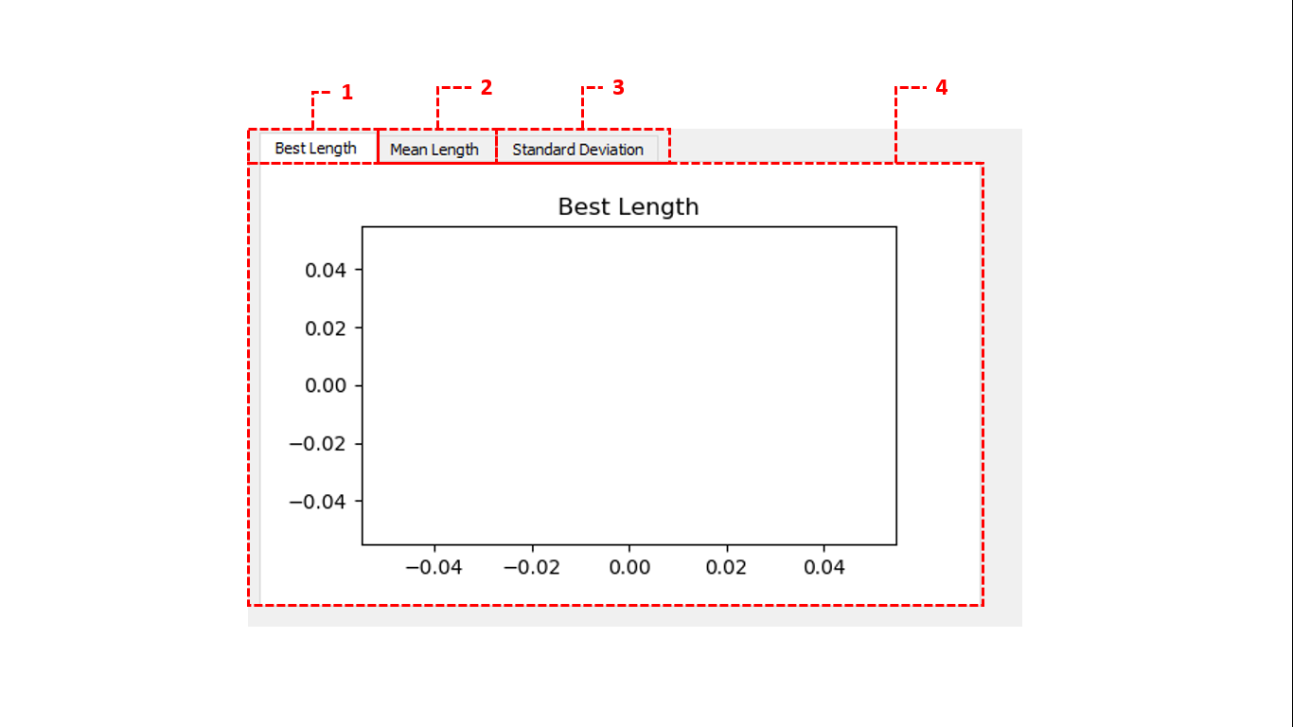

Figure : Chart Container

**Task/Tab Bar**

|  |  |  |  |
| --- | --- | --- | --- |
| **No** | **Function** | **Description** | **Outcome** |
| 1 | Best length tab bar | Show best length of each iteration. | Display best length chart. |
| 2 | Mean length tab bar | Show mean length of each iteration. | Display mean length chart. |
| 3 | Variance length tab bar | Show variance of each iteration. | Display variance chart. |

**Data View**

|  |  |  |
| --- | --- | --- |
| **No** | **Data View Name** | **Description** |
| 4 | Chart Container | Show Line chart. |

##### Function Layout

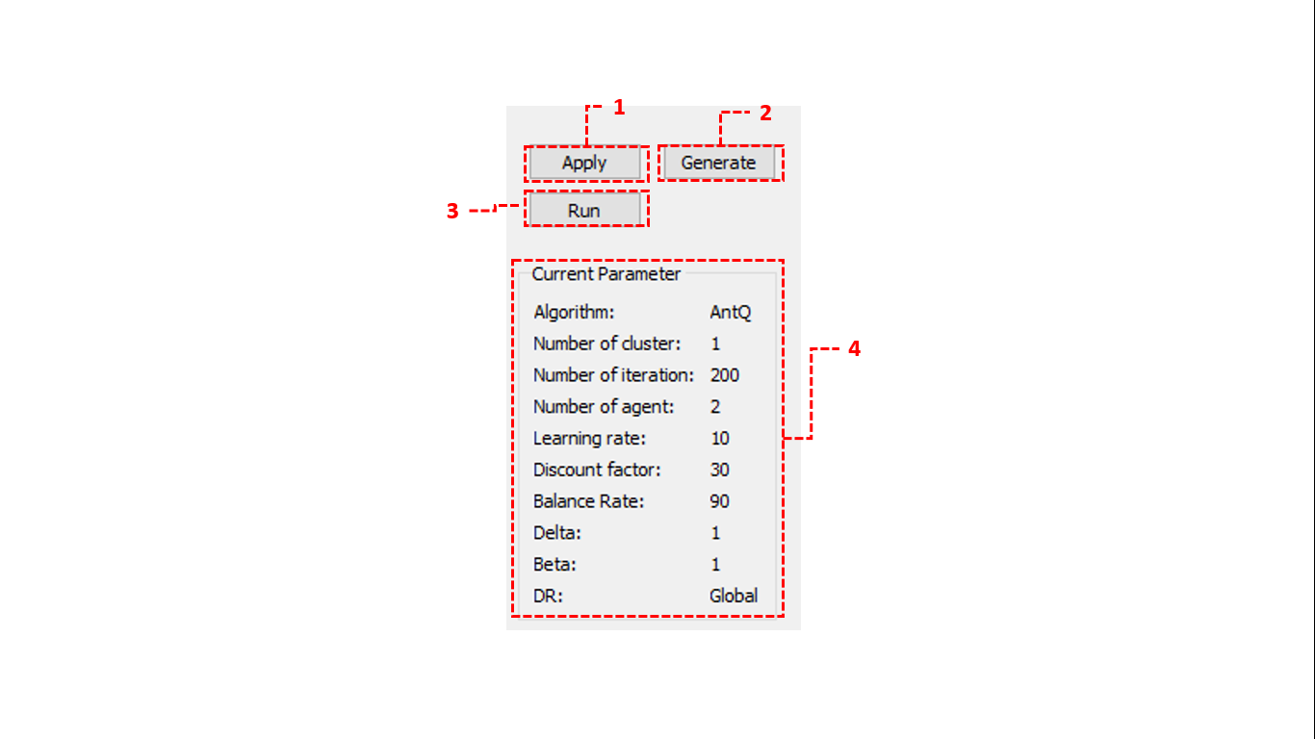

Figure : Function Container

**Buttons**

|  |  |  |  |
| --- | --- | --- | --- |
| **No** | **Button Name** | **Function** | **Description** |
| 1 | Apply | Apply algorithm parameters | Apply current parameters, algorithm and show them on parameters layout. |
| 2 | Generate | Generate log data to set environment for the application. | Generate all locations and show them on graph canvas. |
| 3 | Run | Run the applied algorithm. | Apply the algorithm and show the selection route process on the graph. |

**Data View**

|  |  |  |
| --- | --- | --- |
| **No** | **Data View Name** | **Description** |
| 4 | Parameter Container | Show current parameters. |

#### Google Maps UI

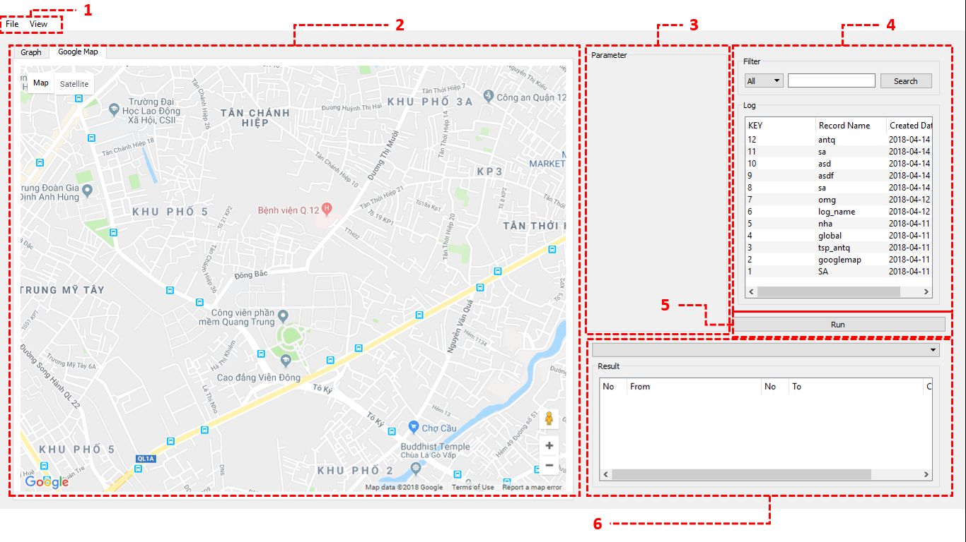

Figure :The Google maps View

**Layouts**

|  |  |  |
| --- | --- | --- |
| **No** | **Layout Name** | **Description** |
| 1 | Task bar | Show points graph and google maps |
| 2 | Canvas Layout | Show the process of algorithms. |
| 3 | Parameter Layout | Show the parameters of selected log. |
| 4 | Log Layout | Manage logs. |
| 6 | Route List Layout | Show route result. |

**Buttons**

|  |  |  |  |
| --- | --- | --- | --- |
| **No** | **Button Name** | **Function** | **Description** |
| 5 | Run | Run the log data. | Apply all properties of the selected log data then show the selection route process on the google maps. |

##### Log Manager

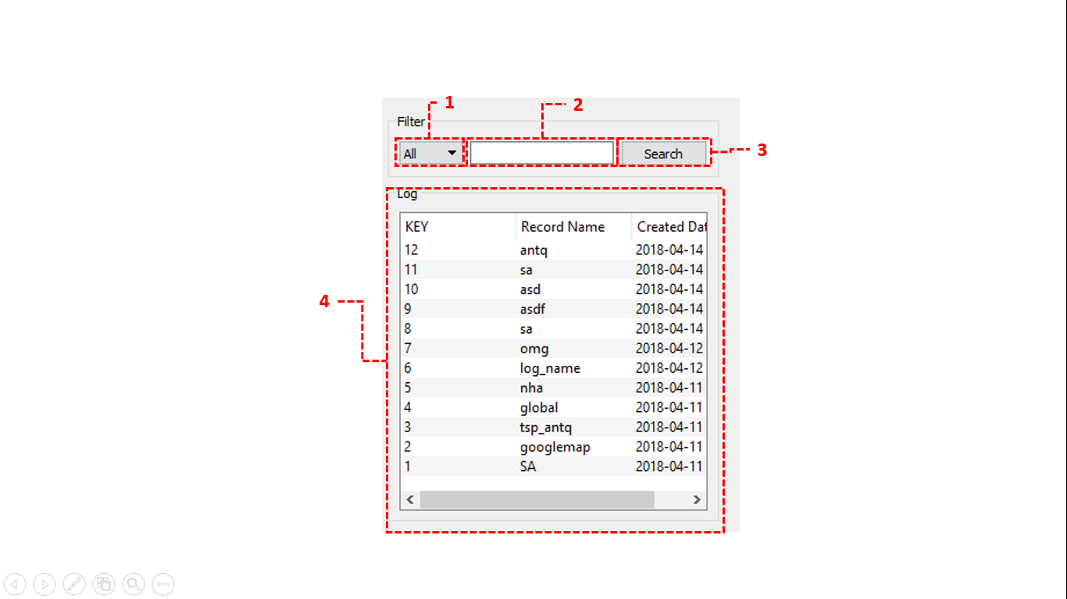

Figure : The Log Management Container

**Combo box**

|  |  |  |
| --- | --- | --- |
| **No** | **Name** | **Description** |
| 1 | Algorithm | Select algorithms. |

**Text Field**

|  |  |  |  |  |
| --- | --- | --- | --- | --- |
| **No** | **Field Name** | **Type** | **Description** | **Validation** |
| 2 | Search Field | String | Search input | length: 0-1000 |

**Buttons**

|  |  |  |  |
| --- | --- | --- | --- |
| **No** | **Button Name** | **Function** | **Description** |
| 3 | Search | Search log file, filtered by name and algorithm. | Filter out the results in accordance with the filter. |

**Data View**

|  |  |  |
| --- | --- | --- |
| **No** | **Data View Name** | **Description** |
| 4 | Function Layout | Show log list. |

##### Route Result

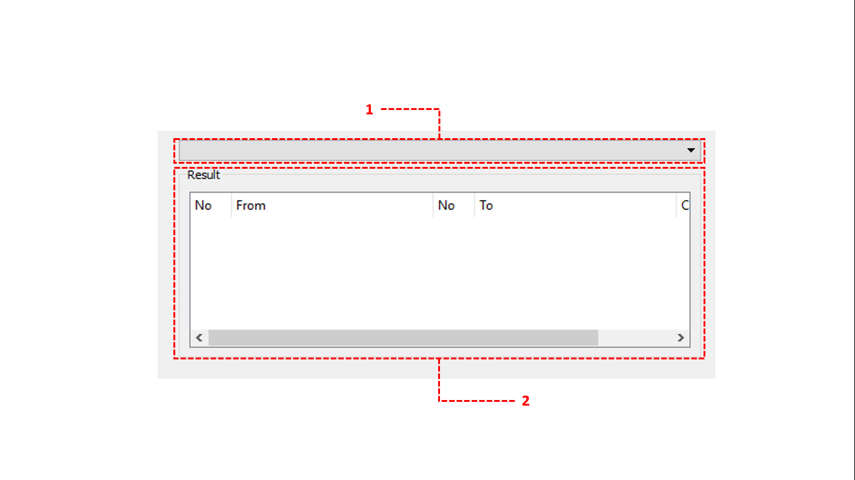

Figure : The route result container

**Combo box**

|  |  |  |
| --- | --- | --- |
| **No** | **Name** | **Description** |
| 1 | List cluster | Select cluster which is displayed on googlemap. |

**Data View**

|  |  |  |
| --- | --- | --- |
| **No** | **Data View Name** | **Description** |
| 2 | List Route Layout | Show route result list. |

#### Task bar

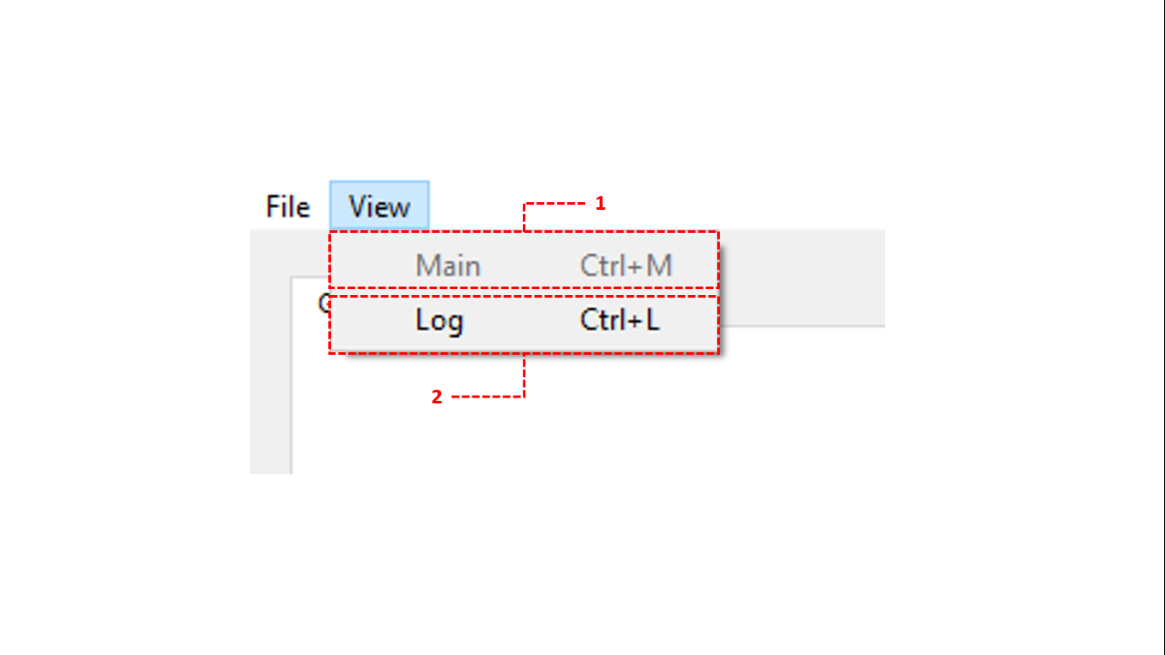

Figure : Header View Bar

**Task/Tab Bar**

|  |  |  |  |
| --- | --- | --- | --- |
| **No** | **Function** | **Description** | **Outcome** |
| 1 | Main View | Changing to Main view | Display main view which helps user run algorithms. |
| 2 | Log View | Changing to Log view | Display log view which helps user can compare results between logs. |

#### Graph Container

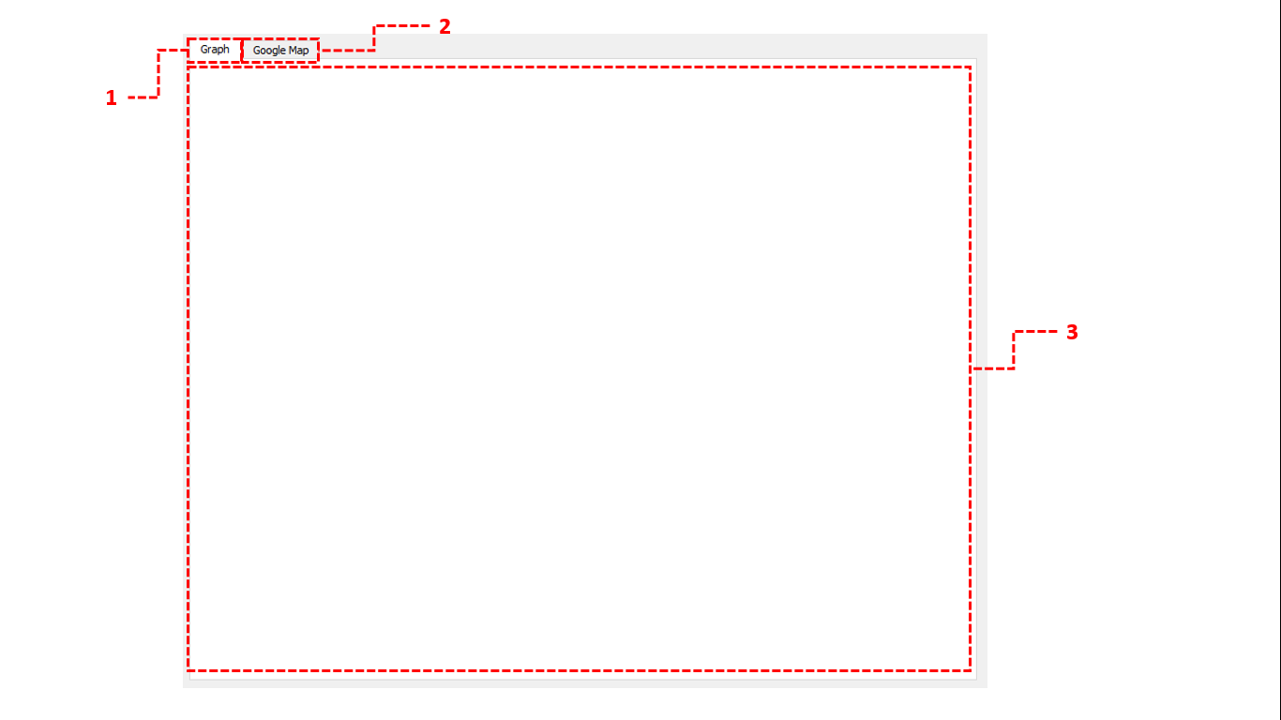

Figure : The Graph Container

**Task/Tab Bar**

|  |  |  |  |
| --- | --- | --- | --- |
| **No** | **Function** | **Description** | **Outcome** |
| 1 | Graph Tab Bar | Changing to Graph view | Display Graph Chart on Canvas and changing UI for Graph |
| 2 | Google Tab Bar | Changing to Google view | Display Google Maps on Canvas and changing UI for Google Maps |

**Data View**

|  |  |  |
| --- | --- | --- |
| **No** | **Data View Name** | **Description** |
| 3 | Graph Container | Show graph. |

### Log User Interface

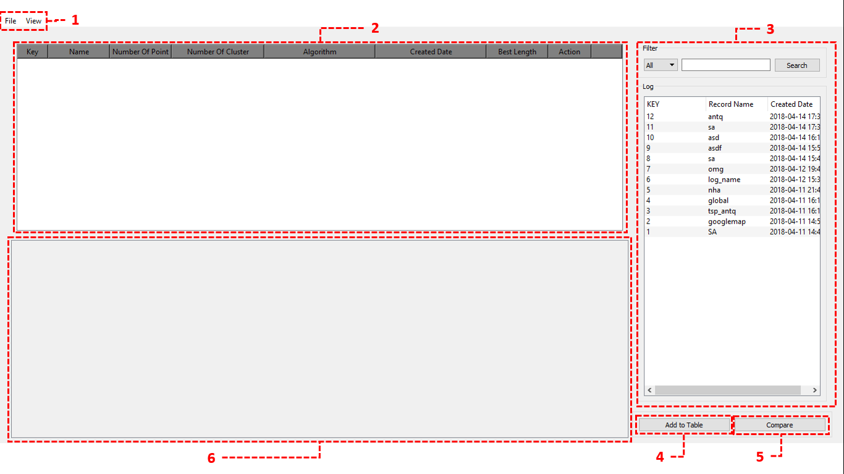

Figure : The Log Management View

**Layouts**

|  |  |  |
| --- | --- | --- |
| **No** | **Layout Name** | **Description** |
| 1 | Task bar | Show points graph and google maps |
| 3 | Log Layout | Manage logs. |
| 6 | Compare logs layout | Show result of comparison |

**Buttons**

|  |  |  |  |
| --- | --- | --- | --- |
| **No** | **Button Name** | **Function** | **Description** |
| 4 | Add to table | Add selected logs from List Log View to Table. | Add selected logs from List Log View to Table. |
| 5 | Compare | Compare the results of each selected logs. | Compare the results of each selected logs. |

**Data View**

|  |  |  |
| --- | --- | --- |
| **No** | **Data View Name** | **Description** |
| 2 | Log Table | Show selected logs |

## Algorithms

### Delivery algorithm

#### Definition

The delivery problem asks the following question: "Given a list of locations and the distances between each pair of locations, what is the shortest possible route that visits each location and returns to the origin location?" It is an NP-hard problem in combinatorial optimization, important in operations research and theoretical computer science.

#### Define Problem

We have a list of locations what can perform on google map. Each location has two attributes that are latitude and longitude. Google also provides some services to solve this problem but we can’t change any parameters between two locations on it and Google only gives us a fixed result with the same list locations. We need more than what Google can do that finding out the best route that visits each location in unstable environment. The exterior conditions can change time, distance which is parameter we travel between each pair of locations such as the weather, traffic situation, etc.

#### Solution

To solve this problem, we use Ant-Q algorithm. By applying Ant-Q, we can create multi agents to find the best route. Given a set of n locations, and for each pair of locations a distance drs (distance from R to S), the TSP is stated as the problem of finding a minimal length closed tour that **visits each location once**. An instance of the TSP is given by a graph (N,E), where:

* + - N,|N| =n, is the set of locations
    - E is the set of edges between locations (a fully connected graph in the Euclidean TSP).

In case **drs≠dsr** we have the more general asymmetric traveling salesman problem (ATSP). Ant-Q algorithms apply indifferently to both problems.

Before going into the formula, we briefly go through the parameters

* **AQ(r,s):** is a positive real value associated to arc (r,s) and is the AntQ algorithm counterpart of Q-learning Q-values. AQ(r,s)'s are changed at run time and are intended to indicate how useful it is to make move s (i.e., to go to location s) when in state r
* **HE(r,s):** is a heuristic function which evaluates the goodness of move s when in location r. For example, in the ATSP HE(r,s) is the inverse of the distance between locations r and s.
* **δ and β:** weigh the relative importance of the learned AQ-values and the heuristic values
* **q:** is a value chosen randomly with uniform probability in [0, 1], and q0 (0≤q0≤1) is a parameter: the smaller q0 the higher the probability to make a random choice
* **S:** is a random variable selected according to the distribution which gives the probability with which an ant in location r chooses the location s to move to.

An agent k situated in location r moves to location s using the following rule, called action choice rule (or state transition rule):

* Pseudo-Random

$s=\left\{\begin{aligned}arg\max_{uϵJ_{k}(r)} \{{[AQ(r,u)]}^{δ}∙{[HE(r,u)]}^{β}\} if q≤q_{0} \\ S otherwise \end{aligned}\right.$*(1)*

* Random-Proportional

$p_{k}(r,s)=\left\{\begin{aligned}\frac{{[AQ(r,s)]}^{δ}∙{[HE(r,s)]}^{β}}{\sum_{uϵJ_{k}(r)}{}{[AQ(r,u)]}^{δ}∙{[HE(r,u)]}^{β}} if sϵJ_{k}(r) \\ 0 otherwise\end{aligned}\right.$*(2)*

* Pseudo-Random-Proportional is a compromise between the pseudo-random state choice rule typically used in Q-learning and the random-proportional action choice rule typically used in Ant System.

We apply the third way Pseudo-Random-Proportional.

The next step is determining AQ-value, AQ-value will be updated by the following rule:

$AQ(r,s)←(1-α)∙AQ(r,s)+α(∆AQ(r,s)+γ∙\max_{zϵJ_{k}} AQ(s,z))$*(3)*

We tested two types of delayed reinforcement, called global-best and iteration-best. The reinforcement ∆AQ is always zero except after each agent has completed its tour. ∆AQ(r,s) is computed by the following formula:

* Global-best

$∆AQ(r,s)=\left\{\begin{aligned}\frac{W}{L_{k_{gb}}} if (r,s)ϵ tour done by agent k_{gb} \\ 0 otherwise \end{aligned}\right.$*(4)*

where W is a parameter which in all experiments was set to W=10 (this value was found to be a good one with AS, and was not optimized for Ant-Q), $k_{gb}$ is the agent who made the globally best tour from the beginning of the trial, and $L_{k_{gb}}$ is its tour length.

* Iteration-best

$∆AQ(r,s)=\left\{\begin{aligned}\frac{W}{L_{k_{ib}}} if (r,s)ϵ tour done by agent k_{ib} \\ 0 otherwise\end{aligned}\right.$*(5)*

where $k_{ib}$ is the agent who made the best tour in the current iteration of the trial, and $L_{k_{ib}}$ is its tour length.

We set a parameter called Iteration limitation. When number of iterations meets the condition, the result will be given by all the steps above.

#### Complexity

Where n is number of locations and m is number of agents. m should belong to the range [0.6·n,  n]. So the complexity of the algorithm is:

$\sum_{1}^{n}{O(m)}=O(n^{2})$*(6)*

#### Flowchart

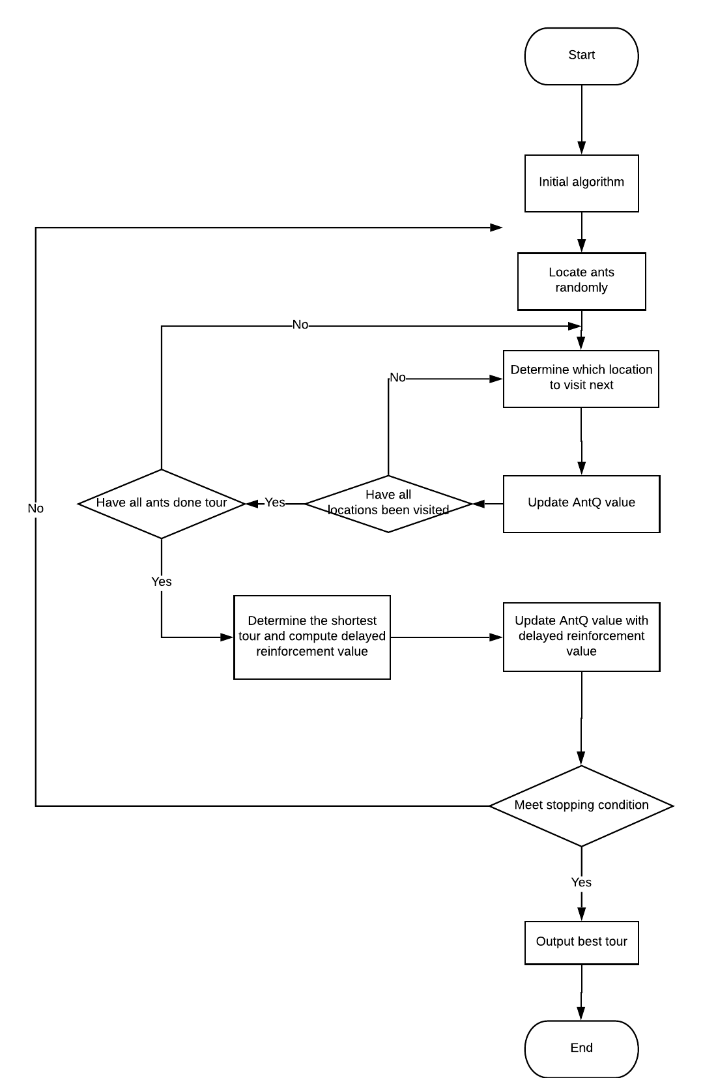

Figure : AntQ flowchart

### K-means++ algorithm

#### Definition

K-mean is the basic and most common clustering algorithm of Unsupervised Learning – a type of Machine Learning . The standard algorithm was first proposed by Stuart Lloyd in 1957. In 1975, it was introduced in detail by Hartigan. With clustering problem, we have N points in M dimensions, k-mean is used to divide this N points into k cluster (group) with k has given.

#### Define problem

As described in the delivery problem, we have a list of locations that we have to deliver to. To improve the performance of delivery, we divide them into several groups. We assume that each location is a point in 2-dimensions space then separating those points into several clustering group.

#### Solution

To solve this problem, we use k-mean algorithm. Given n points in m dimensions and the number of cluster k. We find which cluster each point belongs to. In the standard k-mean algorithm, we will choose initial k centers randomly. According to experiment, if we have the good initial centers, the result will be better. In 2007, David Arthur and Sergei Vassilvitskii proposed a improved k-means algorithm, called **k-means++ algorithm**.

K-means algorithm performs the following steps:

* Step 1a: Choose one center uniformly at random from among the data points.
* Step 1b: For each point x, computing the distance D(x) between point x and the nearest center of it that has already been chosen. Then, choose a new point at random as a new center with probability $\frac{{D(x)}^{2}}{\sum_{x}{}{D(x)}^{2}}$
* Step 1c: Repeat step 1b until k centers have been chosen.
* Step 2: Compute the distance between each point and centers.
* Step 3: Assign each point to the cluster whose center has the minimum distance to that point.
* Step 4: Update center point for each cluster by computing mean of points in this cluster which is determined in assignment step.
* Step 5: Repeat step 2 until there is no changes of points in clusters.

#### Complexity

Complexity of K-Means algorithm O(n*k*d*i), where

* n: number of points.
* k: number of clusters.
* d: number of dimensional
* i: number of iterations.

#### Flowchart

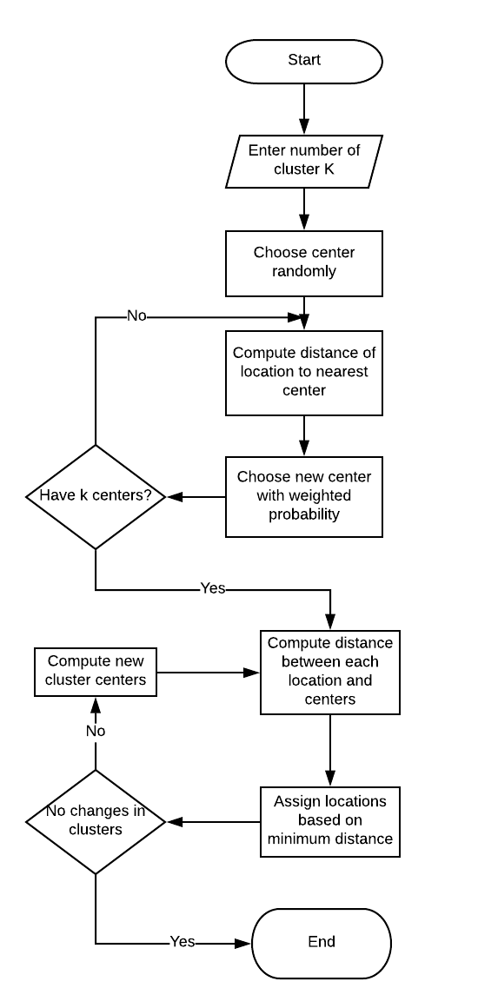

Figure : K-means++ flowchart

### Other heuristic algorithms

#### Ant Colony Optimization algorithm

Ant colony optimization algorithm (ACO) is a probabilistic technique for solving delivery problem. Initially proposed by Marco Dorigo in 1992 in his PhD thesis.

The base of ACO is simulating the real behaviour of ants in nature. Ants deposit pheromone on the way while walking, the others can follow the previous pheromone by probability while passing by. The higher pheromone, the higher probability with which the ants will follow. Because it takes less time for ants to find food and carry them back to the nests through the shortest path, after a long enough period of time, more ants will choose this shortest path and deposit pheromone on it. In this way, all ants eventually choose the shortest path.

Flowchart:

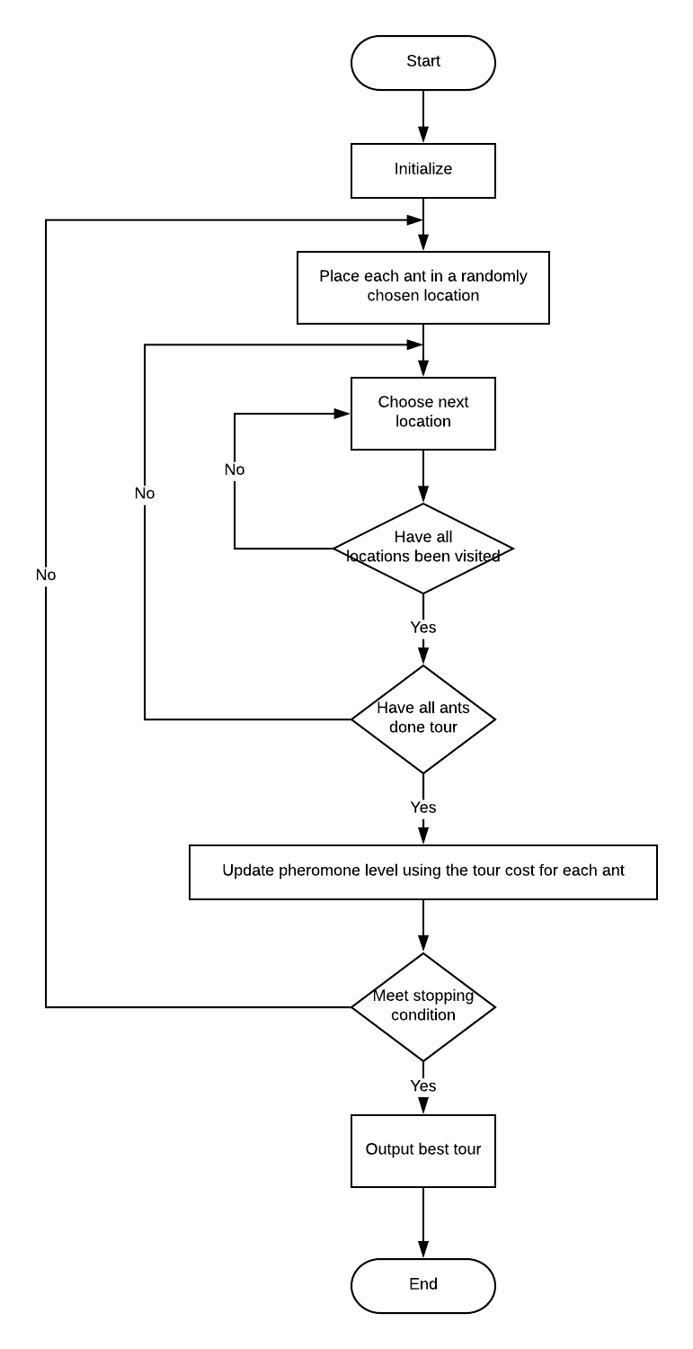

Figure : ACO flowchart

#### Simulated Annealing algorithm

Simulated annealing (SA) algorithm was a method introduced in 1983 by Scott Kirkpatrick, Daniel Gelatt and Mario Vecchi. It is a popular intelligent optimization algorithm which has been successfully applied in many fields, include solving delivery problem.

With simulated annealing, a random tour is chosen and its permutation is slightly modified by switching the order of at least two points to obtain a new tour. If this new tour’s distance is shorter than the original tour, it will become the new tour of the interest. Else if this new tour has a greater distance than the original tour, there will exist some probability that this new tour is adopted anyways. At each step along the way, this probability decreases to 0 until a final solution is settled upon.

Flowchart:

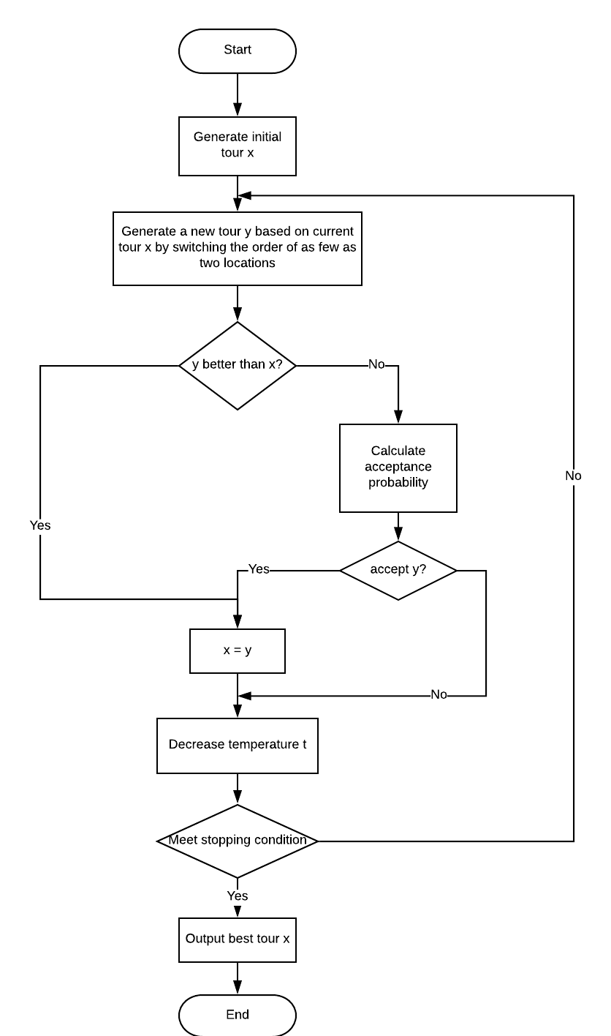

Figure : SA flowchart

# System Implementation & Test

## Introduction

### Overview

This section describes the approach and methodologies used by group to plan and manage the testing of our application. It provides in the detail of all necessary information about the testing procedure of the system include plans, test cases, test result, pass/fail criteria as well as a checklist to cover as much as possible cases that we can.

### Test Approach

* Goal: Test core features of demo application based on the core flow.
* Method: Black-box Testing
* Technique: Check list

## Performance Measures

Because this is an application which is designed to compare algorithms. So, the performance of application is depend on complexity of running algorithm.

* + Complexity of clustering algorithm is O(n*k*I*d)
    - n: number of points
    - k: number of cluster
    - I: number of iteration
    - d: number of attributes
  + Complexity of AntQ algorithm is O(n2) with n is number of locations.
  + Complexity of Ant Colony Optimization algorithm is O(n2) with n is number of locations.
  + Complexity of Simulated Annealing algorithm is O(n2logn) with n is number of locations.

Running each algorithm takes almost the processing time even if we ignore the time needed to load data from file.

The speed of algorithm will vary and it depends on which algorithm is used. The purpose of this project is not about optimizing the time of processing algorithms, it focuses on analyzing the final result after the process is finished so it is accepted if the time of processing algorithm lasts too long. Moreover, the application is designed for researchers so the wait time is acceptable.

## Test Plan

The overall purpose of testing is ensuring the application meets its entire technical functional requirement. The purpose of this document is describing the overall test plan and strategy for testing the application.

The following part will describe which features need to be tested and which not.

### Features to be tested

We will carry out test based on the core workflow of system. All main functions will be tested carefully and clearly by the following phases:

* GUI:
  + View Main Window
  + View Log Window
  + View Graph UI
  + View Googlemap UI
  + View log list
* Main Window:
  + View Graph
  + View Google Map
  + Generate dataset
  + Apply new parameters
  + Run algorithm
  + Save log
  + Run log
  + Choose other cluster
  + Search log
  + Remove log
  + Rename log
* Log Window:
  + Add log to table
  + Compare logs

### Features not to be tested

N/A

## System Testing Test Case

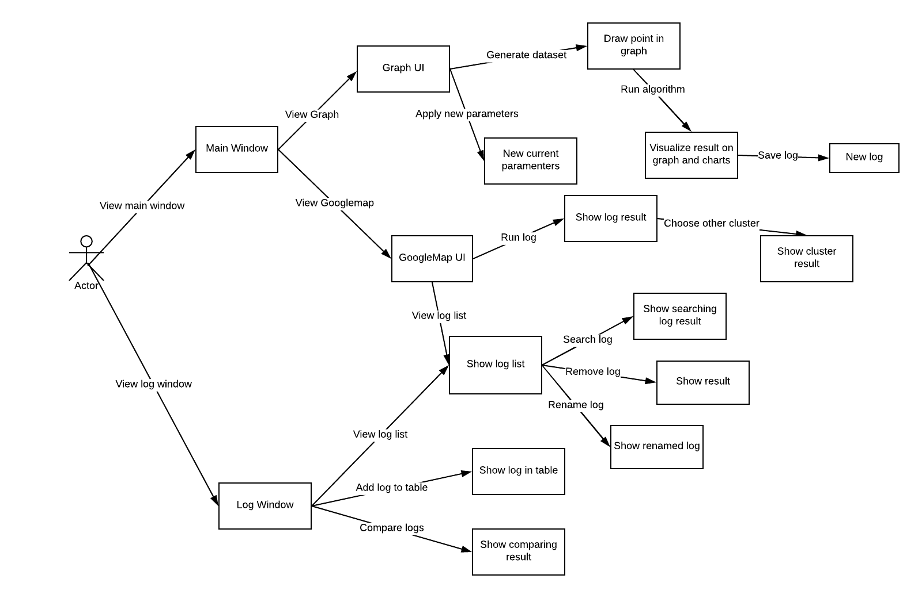

Figure : Test Case Overview

### GUI

|  |  |  |  |  |  |  |  |
| --- | --- | --- | --- | --- | --- | --- | --- |
| **ID** | **Test Case Description** | **Test Case Procedure** | **Expected Output** | **Inter-test Case Dependence** | **Result** | **Test Date** | **Note** |
| 1 | View Main Window | -Open application | -Show graph correctly.  -Show graph WP correctly. | N/A | PASS | 26/03/2018 |  |
| 2 | View Log Window | -On main window, press “Ctrl+L” | -Show log panel correctly.  -Show log table correctly. | N/A | PASS | 26/03/2018 |  |
| 3 | View Graph UI | -On main window and “Google map” tab, click “Graph” tab | -Show graph correctly.  -Show graph WP correctly. | N/A | PASS | 26/03/2018 |  |
| 4 | View GoogleMap UI | -On main window and “Graph” tab, click “Googlemap” tab | -Show googlemap correctly.  -Show googlemap WP correctly. | N/A | PASS | 26/03/2018 |  |
| 5 | View log list | -Change view to googlemap UI or log Window | -Load and update log list on log panel | N/A | PASS | 26/03/2018 |  |

Table : GUI Test Case

### Main Window Function

#### Graph UI Function

|  |  |  |  |  |  |  |  |
| --- | --- | --- | --- | --- | --- | --- | --- |
| **ID** | **Test Case Description** | **Test Case Procedure** | **Expected Output** | **Inter-test Case Dependence** | **Result** | **Test Date** | **Note** |
| 1 | Generate dataset – GoogleMap dataset | -Click “Generate” button  -Choose google map dataset (json file) | -Show corresponding points on graph | N/A | PASS | 27/03/2018 |  |
| 2 | Generate dataset – TSP dataset | -Click “Generate” button  -Choose TSP dataset (tsp file) | -Show corresponding points on graph | N/A | PASS | 27/03/2018 |  |
| 3 | Generate dataset – ATSP dataset | -Click “Generate” button  -Choose ATSP dataset (atsp file) | -Show corresponding points on graph | N/A | PASS | 28/03/2018 |  |
| 4 | Generate dataset – Not supported file | -Click “Generate” button  -Choose a not supported file. | -Show error dialog | N/A | PASS | 28/03/2018 |  |
| 5 | After a generating, user generate dataset again. | -Click “Generate” button  -Choose a supported file. | -Remove all previous generated points.  -Then show corresponding points on graph | N/A | PASS | 29/03/2018 |  |
| 6 | Apply new parameter | -User change parameters and algorithm  -Click “Apply” button and then choose “Yes” | -Show current parameter correctly. | N/A | PASS | 29/03/2018 |  |
| 7 | Run algorithm – With dataset | -After generate dataset, click “Run” button | -Visualize tour on graph correctly.  -Show the result on charts correctly. | N/A | PASS | 30/03/2018 |  |
| 8 | Run algorithm – Without dataset | -Click “Run” button | -Show error dialog | N/A | PASS | 31/03/2018 |  |
| 9 | Save log | -After algorithm running, enter name of log  -Click “OK” | -Show success dialog | N/A | PASS | 02/04/2018 |  |

Table : Graph UI Test Case

#### GoogleMap UI Function

|  |  |  |  |  |  |  |  |
| --- | --- | --- | --- | --- | --- | --- | --- |
| **ID** | **Test Case Description** | **Test Case Procedure** | **Expected Output** | **Inter-test Case Dependence** | **Result** | **Test Date** | **Note** |
| 1 | Run log with selected log which has googlemap dataset | -Select log on log panel  -Click “Run” button | -Visualize all route and point on googlemap. Each route and point have corresponding cluster color.  -Show all route on result table  -Show list cluster on cluster combobox | N/A | PASS | 03/04/2018 |  |
| 2 | Run log with selected log which hasn’t googlemap dataset | -Select log on log panel  -Click “Run” button | -Show error dialog | N/A | PASS | 03/04/2018 |  |
| 3 | Run log without selected log | -Click “Run” button | -Show error dialog | N/A | PASS | 03/04/2018 |  |
|  | Choose cluster after run log | -After running a log, select a cluster on cluster combobox | -Visualize all route and point of selected cluster on googlemap.  -Show all route of selected cluster on result table | N/A | PASS | 04/04/2018 |  |
| 4 | Search log | -Enter name and select algorithm on filter combobox.  -Click “Search” button | -Show all corresponding log on log panel | N/A | PASS | 05/04/2018 |  |
| 5 | Remove log | -Right click on a log.  -Click “Remove” | -Remove the log on panel and json file. | N/A | PASS | 06/04/2018 |  |
| 6 | Rename log | -Right click on a log.  -Click “Rename”  -Enter new name  -Click “OK” | -Rename the log on panel and json file | N/A | PASS | 06/04/2018 |  |

Table : GoogleMap UI Test Case

### Log Window Function

|  |  |  |  |  |  |  |  |
| --- | --- | --- | --- | --- | --- | --- | --- |
| **ID** | **Test Case Description** | **Test Case Procedure** | **Expected Output** | **Inter-test Case Dependence** | **Result** | **Test Date** | **Note** |
| 1 | Add to table with selected log | -Select log on log panel  -Click “Add to Table” button | -Display selected log on table with corresponding attributes | N/A | PASS | 07/04/2018 |  |
| 2 | Add to table without selected log | -Click “Add to Table” button | -Show error dialog | N/A | PASS | 07/04/2018 |  |
| 3 | Remove a row on table | -Click “Remove” button on corresponding row. | -Remove row | N/A | PASS | 07/04/2018 |  |
| 4 | Compare logs - With same algorithm and same number of cluster | -After add corresponding logs to table, click “Compare” button | -Show corresponding multiline charts | N/A | PASS | 09/04/2018 |  |
| 5 | Compare logs - With different algorithm and same number of cluster | -After add corresponding logs to table, click “Compare” button | -Show corresponding multibar chart | N/A | PASS | 10/04/2018 |  |
| 6 | Compare logs - With different number of cluster | -After add corresponding logs to table, click “Compare” button | -Show error dialog | N/A | PASS | 10/04/2018 |  |

Table : Log Window Test Case

# Software User’s Manual

## Installation

### Prepare dependencies

* Before running application, user need to install pyre python and python libraries:
  + Pure python

|  |  |
| --- | --- |
| **Name** | **Version** |
| Python | 3.6.3 |

Table : Pure Python

* + Python libraries

|  |  |
| --- | --- |
| **Name** | **Version** |
| PyQt | 5.10.1 |
| decorator | 4.2.1 |
| googlemaps | 2.5.1 |
| matplotlib | 2.1.2 |
| networkx | 2.1 |
| numpy | 1.14.1 |
| sip | 4.19.8 |

Table : Python libraries

* **Step 1**: Install pure python:
  + Go to page: <https://www.python.org/downloads/release/python-363/>
  + Choose corresponding version based on your Operating System.
  + Then, run it and following instruction to install python on your computer.
  + Check if python is installed: Open Command Prompt. Then type: “python” and press Enter. If it display like this, python is installed successfully.

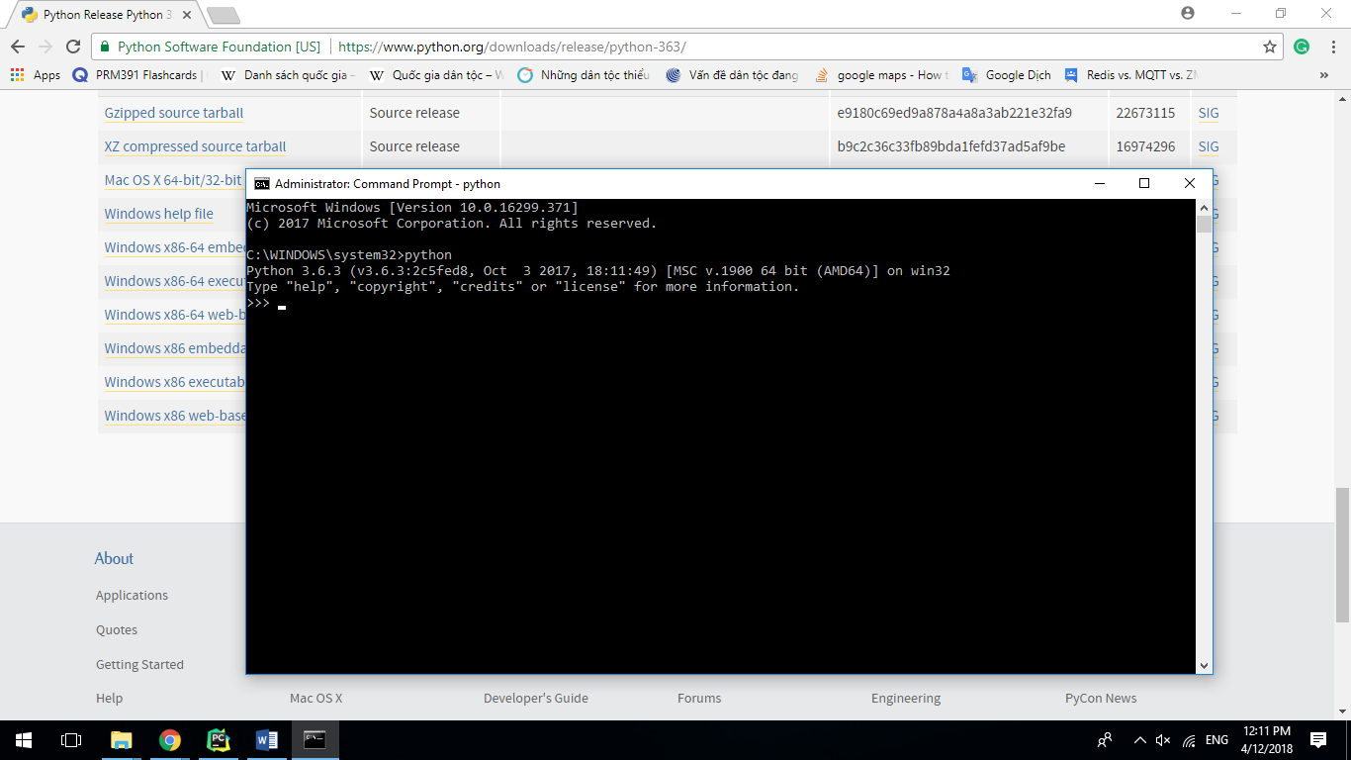

* **Step 2**: Install python libraries:
  + Open **Command Prompt** as **Administrator**: Right click on “**Command Prompt**” in **Start Menu**. Then, select “**Run as Administrator**”

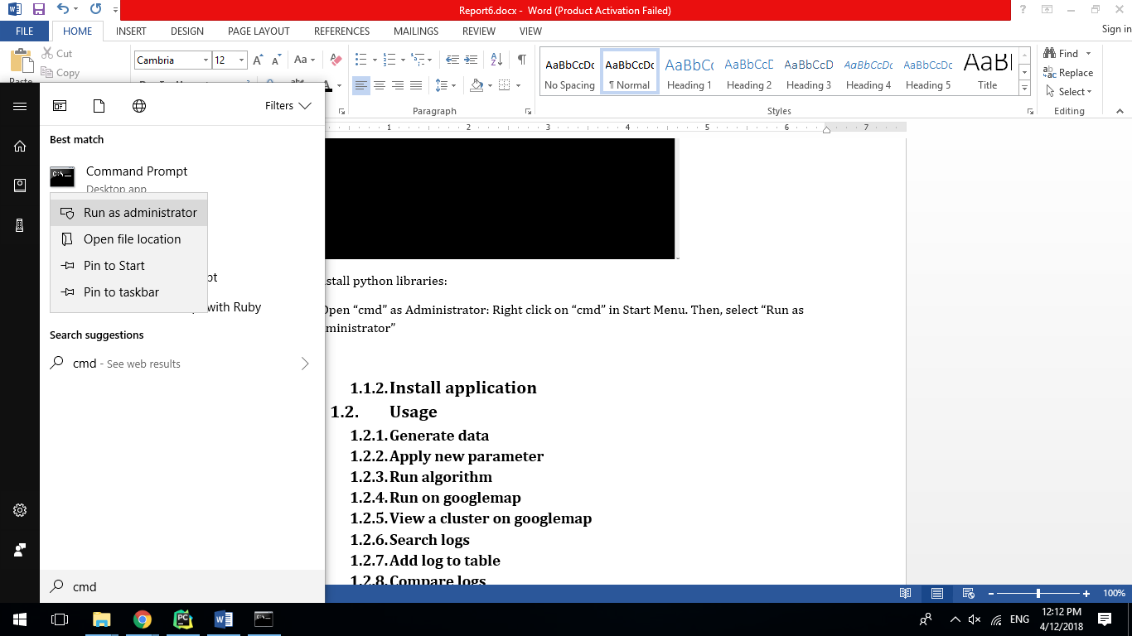

* + Enter each following command to install corresponding python library.

|  |  |
| --- | --- |
| **Name** | **Command** |
| PyQt | pip install PyQt5 |
| decorator | pip install decorator |
| googlemaps | pip install googlemaps |
| matplotlib | pip install matplotlib |
| networkx | pip install networkx |
| numpy | pip install numpy |
| sip | pip install sip |

### Install application

* **Step 1**: Copy “**AntQDemonstration.rar**” file into directory where you want to install application to.

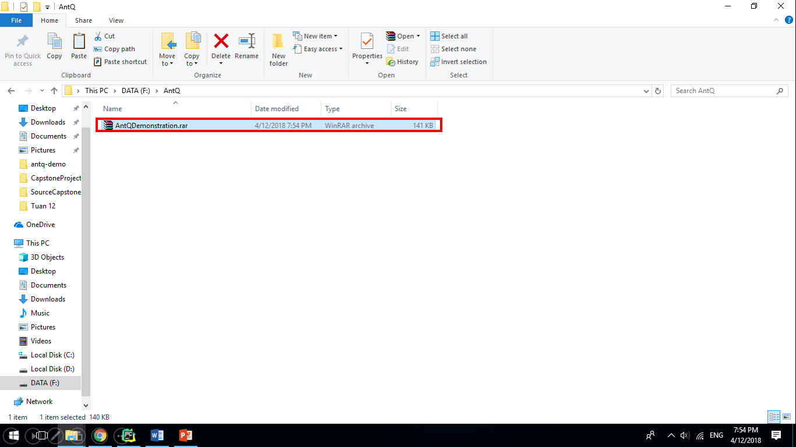

* **Step 2**: Right click on “**AntQDemonstration.rar**” file. Then choose “**Extract here**”.

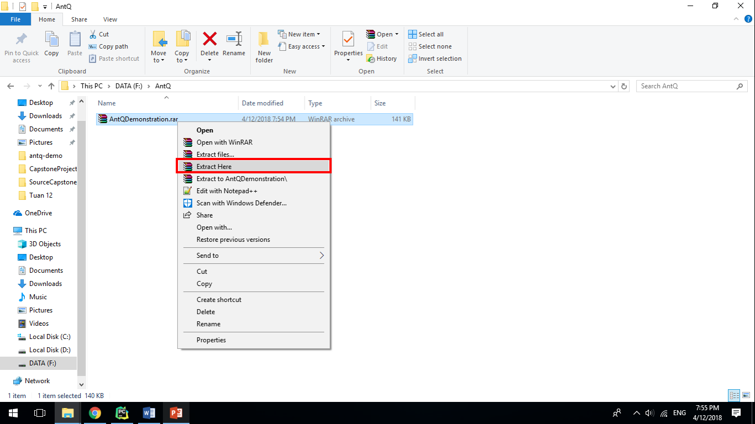

* **Step 3**: “**AntQDemonstration**” folder is created. Open it.

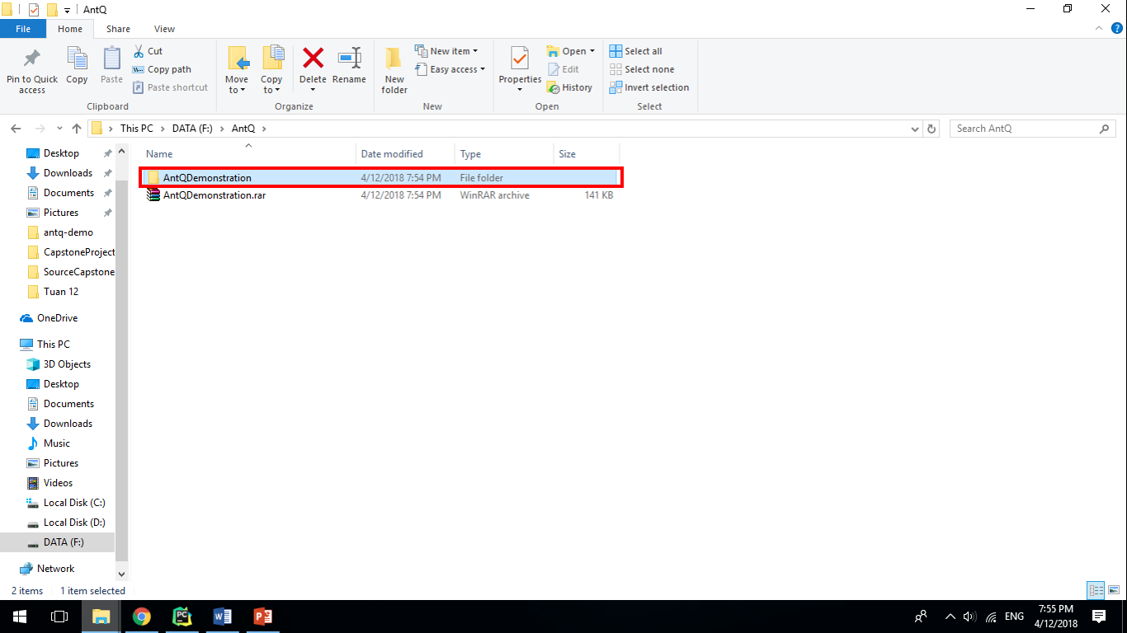

* **Step 4**: Open “**run.bat**” file to run application.

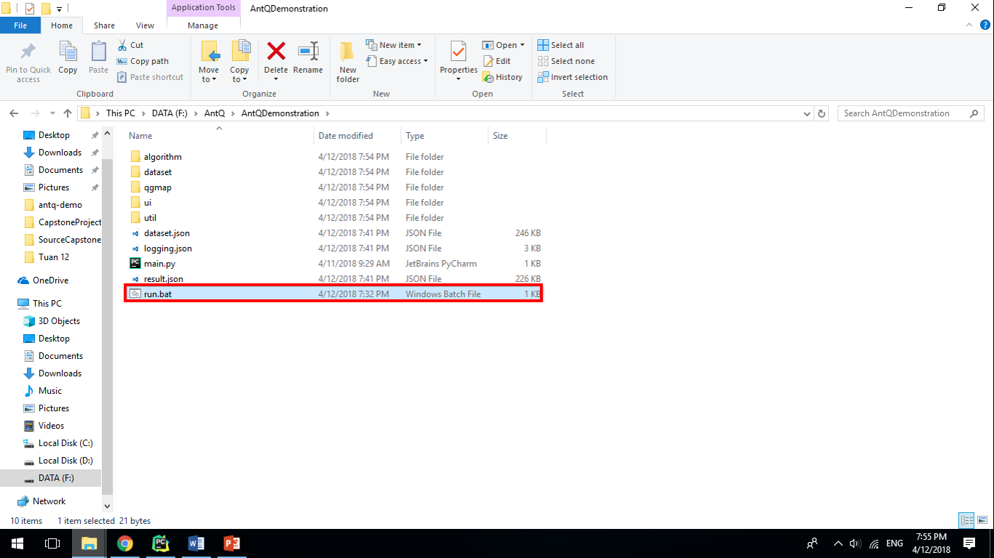

## User guide

### Generate data

* **Step 1**: Click “**Generate**” button.

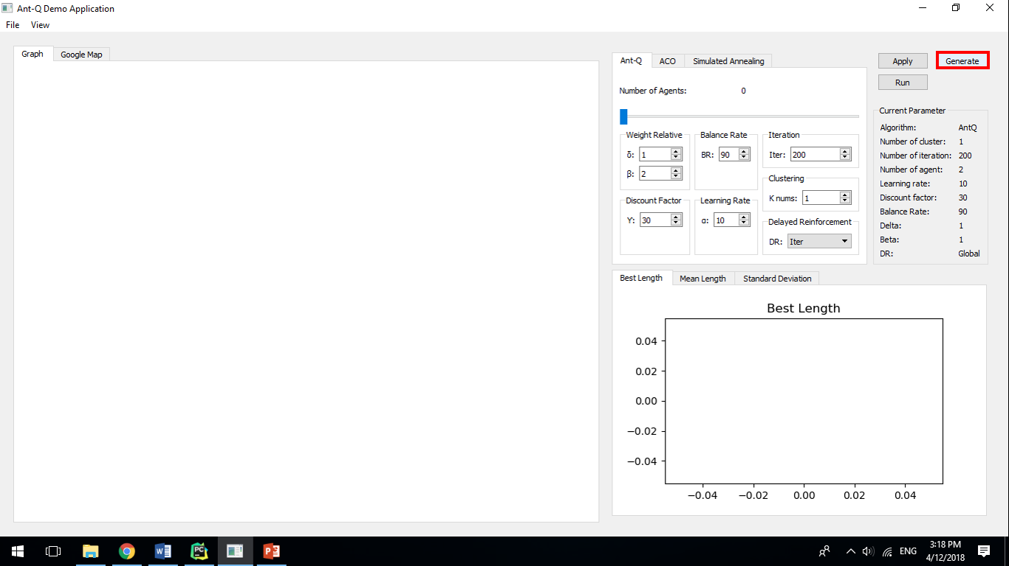

* **Step 2**: A open file dialog will be displayed.

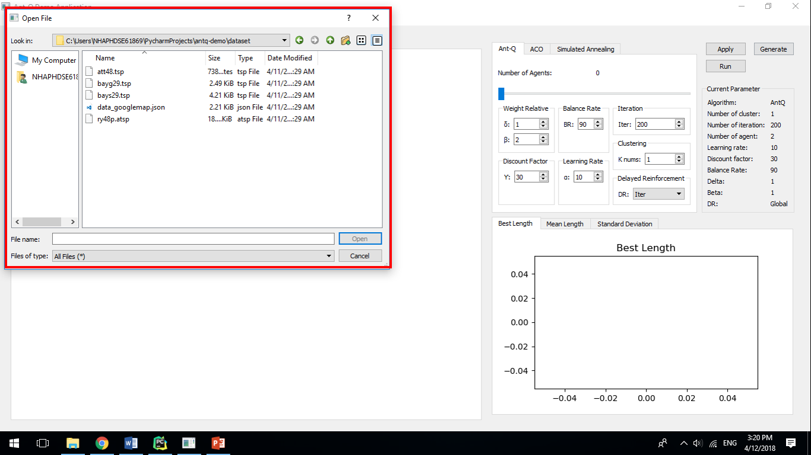

* **Step 3**: Choose a correponding dataset file. There are only 3 dataset types:
  + Googlemap dataset is a json file which has determined structure.
  + TSP dataset is a tsp file which has symmetric data.
  + ATSP dataset is a atsp file which has assymmetric data.

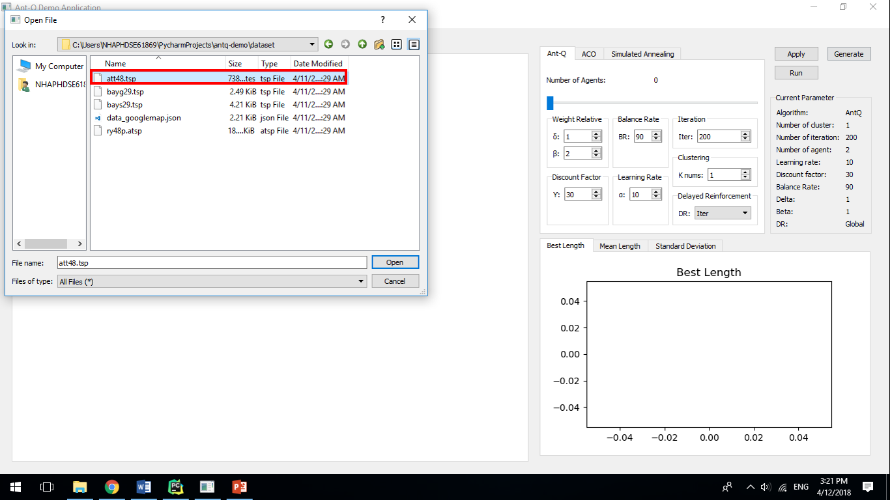

* **Step 4**: Click “**Open**” button.

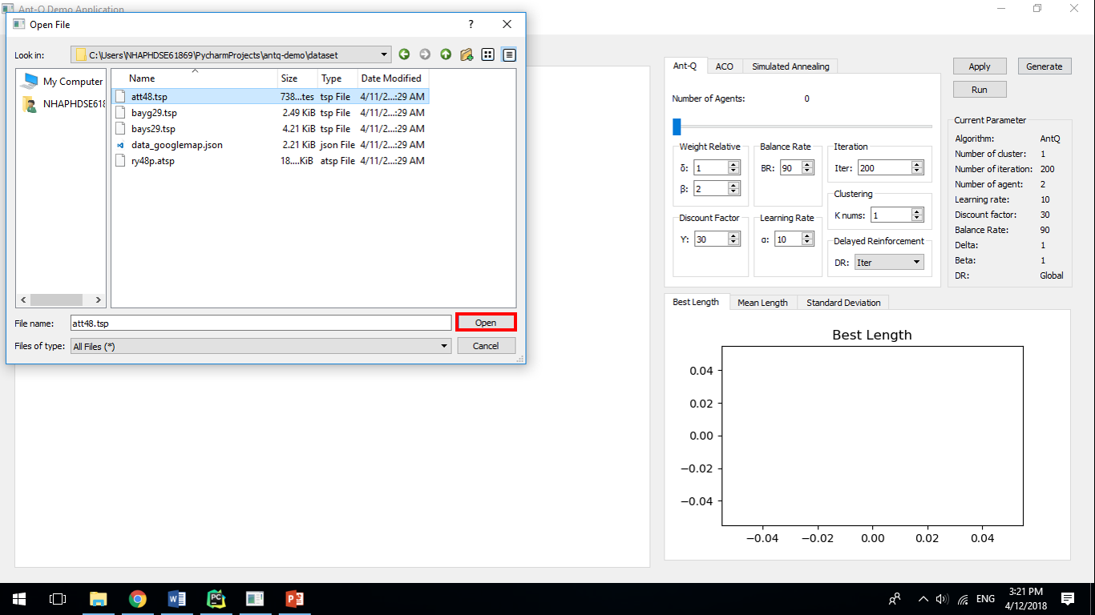

* **Step 5**: Graph will display points of chosen dataset.

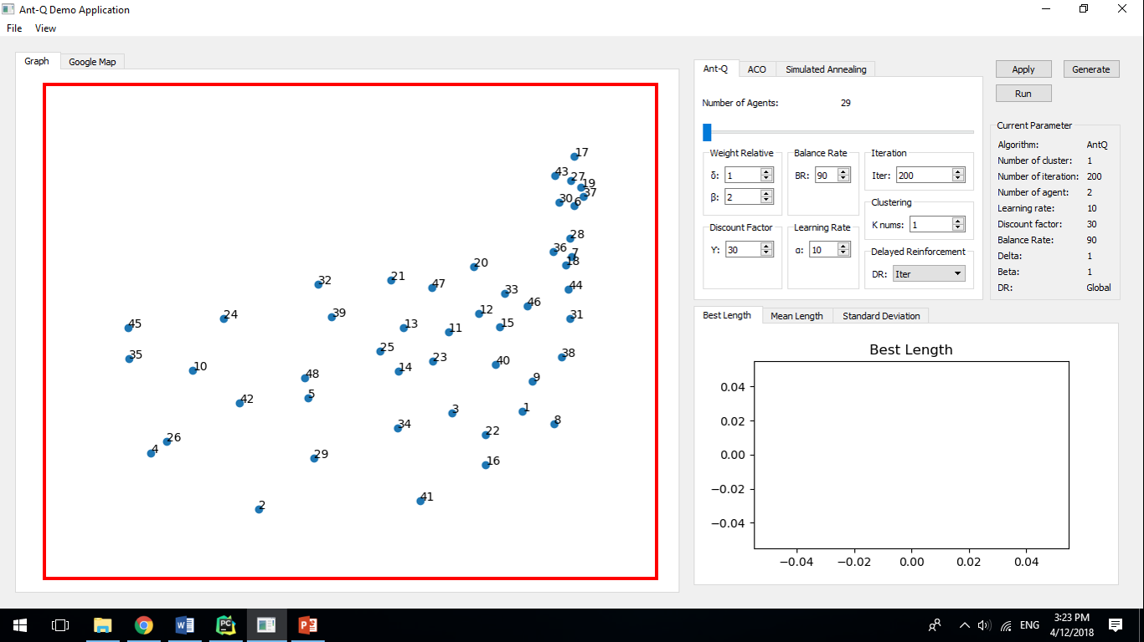

* **Step 6**: If it is not correct dataset file, application will display a error dialog.

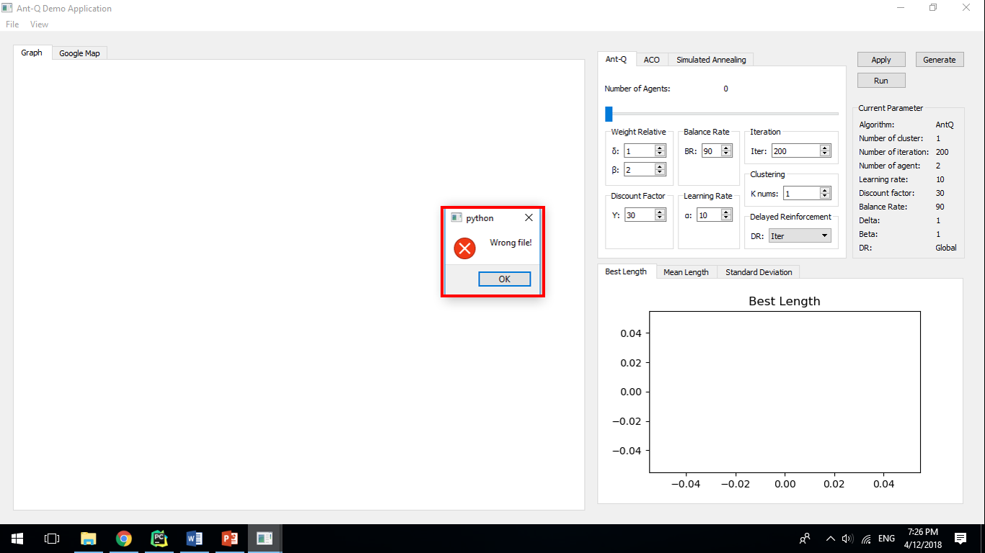

### Apply new parameter

* **Step 1**: Choose the algorithm you want to run.

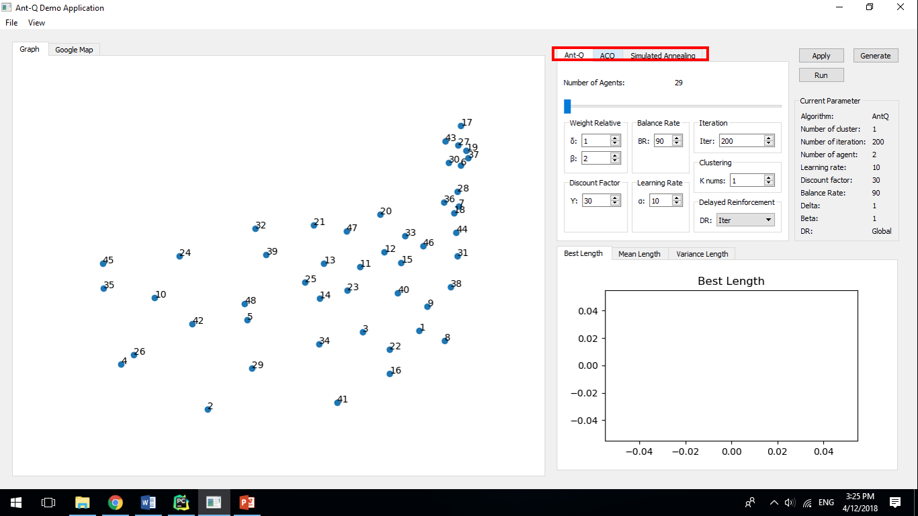

* **Step 2**: Enter the algorithm parameter.

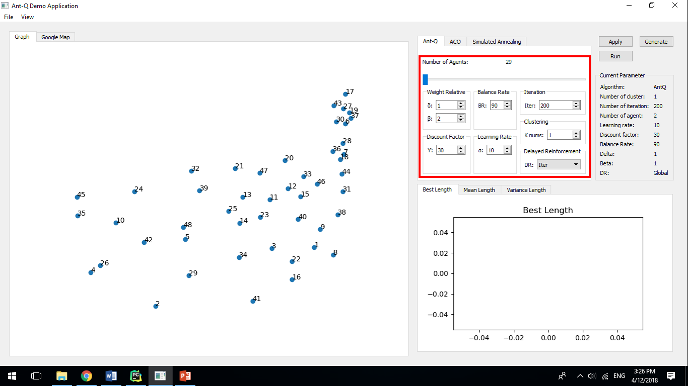

* **Step 3**: Click “**Apply**” button.

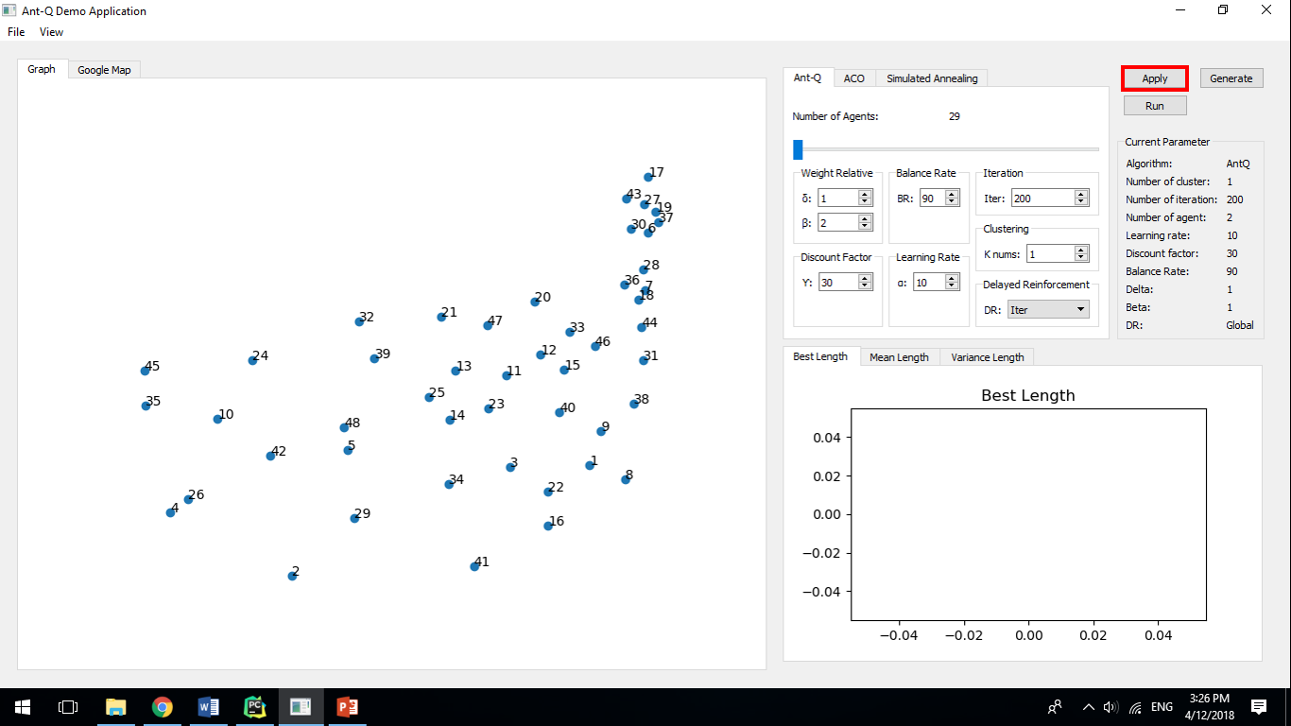

* **Step 4**: Current parameter will change.

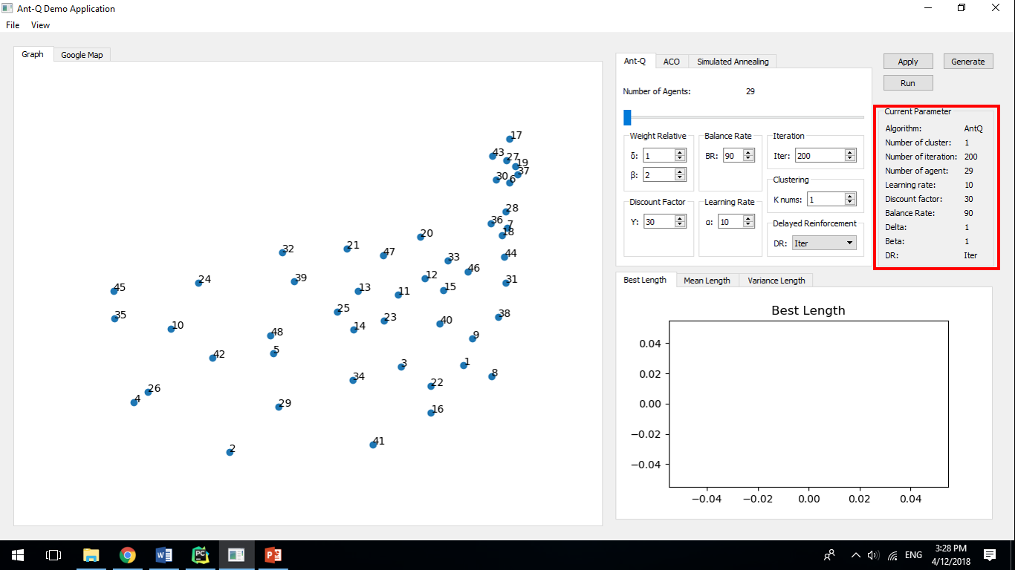

### Run algorithm

* **Step 1**: After generate a dataset, click “**Run**” button.

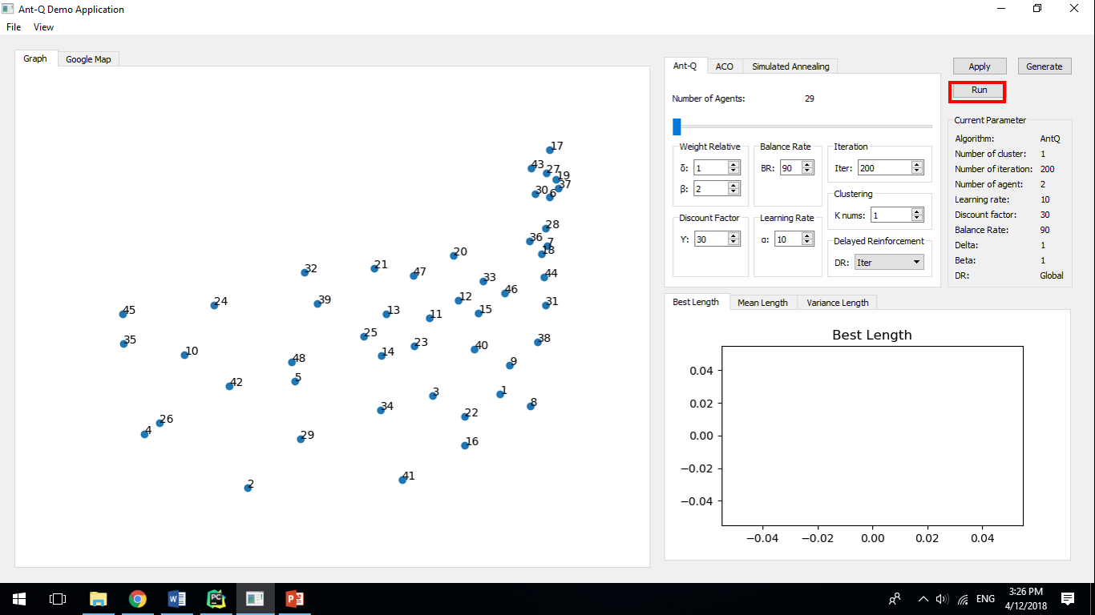

* **Step 2**: The application will use applied current parameter to run.



* **Step 3**: Graph and charts will visualize the running process.

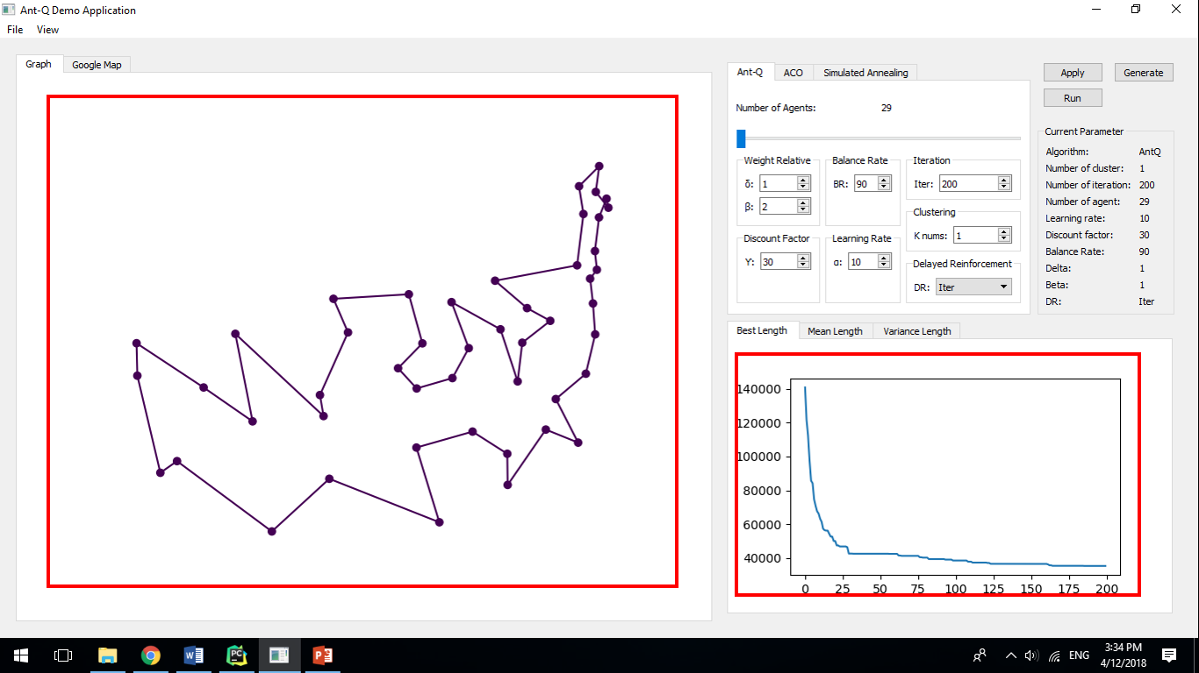

* **Step 4**: After running process completed, a dialog will be displayed to ask you save log.

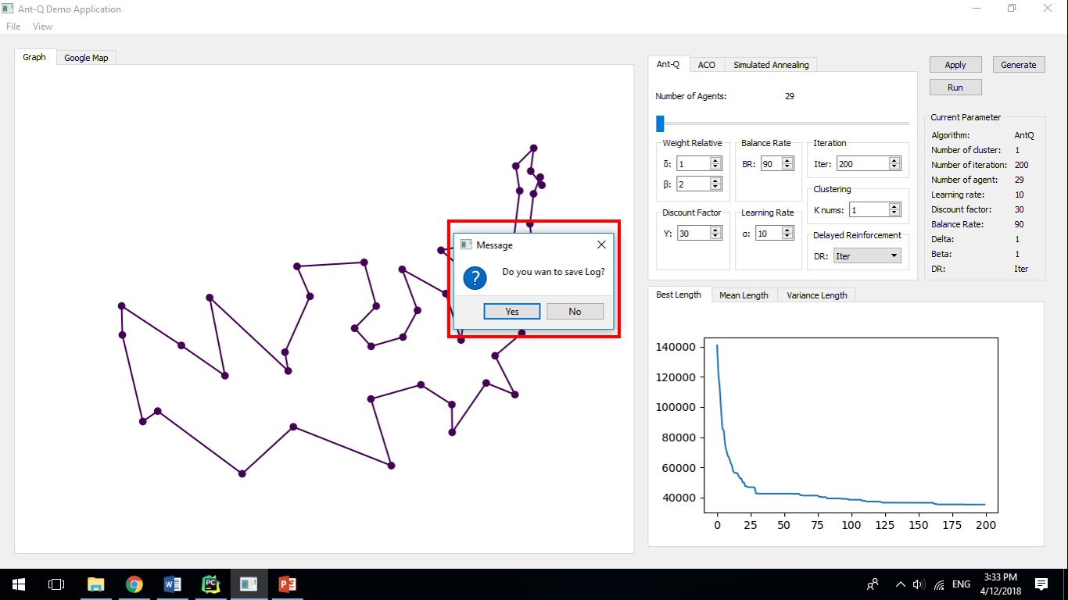

* **Step 5**: Enter name and click “**OK**” button. The log will be saved.

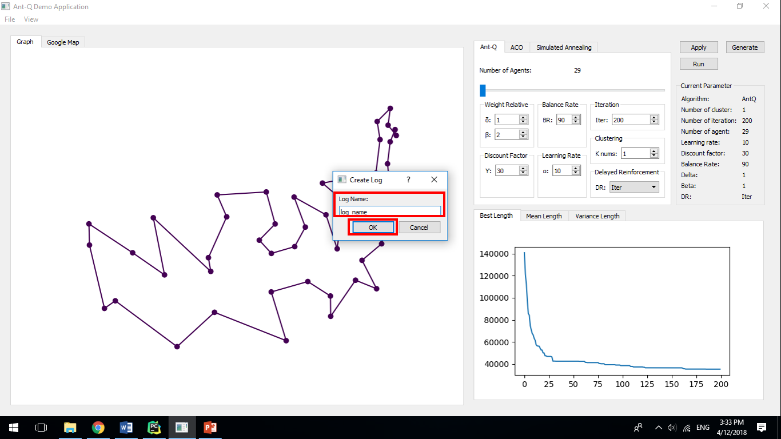

### Run on Google Map

* **Step 1**: Select “**Google Map**” tab. All saved logs will be autoload.

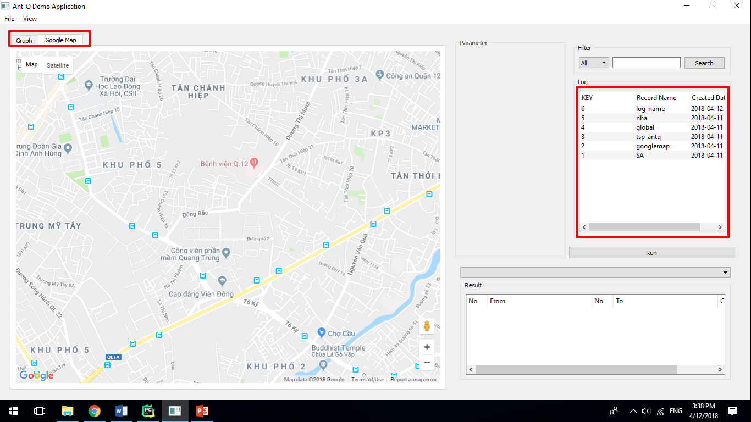

* **Step 2**: Select a log which you have saved when you run algorithm.

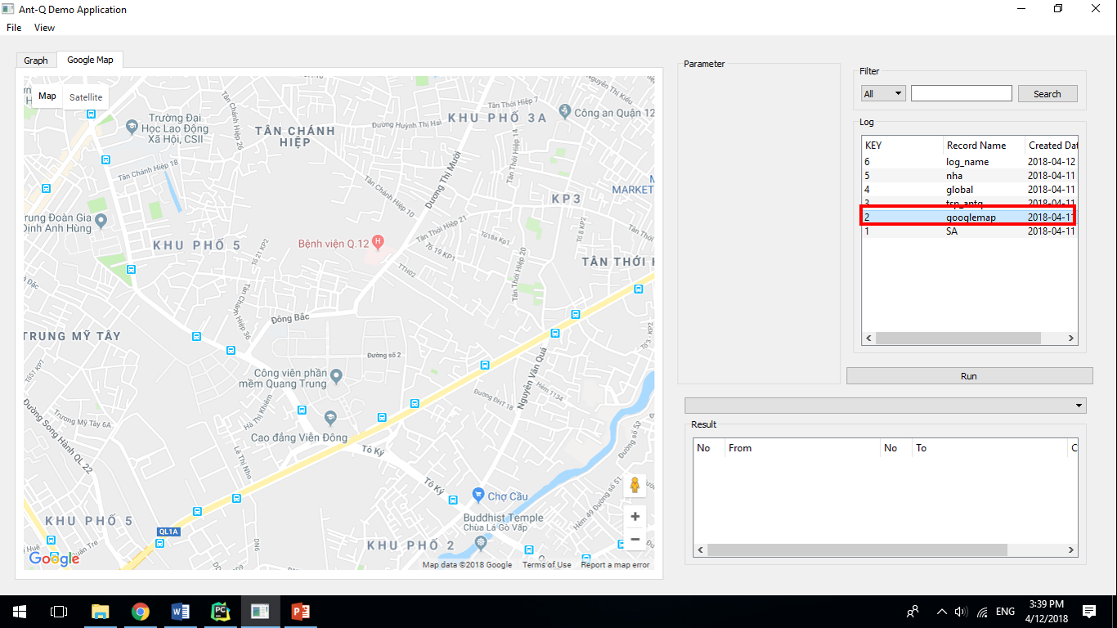

* **Step 3**: Click “**Run**” button.

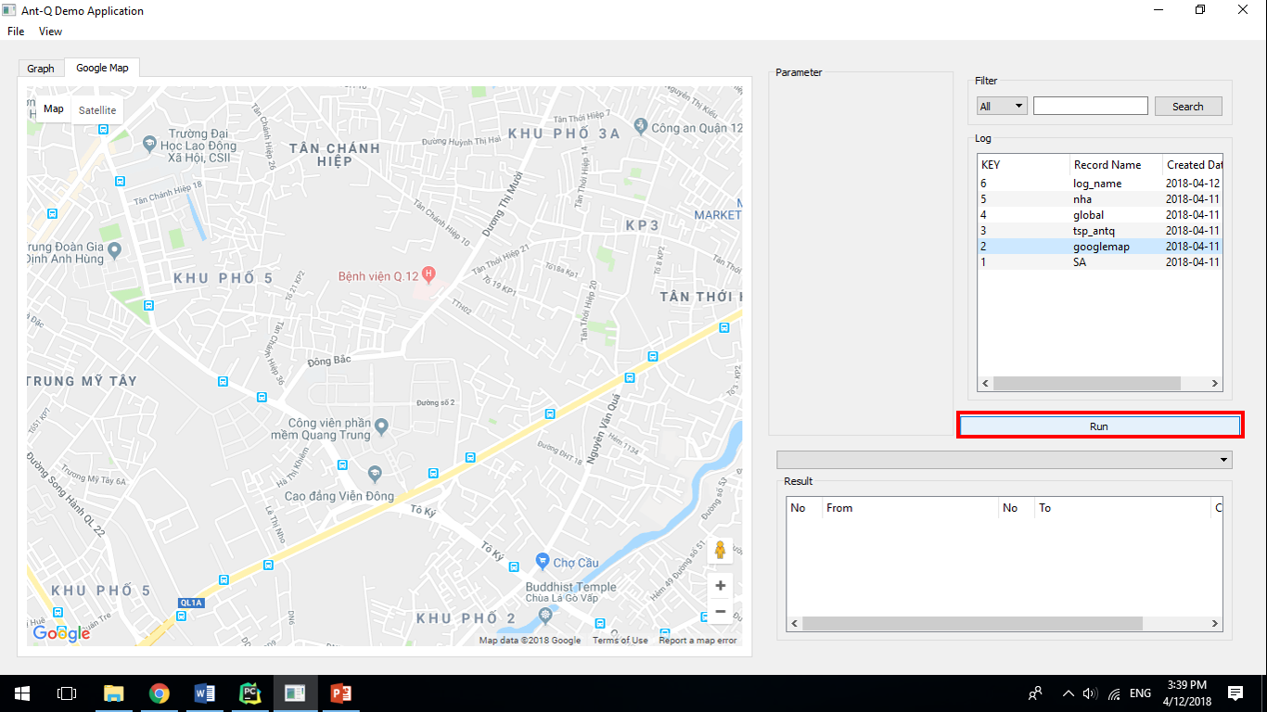

* **Step 4**: Result of log will be display on Google Map and result table.

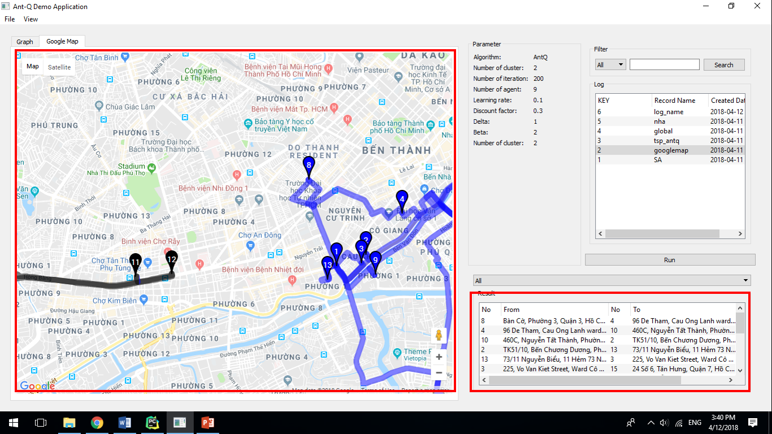

* **Step 5**: If dataset of log which you have selected is not googlemap dataset, an error dialog will be displayed.

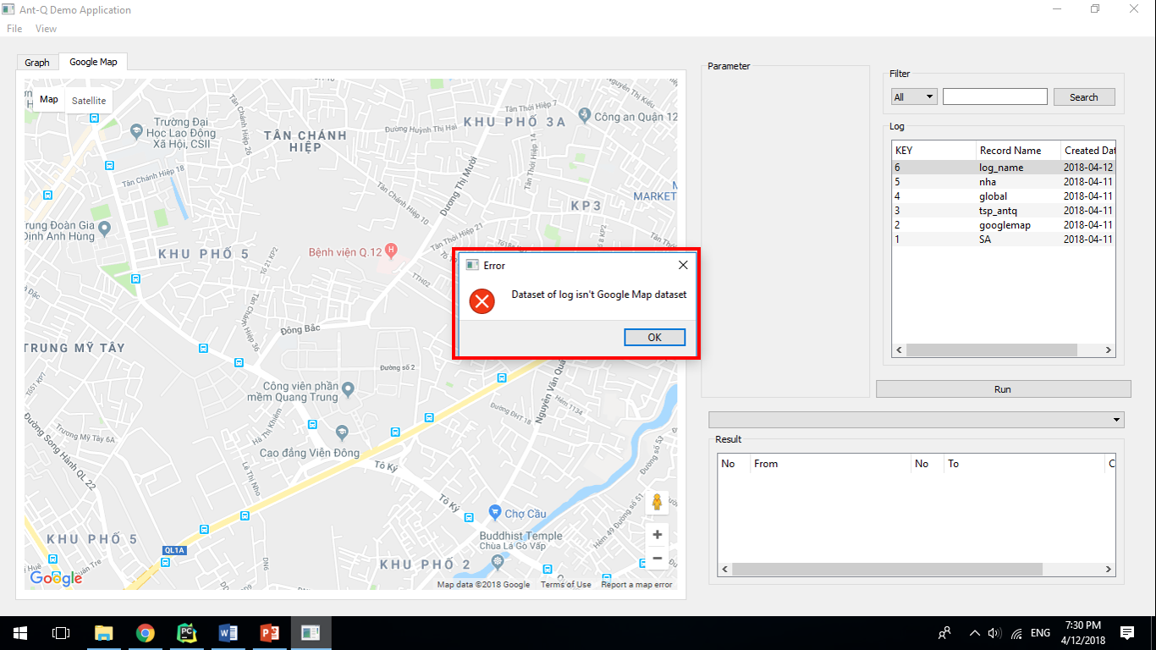

### View a cluster on googlemap

* **Step 1**: After running a log on Google Map, the cluster combobox will have list of clusters.

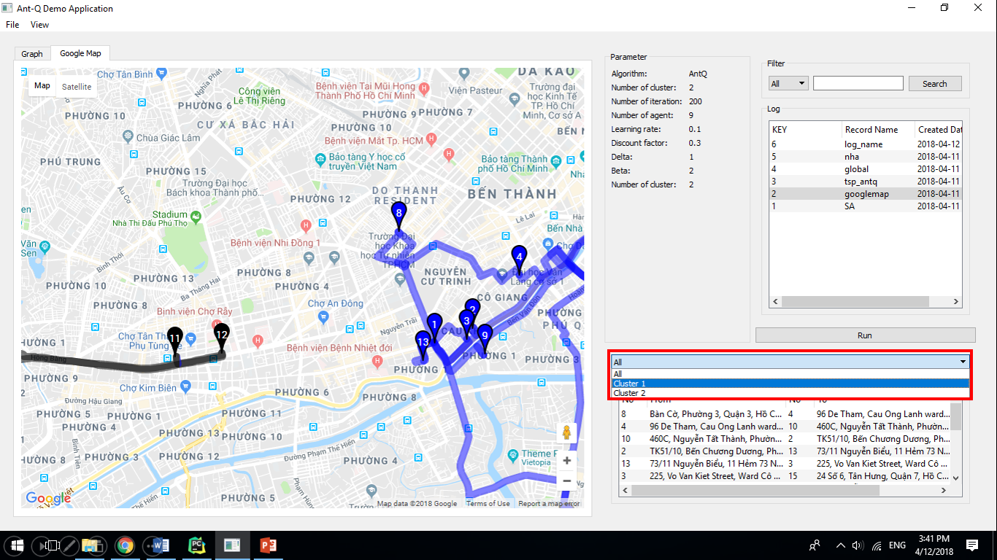

* **Step 2**: Select a cluster in cluster combobox.

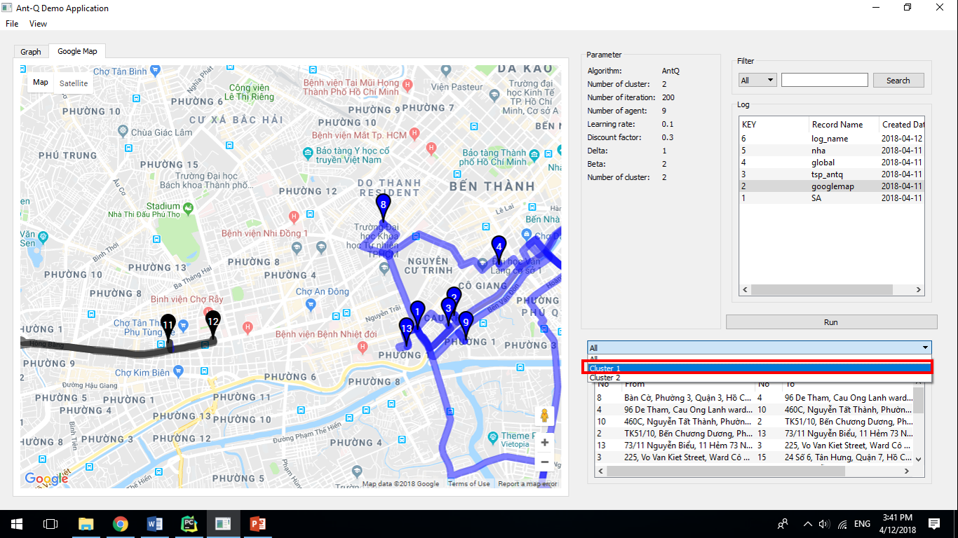

* **Step 3**: Google Map will be display corresponding routes and points of selected cluster.

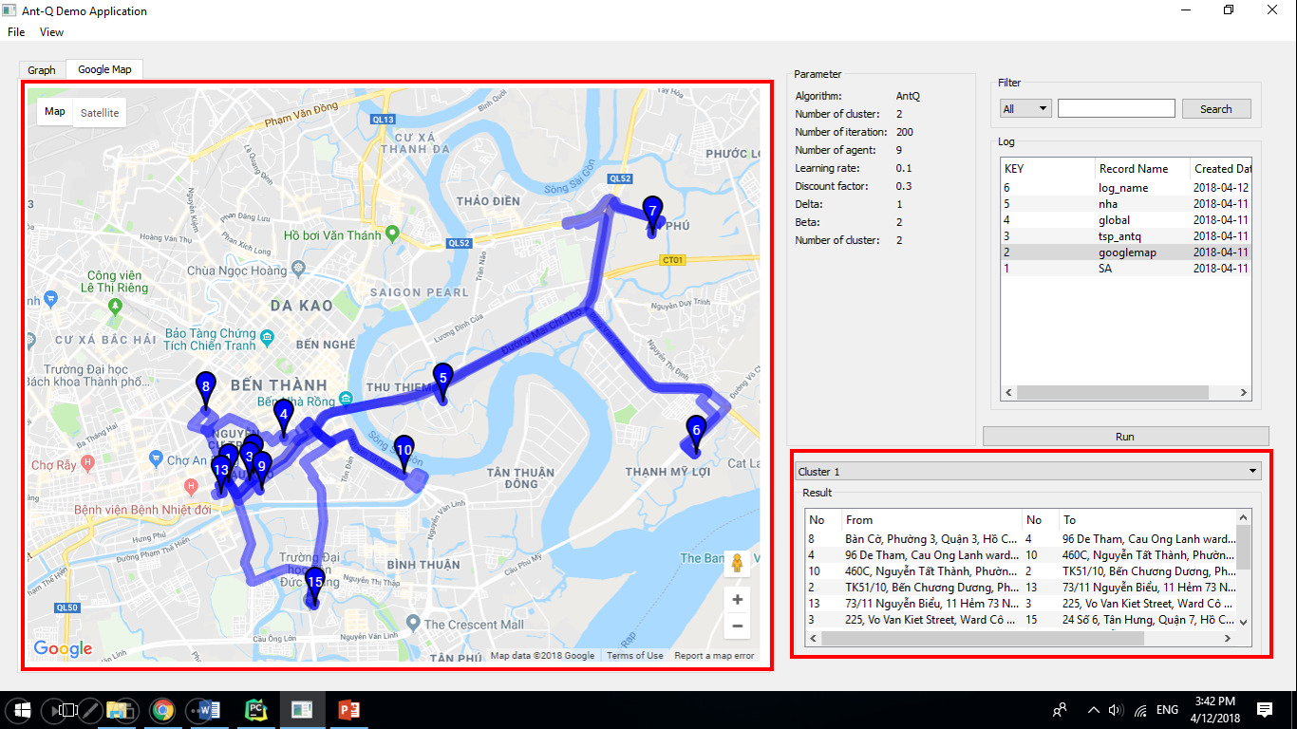

### Search logs

* **Step 1**: Select algorithm you want to filter. Select “**All**” if you want to search all algorithm.

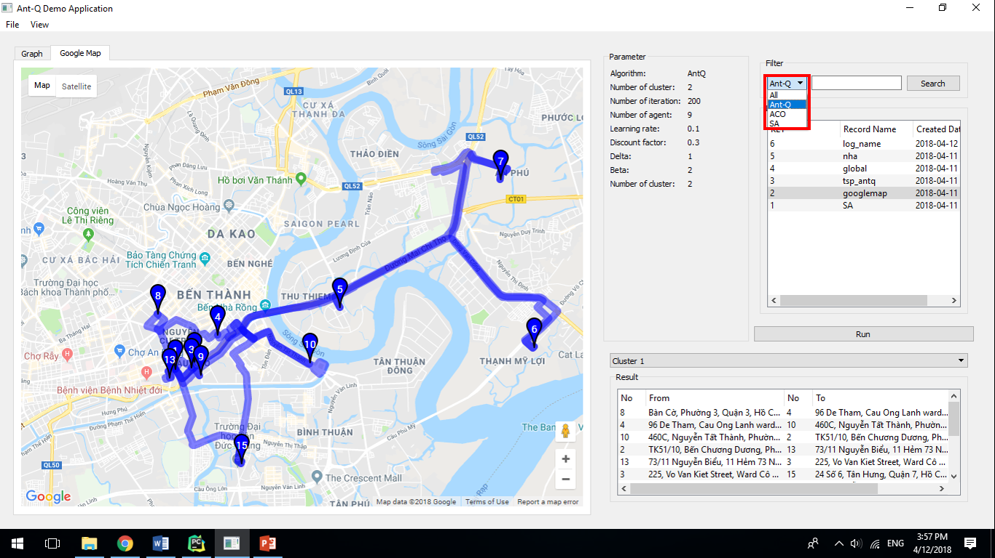

* **Step 2**: Enter a name of log you want to search. Don’t enter anything if you want to search all log names.

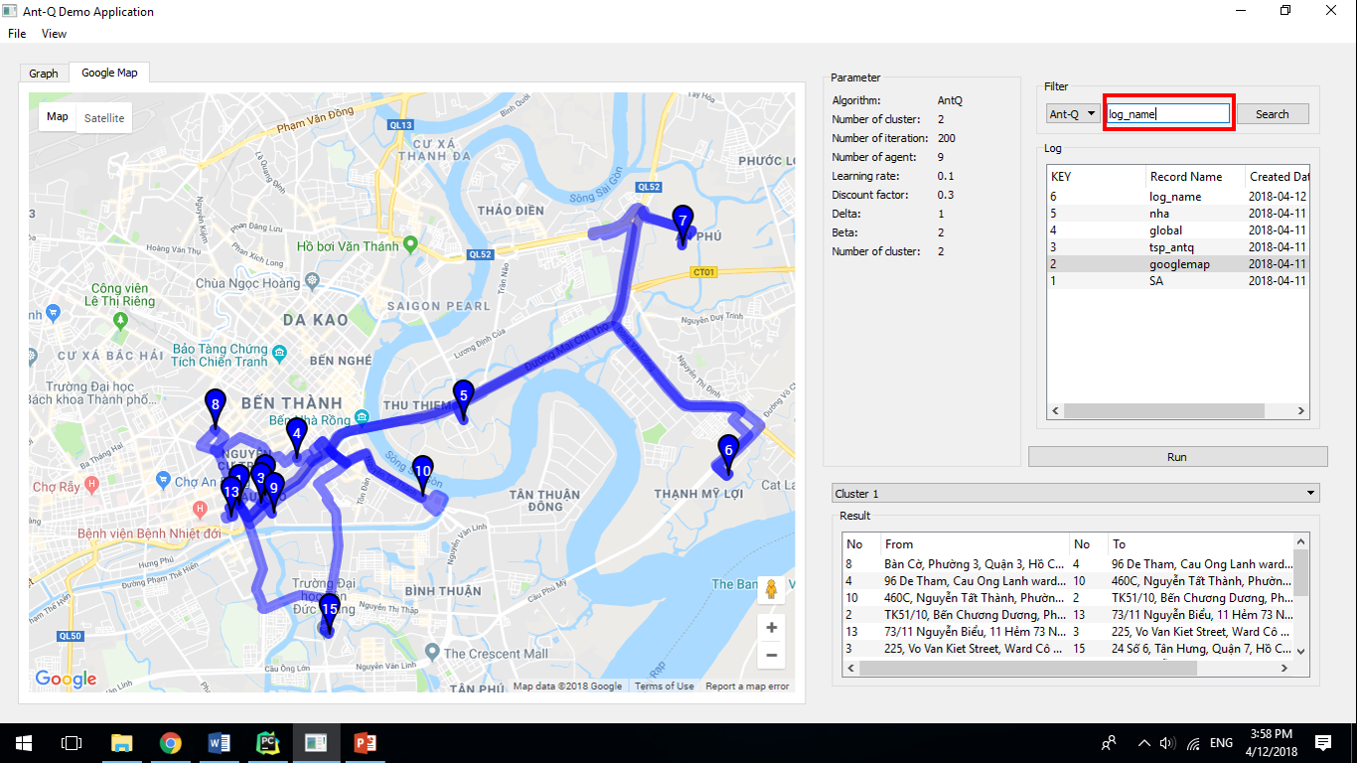

* **Step 3**: Click “**Search**” button.

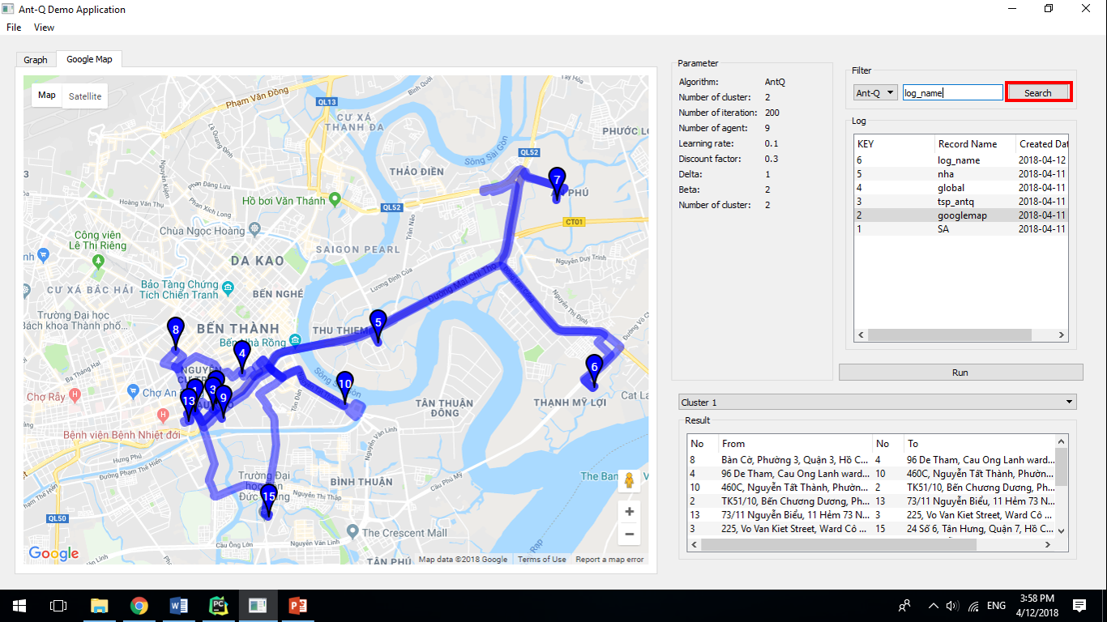

* **Step 4**: Logs have selected algorithm and entered name is showed in below log table.

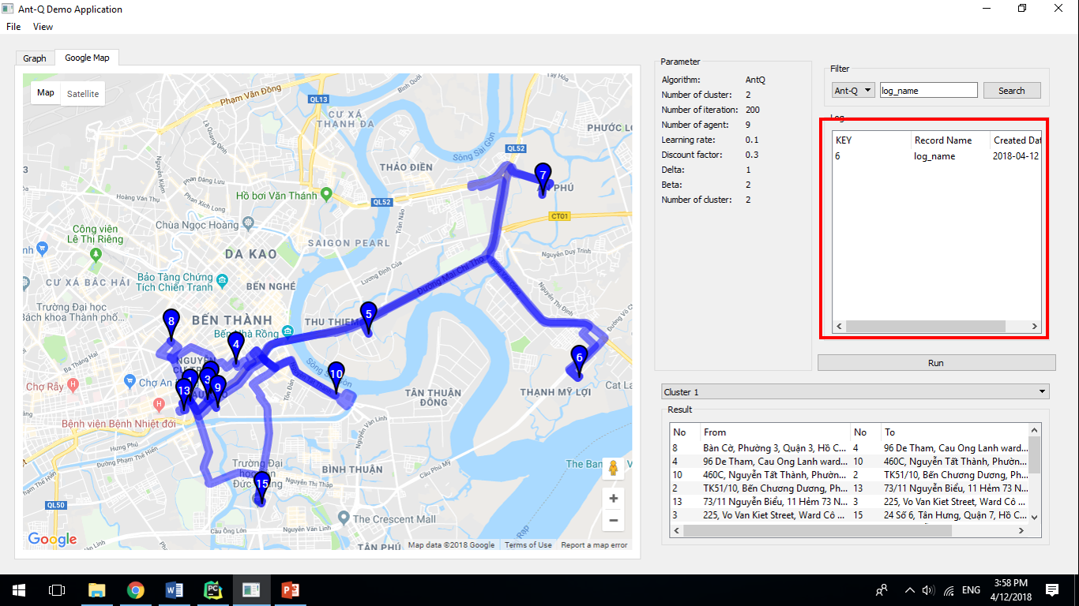

### Add log to table

* **Step 1**: Click menu View -> Log or press “Ctrl+L” to change to Log Window.

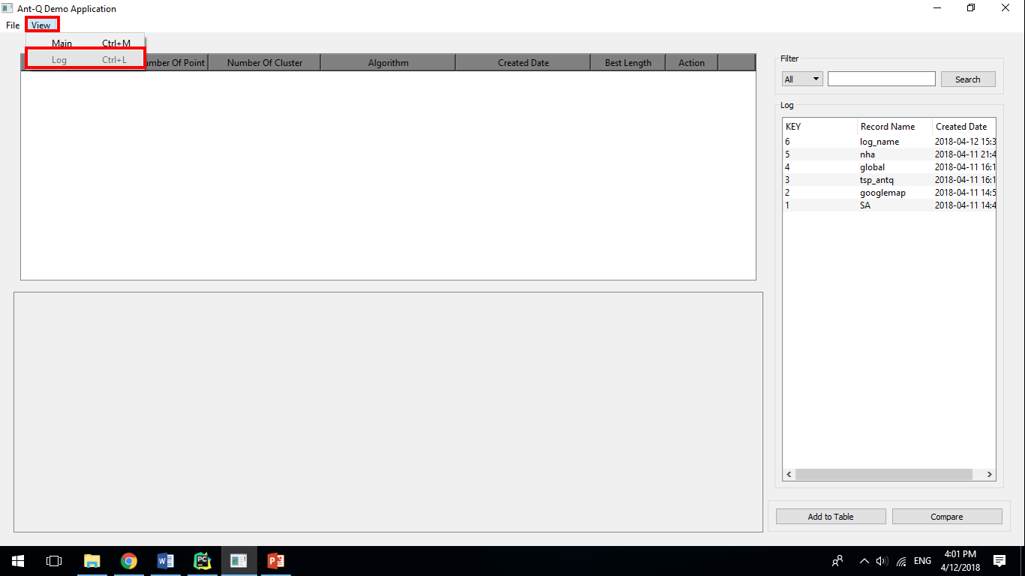

* **Step 2**: Select a log which you have saved when you run algorithm.

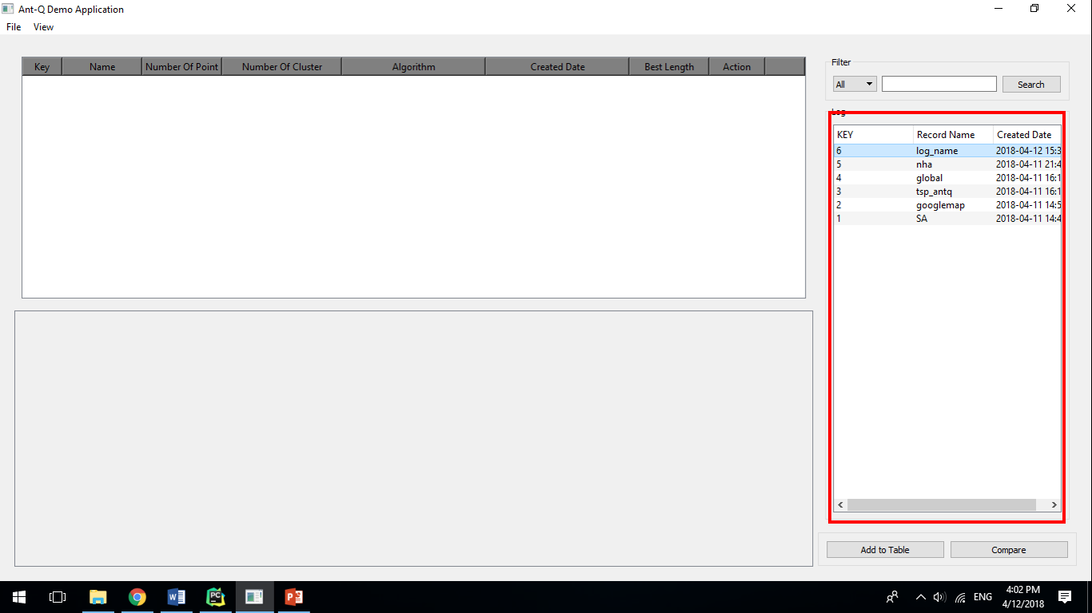

* **Step 3**: Click “**Add to Table**”.

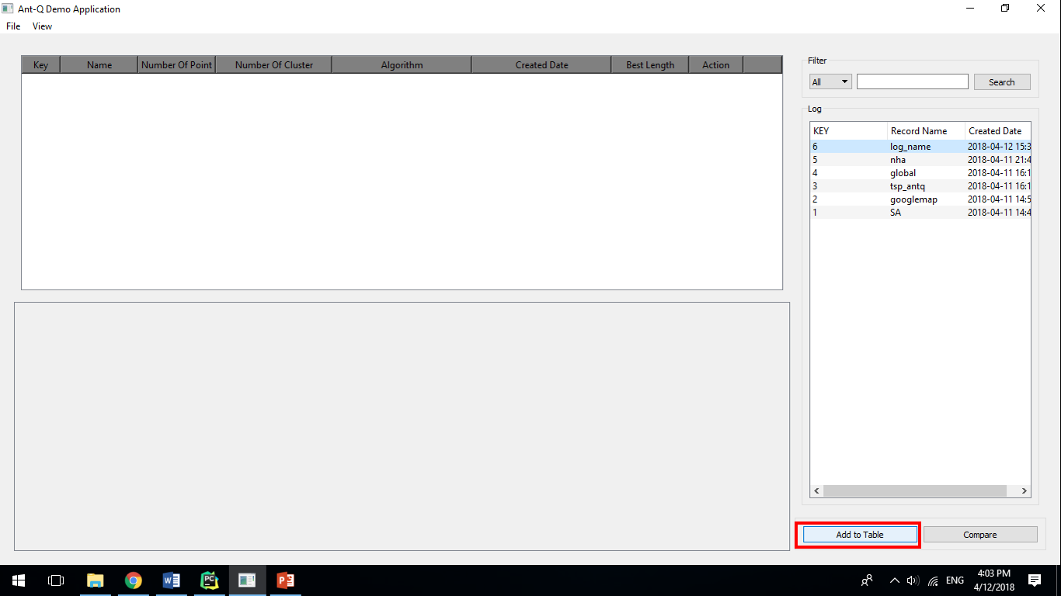

* **Step 4**: Added log will be displayed in left table.

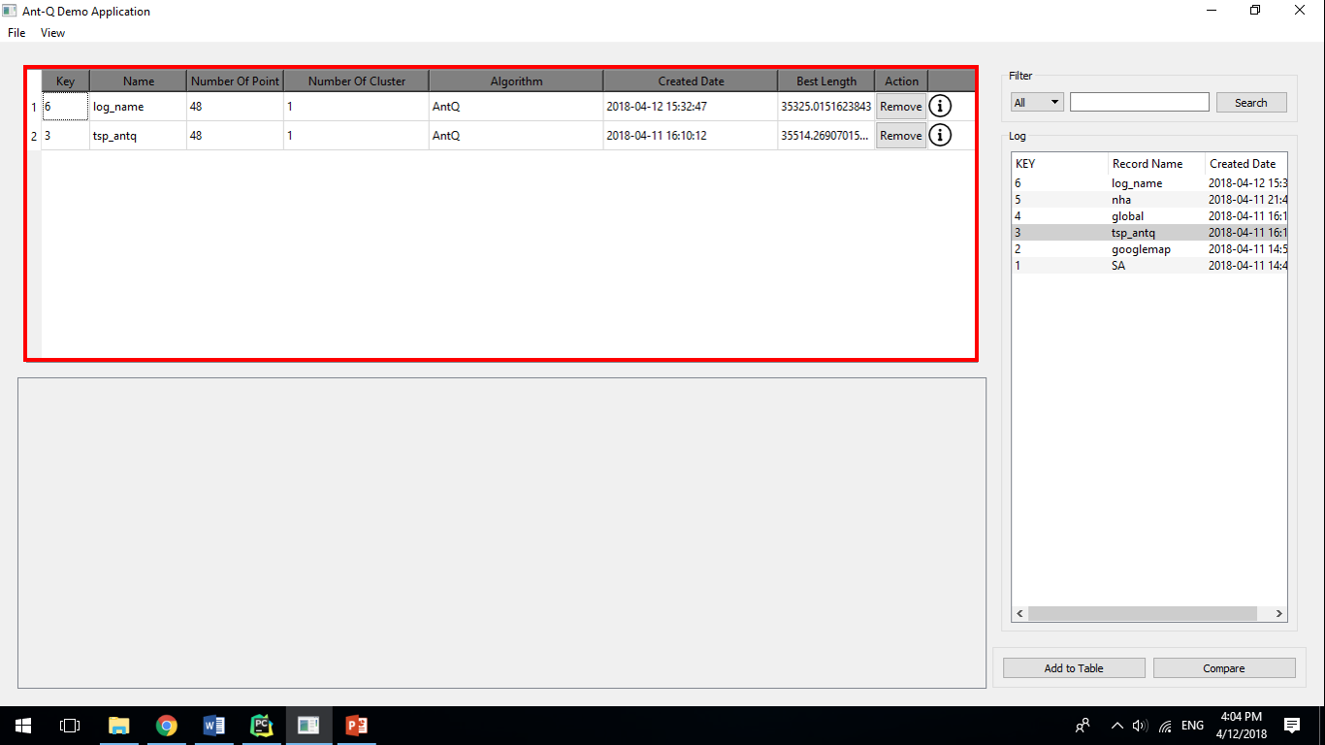

* **Step 5**: Click “**Remove**” button if you want to deselect log.

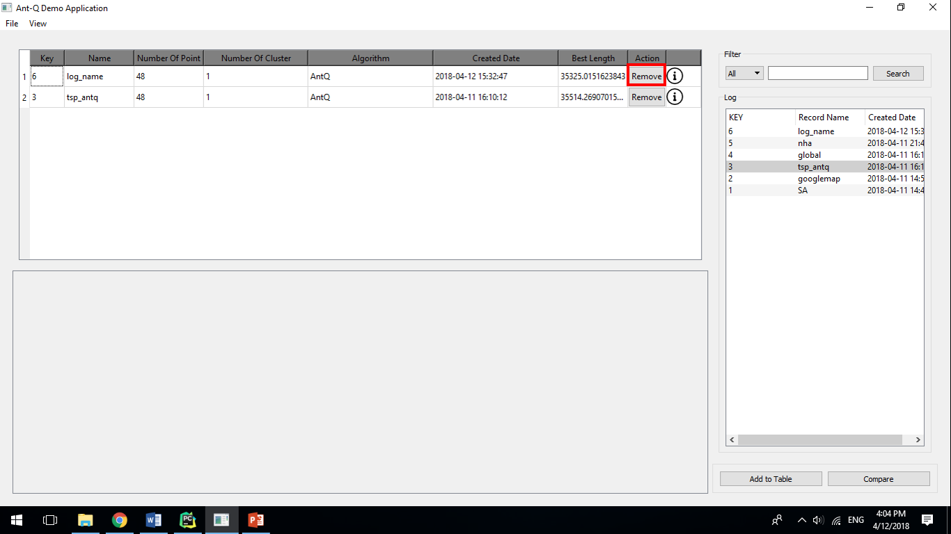

* **Step 6**: Move mouse over “**!**” if you want to see parameter of selected log.

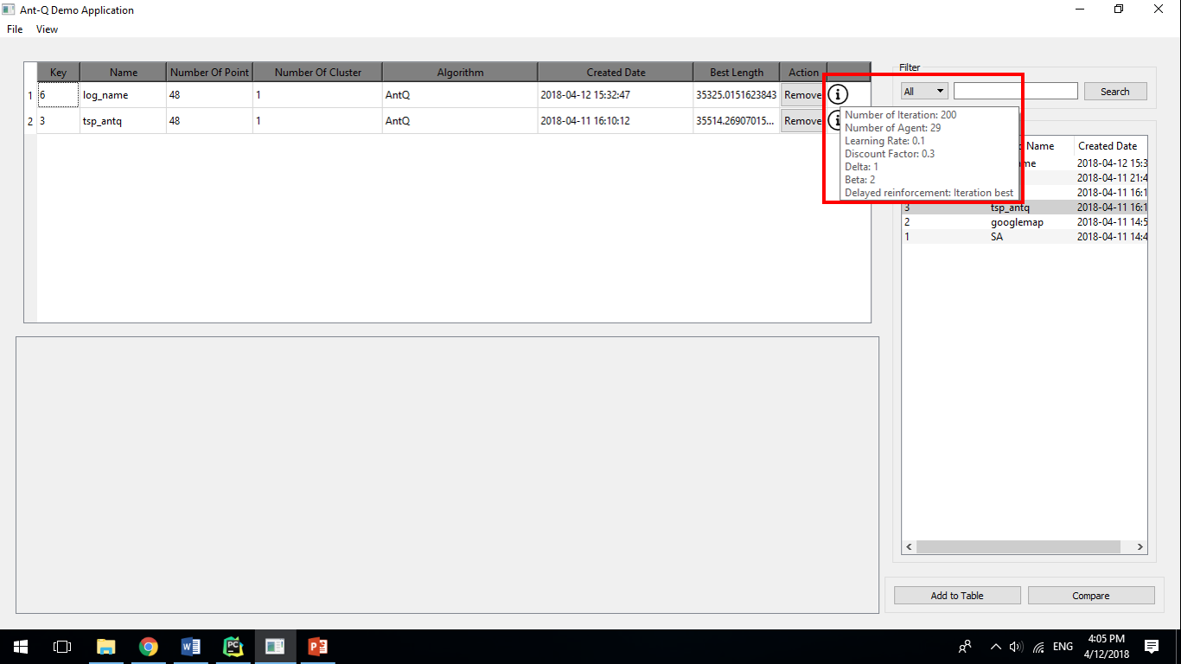

### Compare logs

* **Step 1**: Click menu **View** -> **Log** or press “**Ctrl+L**” to change to Log Window



* **Step 2**: After you select logs, click “**Compare**” button.

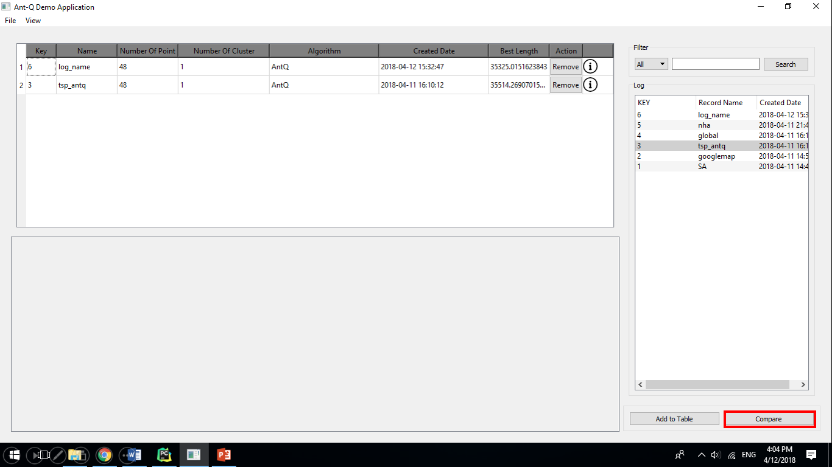

* **Step 3**: Result of comparision will be displayed in bottom panel.

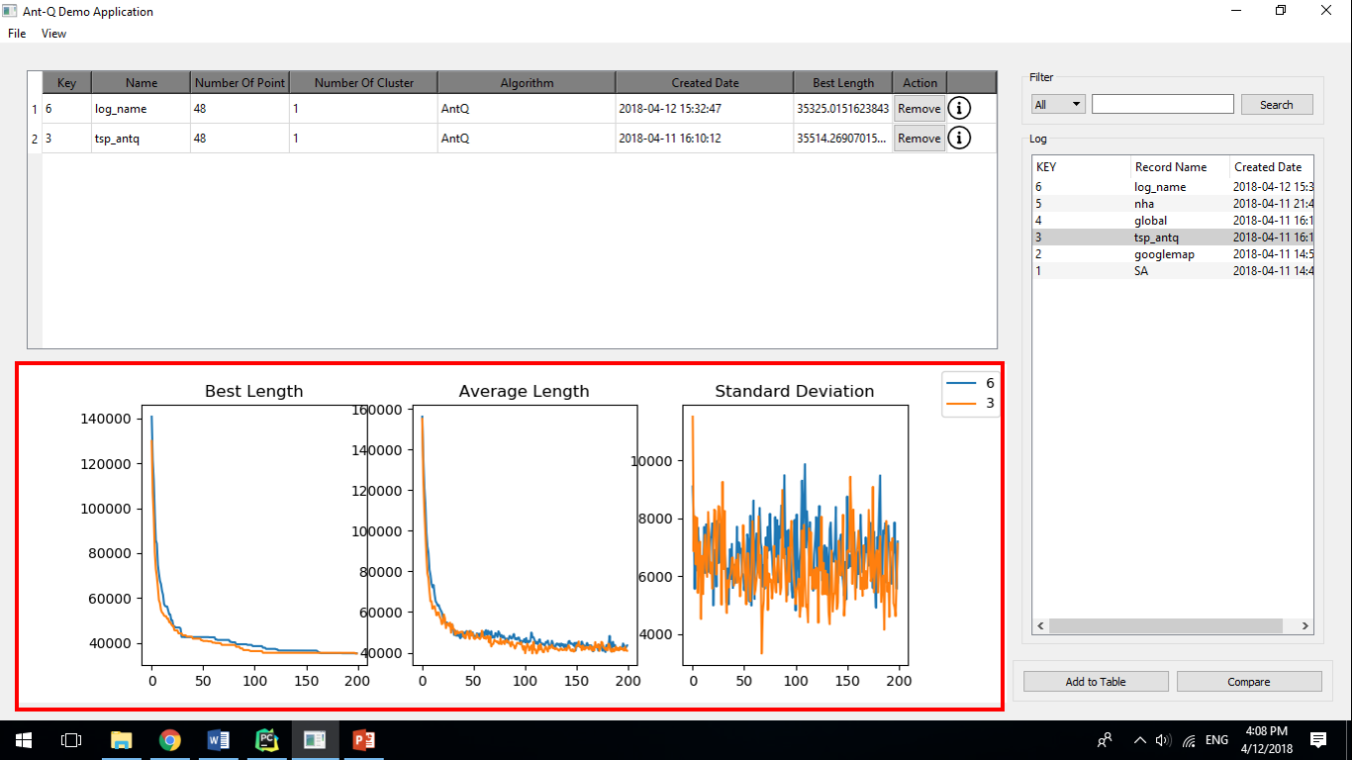

* **Step 4**: If you click “**Compare**” button when you haven’t selected any log, a error dialog will be displayed

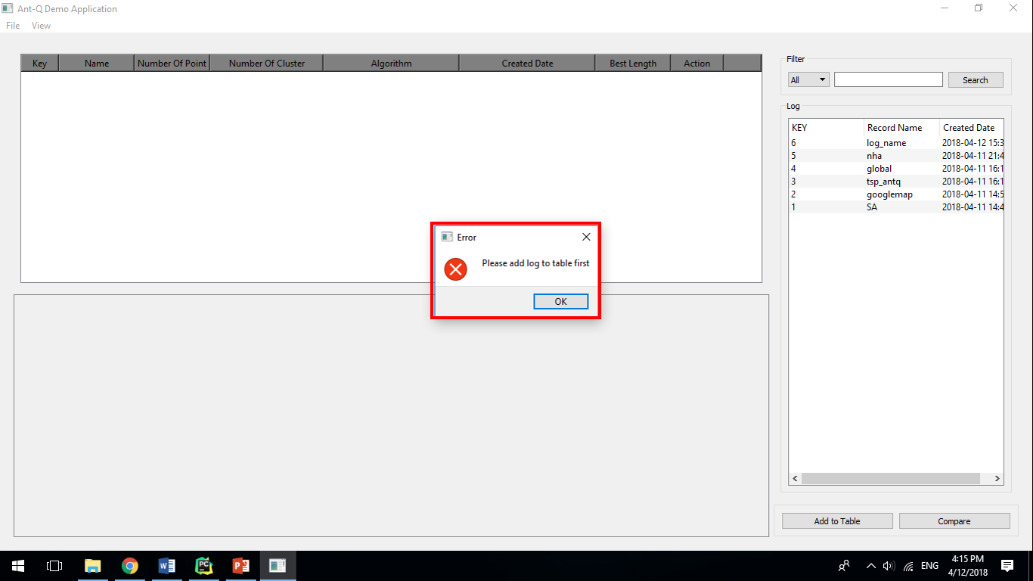

# Appendix

1. Luca M. Gambardella , Marco Dorigo. Ant-Q: A Reinforcement Learning approach to the traveling salesman problem
2. Péter Stefán , László Monostori , Ferenc Erdélyi. REINFORCEMENT LEARNING FOR SOLVING SHORTEST-PATH AND DYNAMIC SCHEDULING PROBLEMS
3. Gilbert L. Peterson, Gary B. Lamont, Maj Christopher B. Mayer. Scaling Ant Colony Optimization with Hierarchical Reinforcement Learning Partitioning
4. Bob Story . Reinforcement Learning with Python
5. Tapas Kanungo, David M. Mount, Nathan S. Netanyahu, Christine D. Piatko, Ruth Silverman, andbAngela Y. Wu. An Efficient k-Means Clustering Algorithm: Analysis and Implementation
6. David Arthur, Sergei Vassilvitskii. k-means++: The Advantages of Careful Seeding
7. Machine learning – Wikipedia: https://en.wikipedia.org/wiki/Machine_learning
8. Reinforcement learning – Wikipedia: https://en.wikipedia.org/wiki/Reinforcement_learning
9. Supervised learning – Wikipedia: https://en.wikipedia.org/wiki/Supervised_learning
10. Cluster analysis – Wikipedia: https://en.wikipedia.org/wiki/Cluster_analysis
11. Markov property – Wikipedia: https://en.wikipedia.org/wiki/Markov_property
12. Markov chain – Wikipedia: https://en.wikipedia.org/wiki/Markov_chain
13. Markov decision process – Wikipedia: https://en.wikipedia.org/wiki/Markov_decision_process
14. Q-learning – Wikipedia: https://en.wikipedia.org/wiki/Q-learning
15. k-means++ - Wikipedia: https://en.wikipedia.org/wiki/K-means%2B%2B
16. k-means clustering - Wikipedia: https://en.wikipedia.org/wiki/K-means_clustering
17. Ant colony optimization algorithms - Wikipedia: https://en.wikipedia.org/wiki/Ant_colony_optimization_algorithms
18. Simulated Annealing – Wikipedia: https://en.wikipedia.org/wiki/Simulated_annealing
19. Travelling salesman problem - Wikipedia:https://en.wikipedia.org/wiki/Travelling_salesman_problem
20. NP-hardness - Wikipedia: https://en.wikipedia.org/wiki/NP-hardness
21. K-means Clustering – Machine Learning Cơ Bản: https://machinelearningcoban.com/2017/01/01/kmeans/
22. Giới thiệu về Machine Learning - Machine Learning Cơ Bản: https://machinelearningcoban.com/2016/12/26/introduce/
23. Phân nhóm các thuật toán Machine Learning - Machine Learning Cơ Bản: https://machinelearningcoban.com/2016/12/27/categories/
24. Simulated Annealing applied to the Traveling Salesman Problem: https://pdfs.semanticscholar.org/e34f/94561872a20130addfaec69de096582516de.pdf
25. Donald A. Norman. Design of Everyday Things
26. Federico Greco. Travelling Salesman Problem